# Upgrade the drivers.

1. Use the FTP transfer software such as: FileZilla Client.

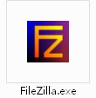

2. Open the FileZilla Client, input the device IP address in to theHost position, such as: 192.168.1.100; Username and Password are both: target



3. click the <Quick connect>. The filezilla will connect to the EMR.

Here, on the right side is the drivers in the EMR.

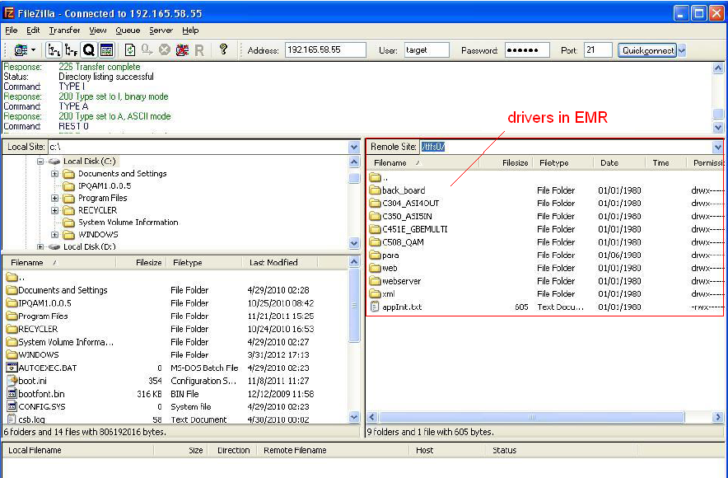

<back_board>,<Para>,<web>,<webserver> ,<xml> and <appInit.txt> files are for EMR platform. Others are drivers for cards.

3. Delete all the old drivers and upload new ones. (if only adding new card to the EMR, just upload the drivers for this card, no need to delete the other drivers)

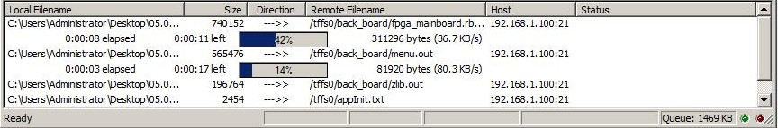

# EMR platform Upgrade

1. Make sure the computer connected with the EMR control port (Directly or through the switch).

Computer can ping to the EMR successful.

2. Update EMR platform. The step as follows:

(1)In vxWorks folder, double-click the <onlineupdata.bat>, then in the cmd window, input the EMR IP address and press “Enter”,the EMR will upgrade automatically.





The device will restart automatically after upgrading.