UPS Power Monitor User’s Manual_Ver 1.17_C

Contents

Introduction 1
1. Hardware Connection of UPS and PC 2
1.1 Serial Communication Introduction 2
1.2 Connection between UPS and PC 4
1.2.1 RS_232 Connection of UPS- PC Monitoring System 4
1.2.2 RS_485 Connection of UPS- PC Monitoring System 5
1.2.3 USB Connection of UPS- PC Monitoring System 5
2. Using UPS-Power-Monitor Software 6
2.1 Software Introduction 6
2.2 UPS Setting on the LCD 6
2.2.1 Color Touch Screen 6
2.2.2 Monochrome Touch Screen 8
2.2.3 Small LCD 9
2.2.4 1/1T (1-3KVA) series Setting 10
2.3 Connecting UPS with Power MTR 11
2.4 UPS Power MTR system setting 12
3 Function selection menu 13
3.1 Introduction 13
3.2 Home 13
3.3 BypassData 14
3.4 MainIpData 14
3.5 OutputData 15
3.6 BatteryData 15
3.7 CabStatus 16
3.8 UnitStatus 17
3.8.1 Dynamic Mode 17
3.8.2 Static Mode 18
3.9 Hislog Down 19
3.10 ScodeDown 20
3.11 RateSetting 21
3.11.1 RateSettings 21
3.11.2 Syscode setting 1 22
3.11.3 Syscode setting 2 23
3.11.4 UPS information setting 24
3.12 ServSetting 25
3.12.1 System Setting 25
3.12.2 Battery Setting 26
3.12.3 Customization 27
3.12.4 WarningSet 28
3.12.5 DryContactSet 28
3.12.6 Shutdown Setting 29
3.13 DetectAdjust 29
3.14 ControlCmd 30
3.15 FWProgram 30
3.16 Help 30
3.17 About 31

Introduction
This software is designed for monitoring and setting UPS. There are two ways to connect with UPS: RS_232 & RS_485. If using RS_485 communication, a “485-232-adaptor” is necessary to connect 485 port of UPS and computer’s Serial port. If using RS_232 communication, a serial cable can be connected directly from UPS 232 port to the computer’s Serial port.

1. Hardware Connection of UPS and PC

1.1 Serial Communication Introduction
1.1.1 Serial Communication Interface Introduction
There are two types 9 cores serial interfaces, one is 9 pins (Male type) interface, another one is 9 holes (Female type) interface. Their Figtures as below:
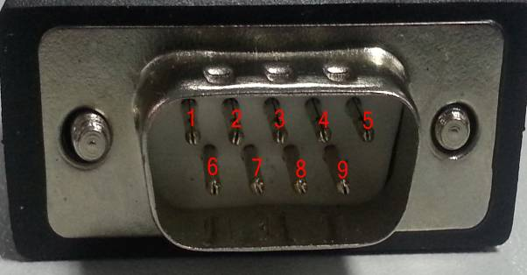
Fig 1-1. Male type interface （for RM060/120/200）
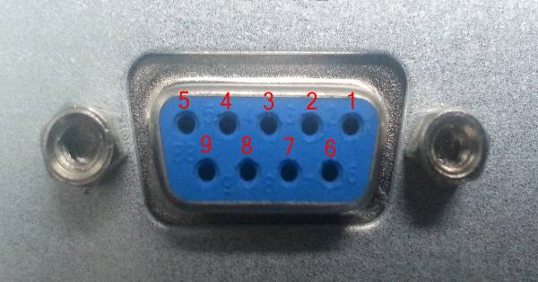
Fig 1-2. Female type interface (For the other products)
1.1.2 RS_232 Definition
- Male type pins definition of RS_232 Port is shown in Fig 1-3.
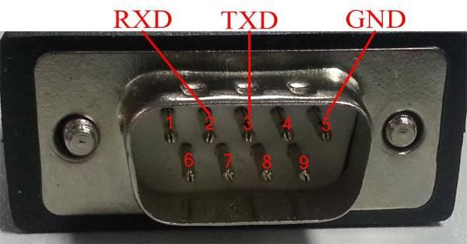
Fig 1-3. Male type pins definition of RS_232 Port
pin2--- RXD
pin3--- TXD
pin5--- GND

- Female type holes definition of RS_232 Port is shown in Fig 1-4.
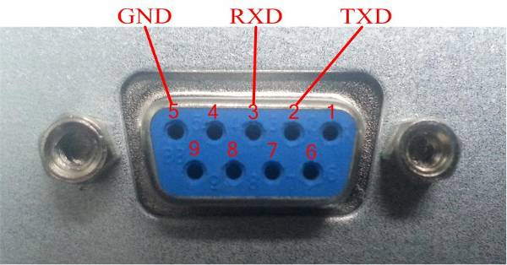
Fig 1-4. Female type holes definition of RS_232 Port
pin2--- TXD
pin3--- RXD
pin5 --- GND
1.1.3 RS_485 Definition
The 9 cores RS_485 interfaces definition is shown in Fig 1-5.
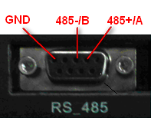
Fig 1-5. RS_485 definition (For RM060/120/200)
pin2--- 485+/A
pin3--- 485-/B
pin5 --- GND

The 3 pins and 2 pins pluggable terminal block definition are shown in Fig 1-6.
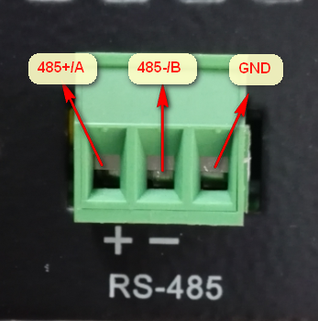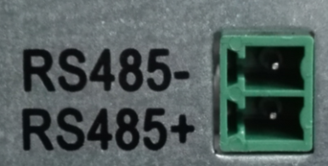
Fig 1-6. RS_485 definition (For the other products)

1.2 Connection between UPS and PC

1.2.1 RS_232 Connection of UPS- PC Monitoring System
As usual, the desktop computer’s serial communication port as shown on Fig 1-7. There is no serial communication port on the notebook computer. The users need a USB-RS_232 cable and install relative drive program at PC, as shown on Fig 1-8.
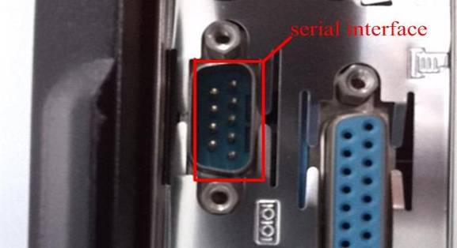
Fig 1-7. Desktop computer serial communication port
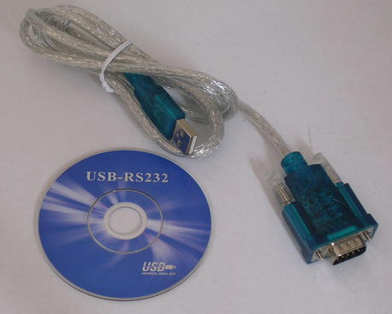
Fig 1-8. USB-RS_232 cable and drive program
- To communicate with standard RS_232 cable
The standard RS_232 cable as shown on the Fig 1-9. As usual, computer’s serial communication port is male type. If your UPS’s serial communication port is also male type, you can connect the computer and UPS with a crossed female-to-female terminal RS_232 cable. If your UPS’s serial communication port is female type, you need a directly connected RS_232 cable with female-to-male terminal.
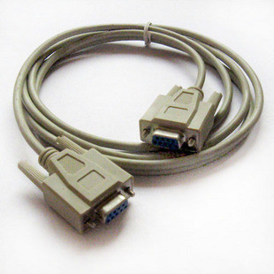
Fig 1-9. RS_232 cable
- To communicate with lead wire
The detailed way is shown on Fig 1-10:
Fig 1-10. PC RS_232 port to UPS RS_232 port
For example, if the PC RS_232 port is male type, UPS RS_232 is female type, the connection way is shown as below:
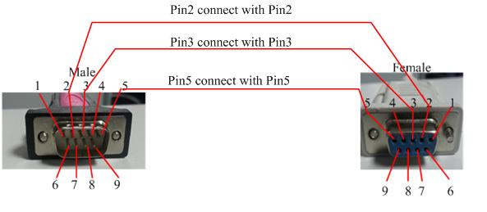
Fig 1-11. PC RS_232 port to UPS RS_232 port

1.2.2 RS_485 Connection of UPS- PC Monitoring System
The connection of UPS- PC monitoring system is shown in Fig. 1-12.
1) Connect the 485-232 adaptor to 485-port of UPS using a customized serial cable, which is an accessory of UPS.
NOTE: Pins definition of this Serial cable is different from a normal one.
2) Connect the serial port of PC to 232 port of 485-232-adaptor using a normal serial cable.
Fig 1-12. UPS and PC monitoring system connection
- If there are more than one UPS connected, the communication bus of RS485 could be applied as below, please set the UPS with different address, and choose the right address when starting the software connection.

Fig 1-13. UPS and PC monitoring system connection via RS485 bus

1.2.3 USB Connection of UPS- PC Monitoring System
RMX series provide a USB (type B) interface, you can connect the computer and UPS with a standard USB cable.

2. Using UPS-Power-Monitor Software

2.1 Software Introduction
After Decompressing, the software can be used directly, need not install it. Please make sure that all 4 files should be put in the same directory, which are described as follows:
UPSPowerMTR.exe：Executable file
UPSPowerMTR.CHS：Language file
UPSPowerMTR.ENU：Language file
CLOSEAPP.EXE：Close application
As hardware connection finished, double click “UPS Power MTR.exe” to start it. Then Home is visible as shown in Fig 2-1. Left side of software window is function selection menu, right side is the energy-flow-diagram.
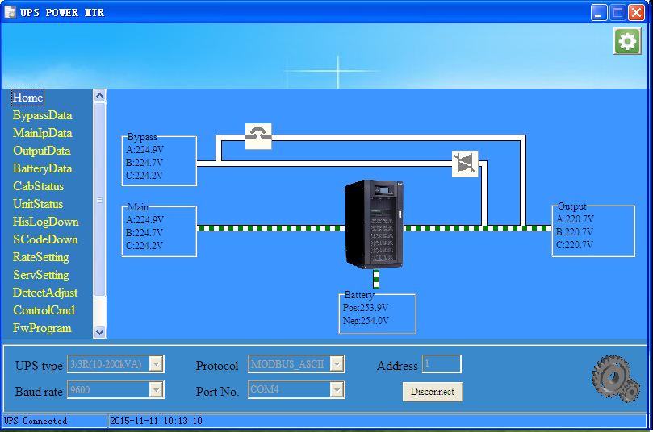
Fig 2-1. Home

2.2 UPS Setting on the LCD
It is necessary to set the UPS communication protocol as Modbus before using UPSPowerMTR.
Different UPS have different LCD, the setting is also different, detailed way as below:

2.2.1 Color Touch Screen
Color touch screen display as shown on Fig 2-2, communication setting way as below:
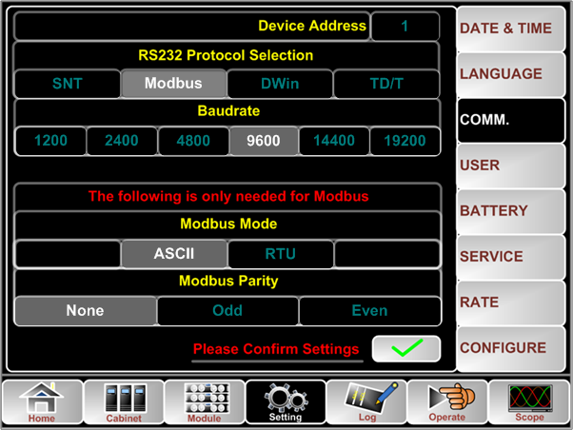
Fig 2-2. Color touch screen display
a. Setting for RS_232:
Click the button , you will get setting manualal, then click the button to enter communication setting page, as shown on Fig 2-2, and set each item step by step:
- RS_232 Protocol Selection: Modbus;
- Baudrate: 9600 or any other value, but it must is the same as monitoring software;
- Modbus Mode: ASCII or RTU, but it must is the same as monitoring software;
- Modbus Parity: None;
- Device Address: 1;
Then click , setting finished.
b. Setting for RS_485:
Click the button , you will get setting manual, then click the button to enter communication setting page, as shown on Fig 2-2, and set each item step by step:
- RS_232 Protocol Selection: SNT;
- Baudrate: 9600 or any other value, but it must is the same as monitoring software;
- Modbus Mode: ASCII or RTU, but it must is the same as monitoring software;
- Modbus Parity: None;
- Device Address: 1 (If there are more than one UPS, please set the address to different number);
Then click , setting finished.
c. Setting for USB:
The setting method of USB communication in the same way with RS_485, so the setting method of RS_485 can be referred.
Note: USB and RS_485 cannot be used at the same time.

2.2.2 Monochrome Touch Screen
Monochrome touch screen display as shown on Fig 2-3, communication setting way as below:

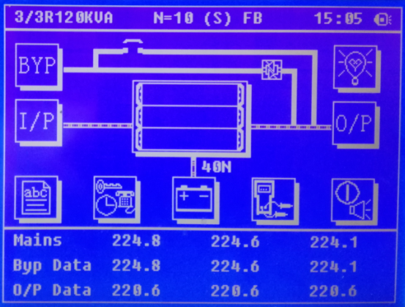
Fig 2-3. Monochrome touch screen display
a. Setting for RS_232:
Note 1: UPS monitoring firmware version should be higher than 003.018.
Note 2: It is not allowed to use RS_232 and RS_485 at same time.
The UPS monitoring firmware version can be gotten by: click first at LCD display home page, then click , you will see it.
The detailed setting as below:
1) click at the home page of UPS LCD display, then click , then click to set communication protocol as “Modbus”.
2) click to enter protocol setting manual;
3) click to enter Modbus setting manual, then click to set Modbus communication mode as “ASCII” mode , you can also choose “RTU” mode, but it must is the same as monitoring software;
4) back to protocol setting manual, click to set Modbus device address as “1” (If there are more than one UPS, please set the address to different number);
5) back to protocol setting manual, click to set Modbus Baud rate as “9600”, you can also choose other value, but it must is the same as monitoring software;
6) back to protocol setting manual, click to set Modbus parity bit as “None”.

b. Setting for RS_485:
1) click at the home page of UPS LCD display, then click , then click to set communication protocol as “Modbus”.
2) click to enter protocol setting manual;
3) click to enter Modbus setting manual, then click to set Modbus communication mode as “ASCII” mode , you can also choose “RTU” mode, but it must is the same as monitoring software;
4) back to protocol setting manual, click to set Modbus device address ;
5) back to protocol setting manual, click to set Modbus Baud rate as “9600”, you can also choose other value, but it must is the same as monitoring software;
6) back to protocol setting manual, click to set Modbus parity bit as “None”.
7) click , back to protocol choose page, click to set current RS_232 communication protocol as “SNT”.
c. Setting for USB:
The setting method of USB communication in the same way with RS_485, so the setting method of RS_485 can be referred.
Note:
1. USB and RS_485 cannot be used at the same time.
2. Only RMX series have USB interface.

2.2.3 Small LCD
The LCD display as shown Fig 2-4:
Fig 2-4 Small LCD
Note 1: Your UPS rectifier version must be advanced than Version 001.001 when using RS_232.
Note 2: Port RS_485 is forbidden to use when using RS_232.
Select icon in the main display interface of UPS LCD, then enter “Version” interface, then you will see UPS REC version.

a. The way to set Port RS_232 of UPS as below:
- Select icon in the LCD of UPS to enter “COMM. SET” interface;
- In the “COMM. SET” interface, set current communication protocol to “ModBus”;
- In the “MODBUS SET” interface, set Modbus communication mode to “ASCII” or “RTU”, set device address to “1”, set baud rate to “9600” or other, as shown on Fig 2-5:
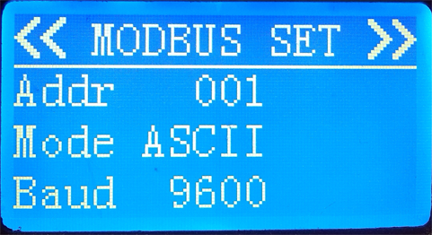
Fig 2-5 Modbus Setting
b. The way to set Port RS_485 of UPS
The way to set Port RS_485 of UPS as below:
1) Select icon in the LCD of UPS to enter “COMM. SET” interface;
2) In the “COMM. SET” interface, set current communication protocol to “SNT”;
3) In the “MODBUS SET” interface, set Modbus communication mode to “ASCII” or “RTU”, set device address to “1”, set baud rate to “9600” or other, as shown on Fig 2-5:
Note: No RS_485 interface on the HT31 10~20kVA and HT11 6~20kVA UPS.

2.2.4 1/1T (1-3KVA) series Setting
1/1T (1-3KVA) UPS LCD display as shown on Fig 2-6:
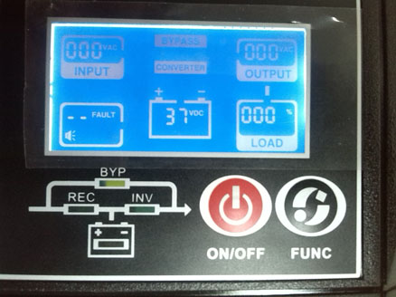
Fig 2-6. 1/1T (1-3KVA) LCD Display
Setting for RS_232 interface of 1/1T (1-3KVA) UPS
1) Press “ON/OFF” and “FUNC” at same time for 5 seconds, then will enter UPS function setting manual;
2) Press “ON/OFF” to select 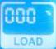, press “FUNC” to modify the number to be “0CC”, it means that the current communication protocol is “Modbus”.
Note: No RS_485 interface on 1/1T (1-3KVA) UPS.

2.3 Connecting UPS with Power MTR
To start monitoring UPS, UPS type, Protocol, Address, Baud rate, Serial port number need be set correctly, Click the button “Connect” to make the software communicate with UPS.
After a few seconds, if hardware connection and the software setting are correct, status bar at the bottom of the window should display “UPS connected”, as shown in Fig 2-7. If not, please check hardware and your setting.
When connected, clicking the button ‘disconnect’ will make the software disconnect with UPS.
The settings are as follows:
UPS type: Auto or choose a type according to your UPS.(Note, some old UPS do not support auto choose)
Baud rate: Auto , you can also choose other value, but it must is the same as UPS
Protocol: MODBUS_ASCII or MODBUS_RTU, it must is the same as UPS
Address: set to the same address as the equipment being accessed.

Note 1: “UPS type” must be set correctly.
Note 2: The software can scan serial port numbers of computer. If there is only one serial port for computer, no need to choose.
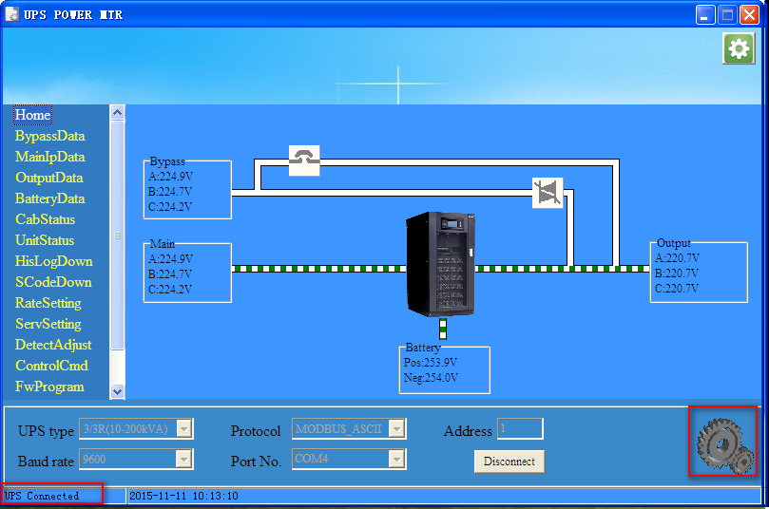
Fig 2-7. UPS connected
Once UPS is connected, UPS status and data are shown on PC. Clicking the menu items on the left side of the window, corresponding data will be shown.

2.4 UPS Power MTR system setting
Click the button at the top-right corner of UPS Power MTR or right click system tray icon and choose ‘Setting’ , then a system setting dialog will popup, as shown in Fig 2-8. In this dialog, you can set the action when click close button, and you also can set the password if you like, the initial password is 12345678.

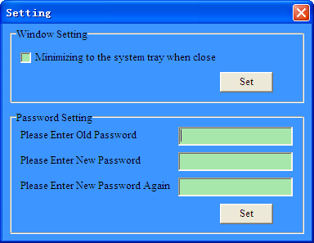
Fig 2-8. Setting

3 Function selection menu

3.1 Introduction
The MTR software has the functions of monitoring , setting and control of the UPS, the functions are shown as below.

3.2 Home
Home Page display the energy-flow-diagram and information of main input voltage, bypass voltage, output voltage and battery voltage. The interface appears to be two different types according to the UPS model selected. Type A with 1/1T(1-3KVA)、1/1T (6-20KVA)、3/1T (10-20KVA) selected as is shown in Fig.3-1; Type B with other type selected as is shown in Fig.3-2.
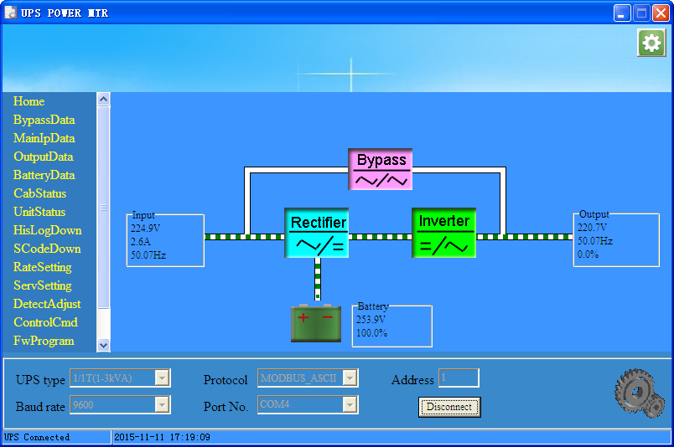
Fig.3-1 Homepage-Type A
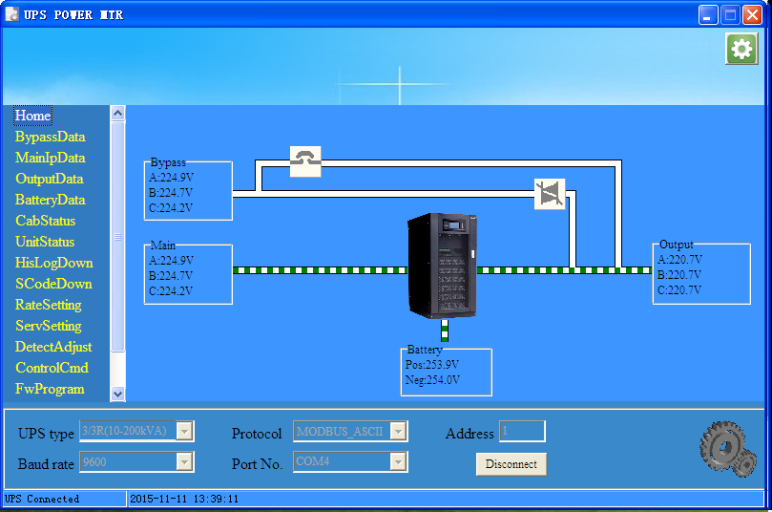
Fig.3-2 Homepage-Type B

3.3 BypassData
This page is to show the data of UPS bypass input, including voltage, current, frequency and power factor, as shown in Fig.3-3.
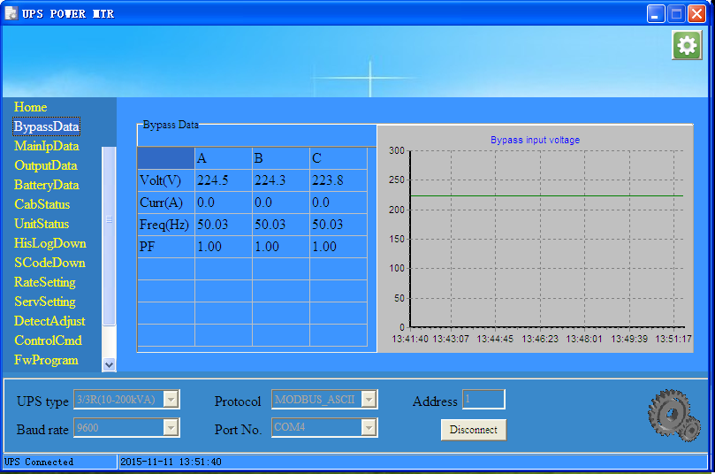
Fig.3-3 Bypass Data

3.4 MainIpData
This page is to show the data of UPS main input, also including voltage, current, frequency and power factor,
as shown in Fig.3-4.
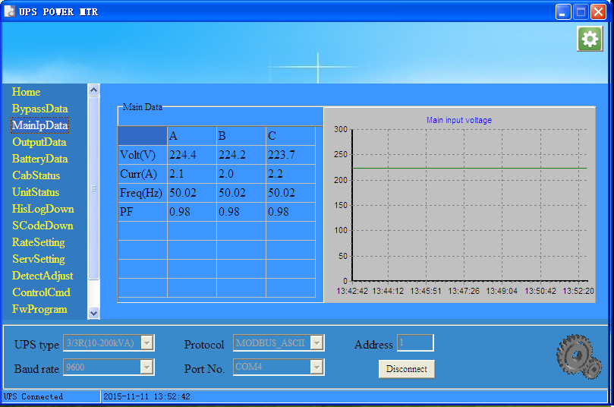
Fig.3-4 Main Input Data

3.5 OutputData
This page is to show the data of UPS output, including voltage, current, frequency, power factor, power, and load percents, as shown in Fig.3-5.
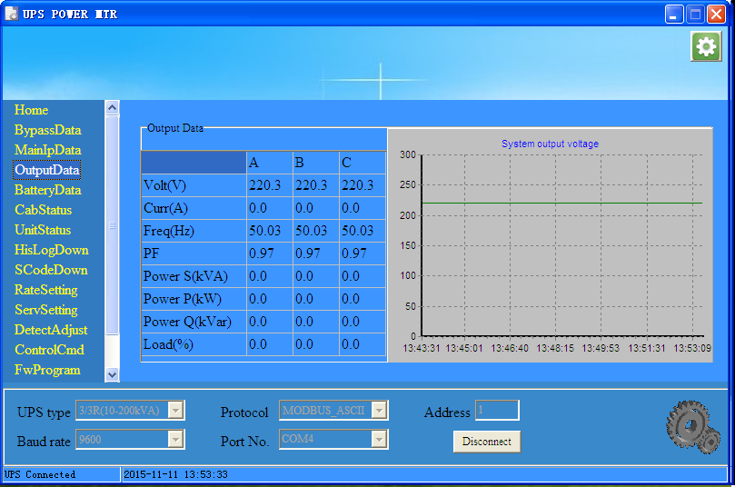
Fig.3-5 Output Data

3.6 BatteryData
This page is to show the data of UPS Battery, including voltage, charge/discharge current, capacity and remind time. The capacity and remind time data are effective when UPS is discharge, as shown in Fig.3-6.
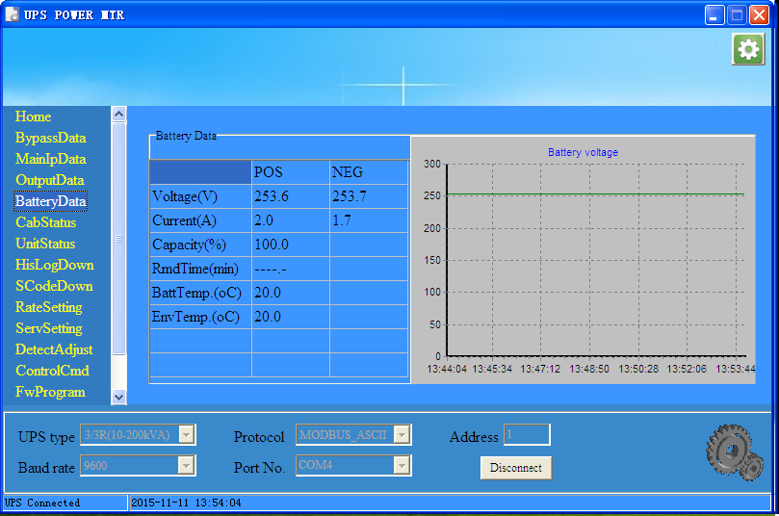
Fig.3-6 Battery Data

3.7 CabStatus
This page is to show the status for the cabinet. As it’s shown in Fig 3-7, the description in the yellow frame indicates the status listed in the red frame. Take the first row as an example, the ‘By UPS’ in the yellow frame indicate the power supply source is UPS.
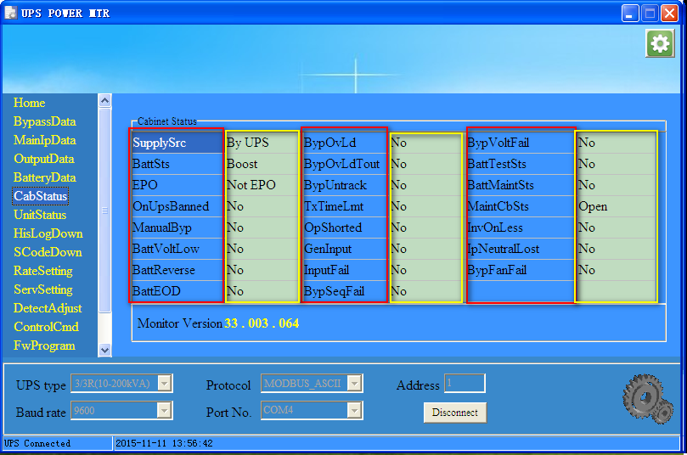
Fig.3-7 Cabinet Status
Cabinet status items explanation:
Display Items | Means
SupplySrc | System power supply source. Available states: None, By UPS, Bypass.
BattSts | The work status of battery. Available states: Not Work, Float, Boost, Discharge.
EPO | Emergency power off. Available states: Not EPO, EPO.
OnUpsBanned | Whether UPS power on is banned. Available states: No, Yes.
ManualalByp | Whether transfer to bypass mode manually. Available states: No, Yes.
BattVoltLow | Whether battery voltage is low. Available states: No, Yes.
BattReverse | Whether battery reversed connected. Available states: No, Yes.
BattEOD | Whether battery End Of Discharge occurred. Available states: No, Yes.
BypOvLd | Whether bypass over load. Available states: No, Yes.
BypOvLdTout | Whether bypass over load timeout. Available states: No, Yes.
BypUntrack | Whether bypass frequency untrack occurred. Available states: No, Yes.
TxTimeLmt | Whether the times of transfer to bypass reach its limit. Available states: No, Yes.
OpShorted | Whether Output short circuit occurred. Available states: No, Yes.
GenInput | Whether generator input. Available states: No, Yes.
InputFail | Whether input fail occurred. Available states: No, Yes.
BypSeqFail | Whether bypass sequence fail. Available states: No, Yes.
BypVoltFail | Whether bypass voltage fail. Available states: No, Yes.
BattTestSts | Battery test status. Available states: No, Ok., Fail, Testing
BattMaintSts | Battery maintenance status. Available states: No, Ok., Fail, Maintaining
MaintCbSts | Maintain CB status. Available states:Open, Close.
InvOnLess | Whether Inverter Capacity is less than required. Available states: No, Yes.
IpNeutralLost | Whether input neutral lost. Available states: No, Yes.
BypFanFail | Whether bypass fan fail. Available states: No, Yes.

3.8 UnitStatus
As shown in Fig 3-8,by selecting the button of ‘Unit Status’ and ‘Module Data’, users can see the status information and analog value of the online module respectively.
The ‘Unit Status’ page can up to show 30 modules. By dragging the horizontal scroll bar, user can view all the information of the modules. For the mark, the “” indicates the normal operation；the mark”’ indicates fault occur.
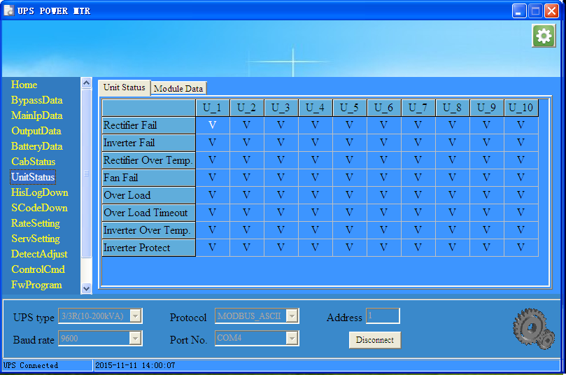
Fig3-8 Status Unit page
The “Module Data” displays the analog value of the current selected module As is shown in Fig 3-9,the number in the red frame is the selected module. By pulling-down menu in the yellow frame and confirm click, users can change the information displayed for different module.
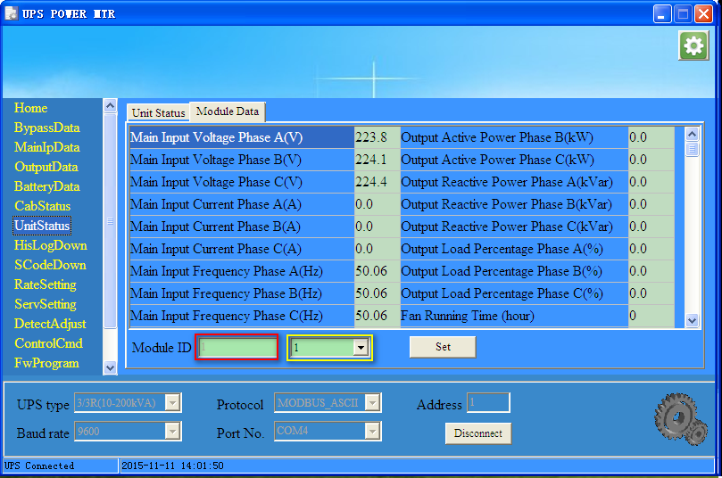
Fig 3-9 Module Data

3.9 Hislog Down
UPS history log can be downloaded to PC on this page. Click ‘Download’ to download history log from UPS which then would be displayed on PC. Click ‘Save’ to save history log to PC as a file. It’s shown in Fig.3-11.
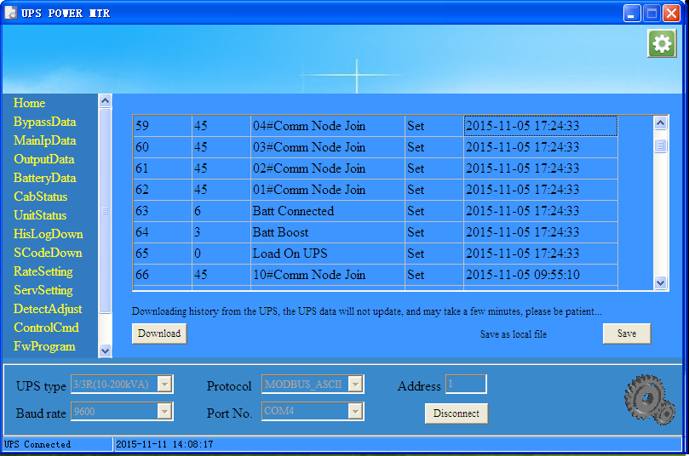
Fig.3-11 Hislog Down

3.10 ScodeDown
“SCode download” interface is shown in Fig 3-12. The SCode can be downloaded to the grid on the left by simply clicking the “Download” button,and click “Save” to save the SCode to the local computer.
If you want to analyze the SCode that was download from UPS, you can input it to the box on the right and click the button “Analyze” then the “Analyze dialog window” will show as Fig3-13.
There are three methods to input the SCode into the SCode box :
(a) Double-click the SCode title on the left, the SCode will be copy to the SCode box, as shown in Fig 3-12.
(b) Save the SCode to the local file and copy it to the SCode box.
(c) Directly type the SCode to the SCode box, make sure the format is as same as the one on the left box. Normally you can copy and paste from the SCode file.
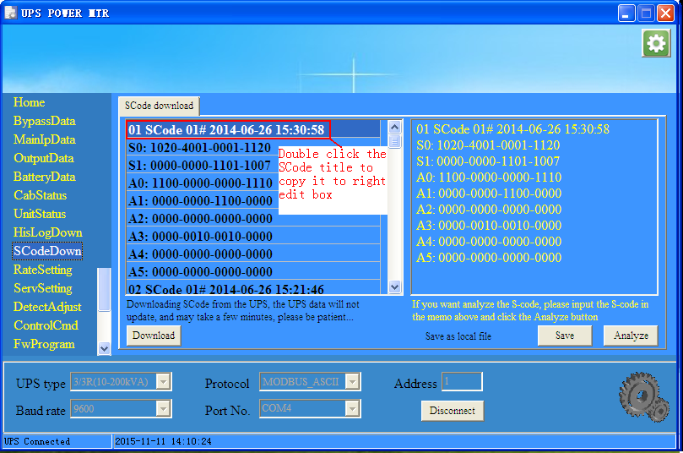
Fig 3-12 Scode Download
“Analyze dialog window” as shown in Fig 3-13, the failure will be shown in red in order to attract attention. For the mark , it means the parameter is not detected , the mark it indicates the data is out of range.
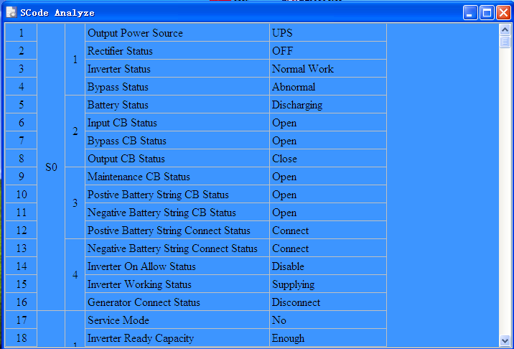
Fig 3-13 Scode analyze

3.11 RateSetting
“RateSetting” page is for factory use. A password is needed for the access to the page.

3.11.1 RateSettings
“RateSettings” menu can set the rated system voltage and frequency. The values in red rectangle are currently used by UPS, while in yellow rectangle are the new values to be set. Click button “set” can save the data to the UPS, as is shown in Fig.3-14.
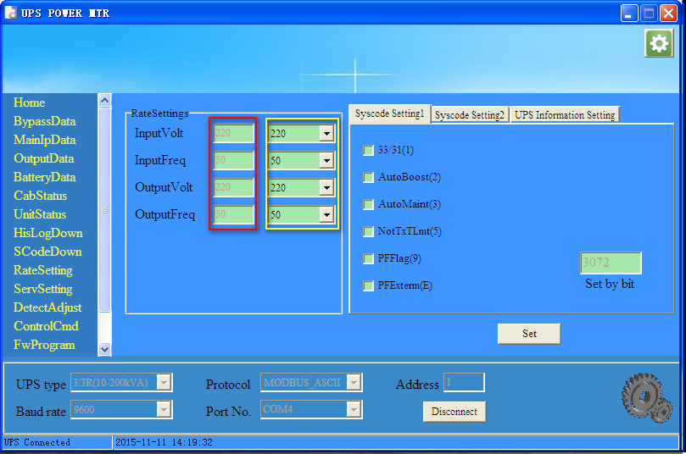
Fig 3-14 RateSetting
The items are described as follows：
Contents | Description
InputVolt | The system rated input voltage(V)
InputFreq | The system rated input frequency(Hz)
OutputVolt | The system rated output voltage(V)
OutputFreq | The system rated output frequency(Hz)

3.11.2 Syscode setting 1
The syscode setting 1 is set by bit. Different bit may has different meaning to different model of UPS. Users can check or uncheck the checkbox and click “Set” to save the setting to the UPS. As is shown in Fig3-15.
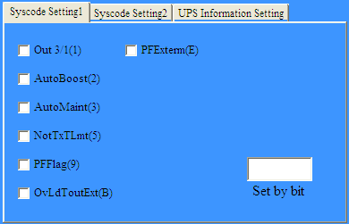
Fig3-15 Syscode setting1
System code is set by bit, described as follows:
Setting items | Choose (1) | Not choose (0)
Out 3/1 | Single phase output (Do not choose this function unless confirmed by manufacturer) | 3 phase output
AutoBoost： | Enable battery auto boost | Disable battery auto boost
AutoMaint： | Enable battery auto maintenance | Disable battery auto maintenance
NotTxTLmt： | No switching limit to bypass times | Switching limit to bypass (5 tims per hour)
FreqSelfAdpt： | Enable frequency self adaptive function | Disable frequency self adaptive function
PFFlag： | Combine with PFExtern to set different output PF.  PFFlag PFExterm PF  0 0 0.8  0 1 0.7  1 0 0.9  1 1 1
PFExterm： | See PFFlag | See PFFlag
OvLdToutExt(B) | Long inverter overload time | Short inverter overload time
Note：Different UPS model has different system code.

3.11.3 Syscode setting 2
The syscode setting 2 is set by bit. Different bit may has different meaning to different model of UPS. Users can check or uncheck the checkbox and click “Set” to save the setting to the UPS. As is shown in Fig3-15.
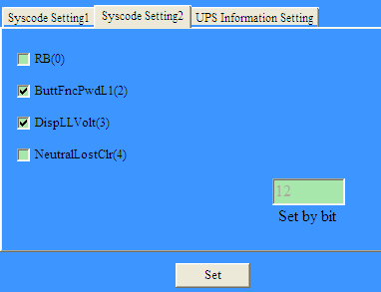
Fig 3-16 Syscode setting 2
System code is set by bit, described as follows:
Setting items | Choose (1) | Not choose (0)
RB： | Set UPS mode as RB( In-built battery pack) | Not RB mode
ButtFncPwdL1： | Set monochrome touch LCD function page password for 1 level | Set monochrome touch LCD function page password for 2 level
DispLLVolt： | Display line voltage | Not display line voltage
NeutralLostClr： | Neutral line lost auto clear faults | Normal logic
EpoNormClose： | Epo terminal normal close | Epo terminal normal open
PFExterm： | See System code 1 PFFlag | See System code 1 PFFlag

3.11.4 UPS information setting
The UPS information setting include : UPS Mode , UPS Type, Company Name, as is shown in Fig3-17. You can set the UPS Type and Company Name by input it in right edit, then click set button.
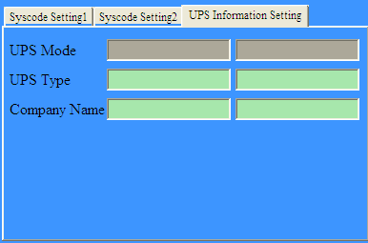
Fig 3-17 UPS information setting

3.12 ServSetting
In the “ServSetting” menu, a password is needed before entering. The submenu “System Setting”, “Battery Setting”, “Customization” , “DryContactSet” are for factory use, the “Warning Set” and “Shutdown setting” are for customer use.

3.12.1 System Setting
“System Setting” interface is shown as Fig3-18. The values in red rectangle are currently used by UPS, while in yellow rectangle are the new values to be set. Click “Set” to send new values to UPS. In the system Settings page, click the “SaveAll” button can save all the data and setting to the local disk, also the data can be restored to the monitoring software from the local disk by clicking the “Recover” .
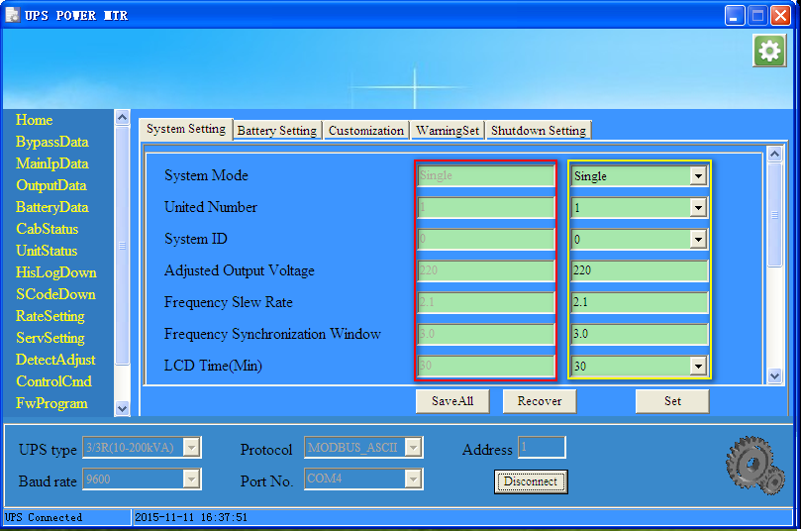
Fig 3-18 System Setting
The items of System Setting are described as follows(Different UPS type may have different items)：
Setting item | Description
System Mode | Set the operation modes of UPS.  Single : Single mode  Parallel : Parallel mode  SingleECO: ECO mode in single unit  ParallelECO: ECO mode in parallel system  LBS : Load Bus Synchronizer installed for dual bus system, see more detail of the technical doc of LBS.  ParallelLBS : Dual bus system built up with parallel units, see more detail of the technical doc of LBS  Selfaging : Selfaging mode, see more detail of technical doc of selfaging.  The selected operation mode could be active after confirmed by the button of “Set”.
United Number | Set the number of UPS in parallel system
System ID | Set the ID of UPS in parallel system  For parallel system, the ID starts from 0.
Adjusted Output Voltage | Adjusted output voltage, Unit: V
Frequency Slew Rate | Slew rate of track, Unit: Hz/s
Frequency Synchronization Window | Frequency Synchronization window, Unit: Hz
LCD Time(Min) | Set the time of LCD screen saver, Unit: Min
Logo Show Time(s) | Set logo page show time
Redundant Module Number | Set the number of N+X redundant modules  If the redundant modules are less than the set number, there could be an alarm of “Lost Redundancy”.  For example, if 5 modules installed ,the redundant module number is set to 2, if the load rate is higher than 60%, there could be an alarm.
Bypass Voltage UP Limited（%） | Set bypass voltage up limited
Bypass Voltage Down Limited（%） | Set bypass voltage down limited
Bypass Frequency Limited（Hz） | Set the range of frequency fluctuation, Unit: Hz
Battery Transfer to Main Delay(s) | Set the delay time from battery transfer to main
System Auto Start Mode After EOD | Set system auto start mode after EOD, that means, after battery EOD, when the AC input recover ,the system should behave as below:  Normal: auto restart and transfer to inverter mode  BypOnly: auto restart of rectifier, but the inverter does not start, the system stay on bypass  NoneOp: no any action with just the controller and LCD are active
Aging Current(%) | Used in Aging mode to set aging current from 30%-100% of nominal current. See more detail of the technical doc of selfaging.
Fan Speed 3 Level Enable | Enable or disable fan speed 3 level  Yes: There are 3 levels of fan speed according to the load rate (slow, medium, fast)  No: There are 2 levels of fan speed according to the load rate (medium, fast)
Allow Lost Phase Work | Enable or disable UPS lost phase work  Yes: If one of the phases lost, rectifier could continue to work if only the current is lower than the set limit.  No: Rectifier will stop if one phase lost.
Temperature Rise Limit Level | Set temperature rise (outlet temperature to inlet temperature) limit level, there are different settings according to the product, please do not change the value unless confirmed by the manufacturer.
Inlet Temperature Level | Set inlet temperature level. It’s about the internal control logic and please do not change this setting.
Motor Mode | Enable or disable motor mode. This function is used for motor application.  Yes: System start with inverter (not bypass), with a current limit and different control algorism.  No: System start with bypass as normal.
Frequency Convertor Mode | Enable or disable frequency convertor mode, this allow the system operates as a frequency converter.  Yes: Operates as a frequency converter and disable the alarm of bypass frequency fail.  No: Normal mode
Bypass Backfeed Protected Enable | Enable or disable bypass backfeed protected  Yes :Enable the bypass Backfeed detection  No :Disable the bypass Backfeed detection
Input Overvolt Fast Check Enable | Enable or disable input overvoltage fast detection.  This function is used for the applications that unexpected transient spike of input presents in the input. It could be more sensitive to the spike and transfer to battery mode in case of any abnormal voltage.
Charger Fail Alarm Enable | Enable or disable charger fail alarm
Module Fan Maintenance Period | Set the maintenance period of module fan
Bypass Fan Maintenance Period | Set the maintenance period of bypass fan
Module Capacitor Maintenance Period | Set the maintenance period of module capacitor
Generator In Charger Off Enable | Set if disable charger when generator switch in  Yes : Disable the charger if a generator is connected  No : Enable the charger if a generator is connected
System Time | Launch the system time of PC to the controller, it’s only available for the monochrome LCD.

3.12.2 Battery Setting
“Battery Setting” interface is shown in Fig3-19. The values in red rectangle are the current parameter of UPS, while in yellow rectangle are the new values to be set. Click “Set” to send new values to UPS.
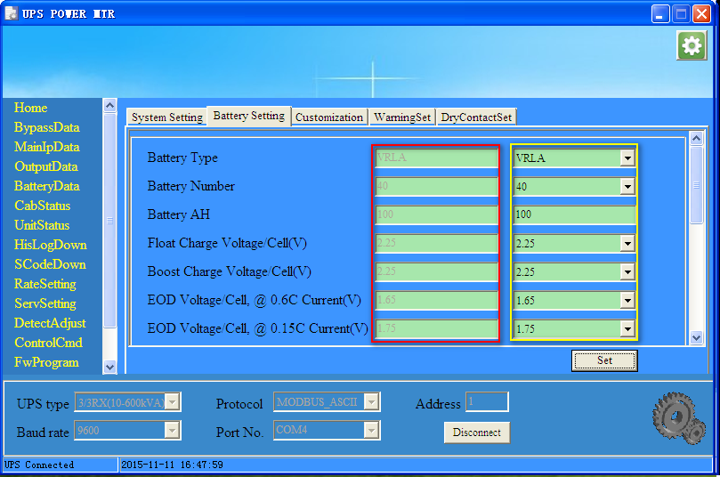
Fig3-19 Battery Setting
The items of Battery Setting are described as follows(Different UPS type may have different items)：
Setting item | Description
Battery Type | Set the type of battery used by your UPS.  VLRA or Lithium-ion battery is available.
Battery Number | Set battery number
Battery AH | Set battery AH  Pay attention that the max charging current is limited to 0.2*AH
Float Charge Voltage /Cell(V) | Set the float charge voltage of battery cell  Calculate the charging voltage as below,  Vchg= cell voltage*6*battery number
Boost Charge Voltage/Cell(V) | Set the boost charge voltage of battery cell  Normally it’s recommended no higher than 2.35V/cell.
EOD Voltage/Cell, @ 0.6C Current(V) | EOD voltage of Battery cell at 0.6c
EOD Voltage/Cell, @ 0.15C Current(V) | EOD voltage of Battery cell at 0.15c
Charge Current Percent Limit % | Set charge current limit.  Calculate the charging current as below  Ichg= Set Percentage %*Pout/(2.35*6*battery number)
Battery Temperature Compensate | Battery temperature compensate, unit: mV/ºC  Optional battery temperature sensor is needed.
Boost Charge Time Limit | Boost charge time limit, unit: hour
Auto Boost Period | Auto boost period, unit: hour.  The parameter is only valid after enable the function of Auto Boost.
Auto Maintenance Discharge Period | Auto maintenance discharge period, unit: hour  The parameter is only valid after enable the function of Auto Maintenance.
Deep Discharge Time | Deep discharge time, unit: hour  It’s only valid for single phase UPS.
No Battery Detect Period | No battery detect period, unit: minute  It’s only valid for single phase UPS.
No Battery Detect Time | No battery detect time, unit: minute  It’s only valid for single phase UPS.
Critical Battery Temperature | Critical battery temperature, unit: ºC  Set the battery temperature limit for alarm.
Critical Battery Ambient Temperature | Critical battery ambient temperature, unit: ºC  Set the ambient temperature for alarm.
Charge module current limit | Set the max charging current of each charging module, unit:A.

3.12.3 Customization
“Customization” interface is shown in Fig3-20. The CustomCode on the left is set by bit, check or uncheck the box and click the “Set” button can send the data to the UPS; CustomCode on the right set the load level and rotation time of sleeping and waking.
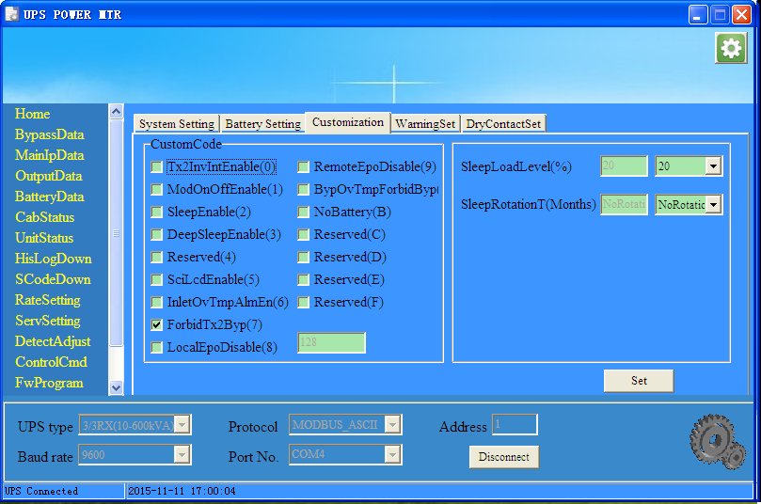
Fig3-20 Customization
c | Checked | Unchecked
Tx2InvIntEnable | This function enable interrupt transfer to inverter, it should be manually operated and may lead to an interruption during transfer. | Disable interrupt transfer to inverter
ModOnOffEnable | Enable the individual operations of module power on/off.  With this setting, operations shown in “ControlCmd-->Module operation command” could be available. | Disable module power on/off
SleepEnable | Enable sleep mode. | Disable sleep mode.
DeepSleepEnable | Enable deep sleep mode.  This setting should be enabled together with the “SleepEnable” setting. | Disable deep sleep
KoreaEco | Enable KoreaEco(Korea nonstandard)  This is an option for special model. | Disable KoreaEco
SciLcdEnable | Configurate Lcd as serial port screen | Configurate Lcd as blue and white screen
2PhasOut | Enable two phase output  It’s only valid for special model. | Disable two phase output
usedAsOne | Enable used as one phase output  It’s only valid for special model. | Disable used as one phase output
ForbidTx2Byp | Forbid transfer to bypass | Not forbid transfer to bypass
EpoDisable | Disable EPO | Enable EPO
LocalEpoDisable | Disable local EPO | Enable local EPO
RemoteEPODisable | Disable remote EPO | Enable remote EPO
BypOvTmpForbidByp | Forbidden the bypass output if bypass over temperature. | Bypass over temperature not forbid bypass
NoBattery | Disable the detection of “Battery not connected” | Enable the detection of “Battery not connected”

CustomCode on the right is described as the following table
Contents | Meaning | Note
Sleeping Load Rate | Setting the sleeping load rate
Interval Time for sleeping | Setting the interval for the sleeping | The period of rotation for the sleep modules.

3.12.4 WarningSet
The “WarningSet” is shown in Fig 3-21. If the selected event occurs, there appears a warning window of the PC. The switch of beeper can control the buzzing. Click the “SelectAll” button to select all the events and click the “ClearAll” to uncheck all the events.
Notes: This warning setting is only about the warning of the PC, NOT THE HISTORY LOG OF UPS ITSELF.
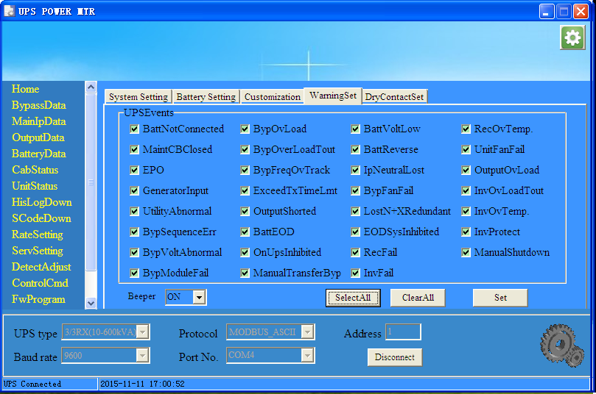
Fig 3-21 WarningSet

3.12.5 DryContactSet
“DryContactSet” interface is shown in Fig 3-22, The values in red rectangle are currently used by UPS, while in yellow rectangle are the new values to be set. Click “Set” to send new values to UPS.
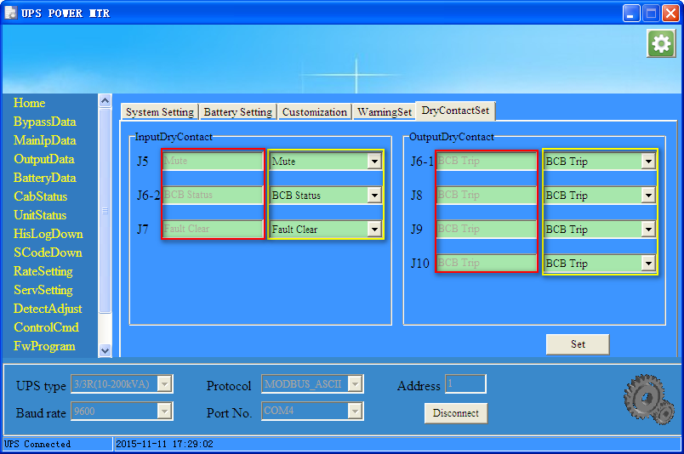
Fig 3-22 DryContactSet
Notes: The list of dry contact signals is subject to change with the upgrade of firmware, for more details, contact your technical support from factory.

3.12.6 Shutdown Setting
Shutdown setting page include “Shutdown Setting” and “Shutdown time setting”, this function only be allowed by the single phase 1-20K UPS.
Do not change the setting unless it’s confirmed by the manufacturer.
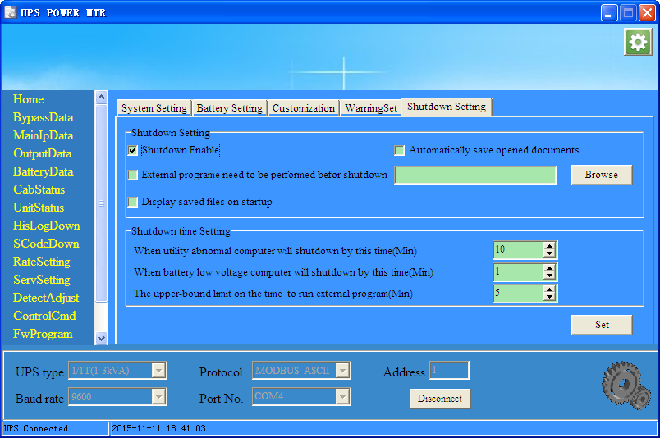
Fig 3-23 Shutdown Setting

3.13 DetectAdjust
This function is only for factory setting

3.14 ControlCmd
In the “ControlCmd” menu, a password is needed before entering. This page include “Function Key”, “Test Command” and “Module Operation Command”. For “Function Key” and “Test Command” parts, you can click the red button to execute corresponding command, then the command will be send to UPS. For “Module Operation Command” part, you can choose a module and choose a action then click “Done” button, so the command can be sent to UPS module.
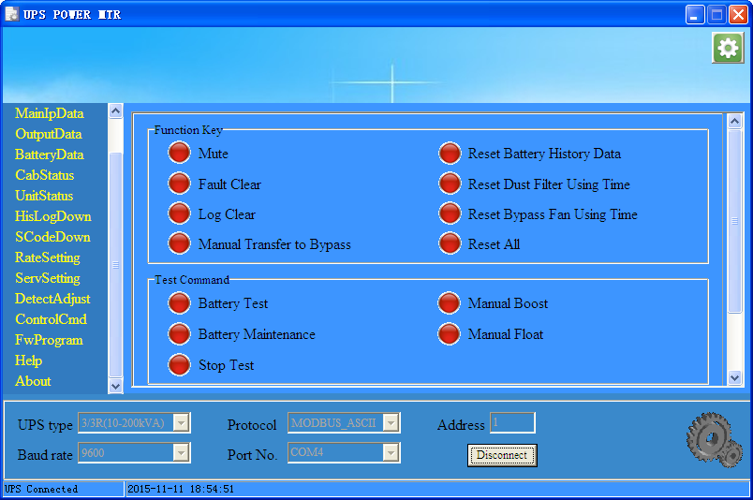
Fig.3-24 ControlCmd

3.15 FWProgram
This function is only for factory setting, disabled for users.

3.16 Help
Brief description of the software, as shown in Fig.3-25.
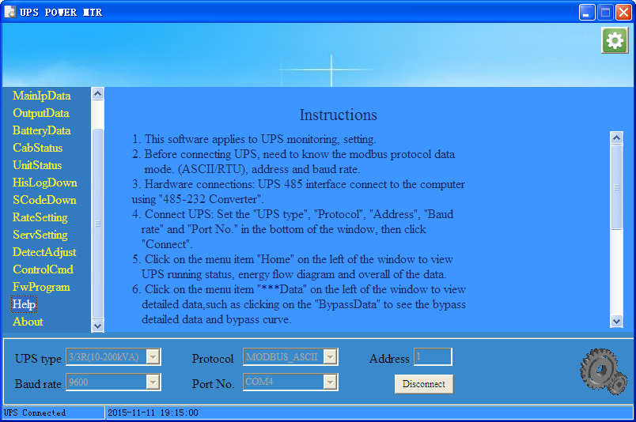
Fig.3-25 Help

3.17 About
Version information of the software, as shown in Fig.3-26.
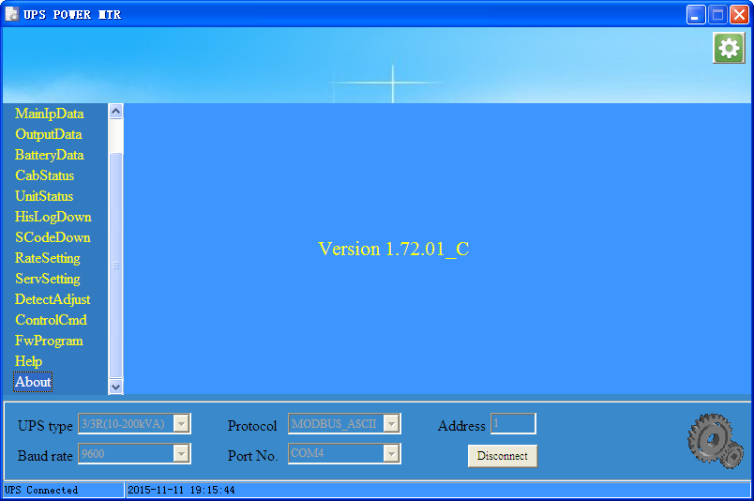
Fig.3-26 About

