Y version SNMP Upgrade 3.7 Method Summary
Includes 3.5 or 3.6 upgrade to 3.7 firmware ver.

Contents
Suitable for LAN upgrade method: 3
1. Prepare for the upgrade 3
2. Upgrade with Netility 11
3. Upgrade through a well-configured FTP server on the LAN 14
4. Upgrade through the default FTP server icv99.com 18
5. Use the SNMP card's own FTP function to upgrade the firmware (Only for 3.6 ver. and above) 20
Suitable for the World Wide Web upgrade method 24
1. Prepare for the upgrade 24
2. Upgrade through a well-configured FTP server on the remote network 26
3. Upgrade through the default FTP server icv99.com 27
4. Use the SNMP card's own FTP function to upgrade the firmware (Only for 3.6 ver. and above) 28

Suitable for LAN upgrade method:
Upgrade Notes: Upgrading via LAN is the most stable upgrade method. During the upgrade process, the network of PC and SNMP communication and the power supply of the SNMP card can't be interrupted. Once it is interrupted, the upgrade will fail and the SNMP card needs to be returned to our company for repair.

Prepare for the upgrade
- Install the Netility software on the PC. The installation package can be found on the attached CD or downloaded from our website (http://www.icamview.com/pub/pub/netagent%20utility/Netility%20for%20Windows%20v5.1.rar）。During the installation process, it is recommended to completely quit the relevant security anti-virus software, or all options in the permission prompt window option popped up by the security anti-virus software are allowed. After the installation is complete, it can be found in ALL PROGRAMS, as shown in the figure;
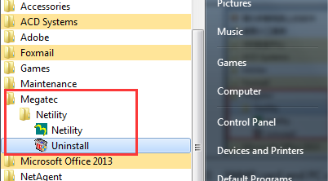
- SNMP card and PC communication network construction:
Method 1: The SNMP card and the PC are connected to the same LAN through a router or a switch; -- Suitable for one or more SNMP cards to be upgraded at the same time.
- Connect the PC cable to the LAN port of the same router as the SNMP card or under the same switch. (If you are not sure, please consult the network management)
Method 2: The SNMP card and the PC are directly connected through the network cable; -- Suitable for one SNMP card upgrade at a time.
- Connect the SNMP card to the PC with a network cable
- Check the current IP settings of the PC. If it is automatic, please refer to the following settings.
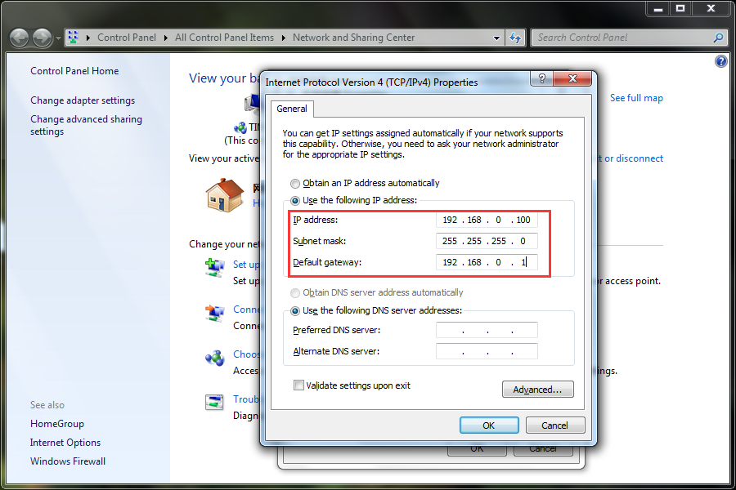
- Run Netility on the PC, search for the SNMP card, and set the IP address of the SNMP card. See below:
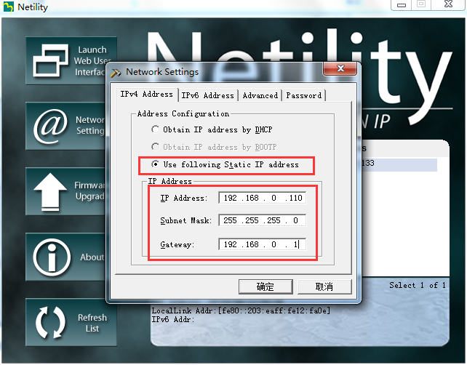
So far, two ways to build a LAN have been completed.

- Restore the SNMP card to the factory default setting; (This step can greatly reduce the chance of an upgrade failure due to an unknown problem during the upgrade process.)
- Double-click the SNMP card in the Netility list to open the SNMP card web page management page.
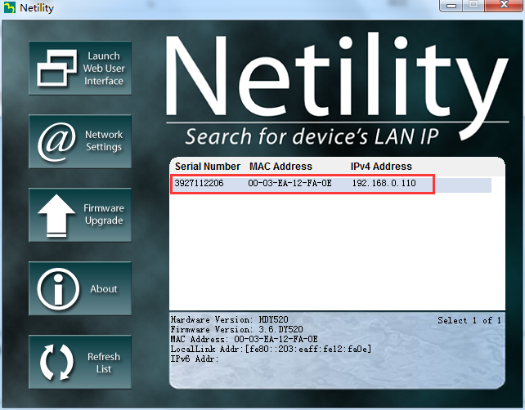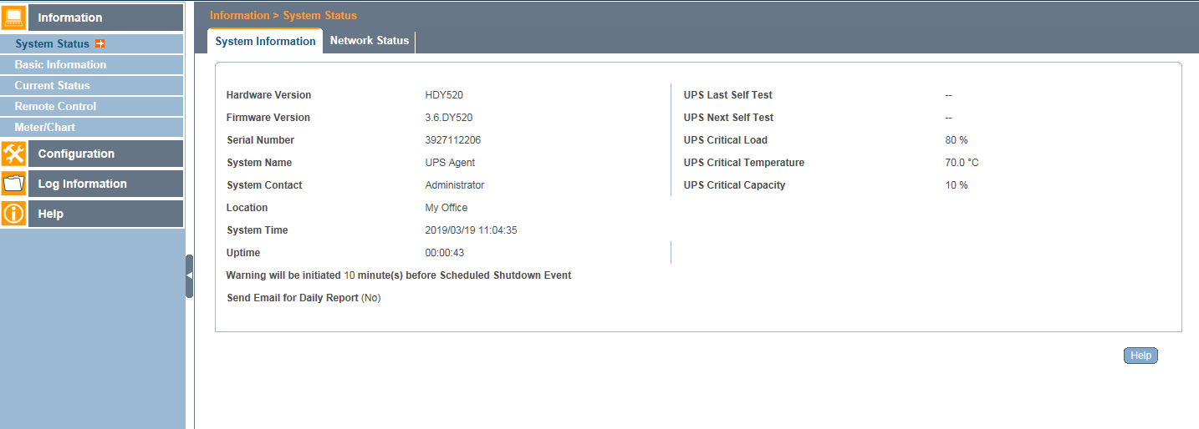

- For the SNMP card that has been set up, take the photo or screen capture record of the changed settings in the parameter setting bar to facilitate resetting after upgrading. (If you have not used an SNMP card, you can ignore this step)
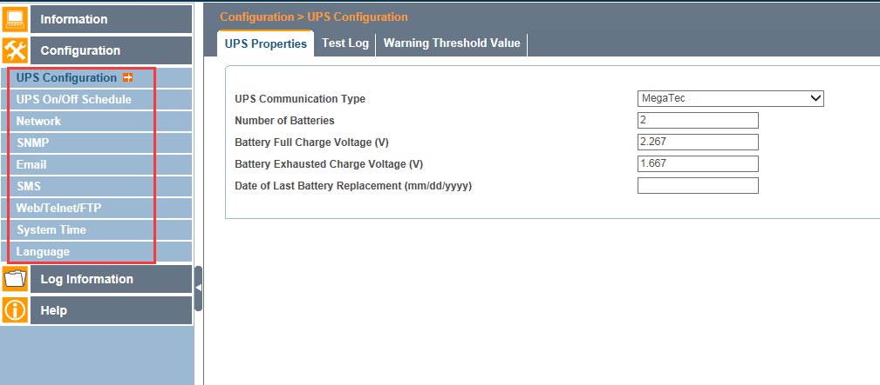

- On the left side of the web page management page, click “Help” “About” “Reset to factory default”, and click the “Reset” button.
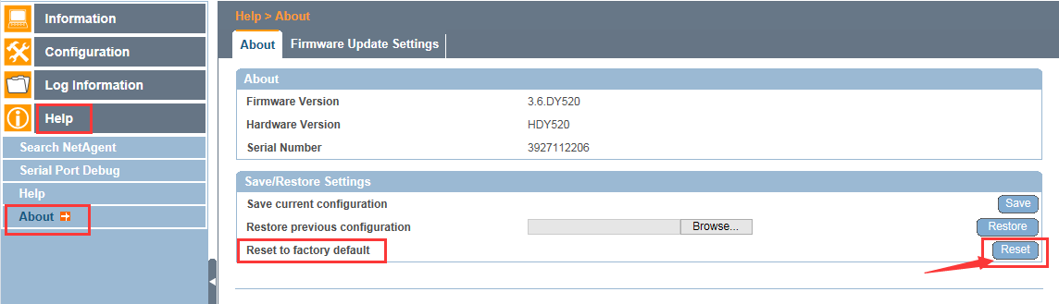

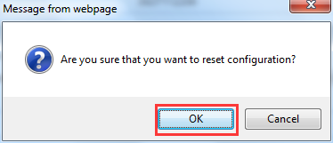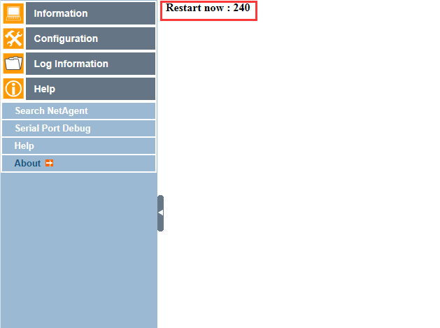

At this point, the preparation for the upgrade is complete.

Upgrade with Netility
- Open the main interface of Netility, select one or more SNMP cards that have been restored to the factory default settings, click the left menu button “Firmware Upgrade”, and select 3.7 firmware in the pop-up window.
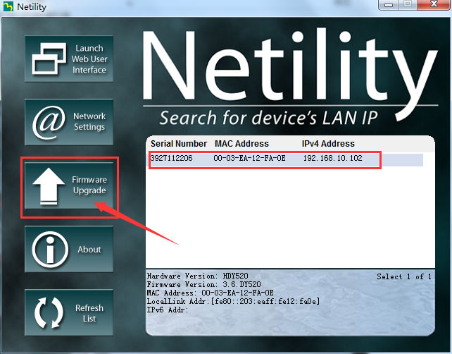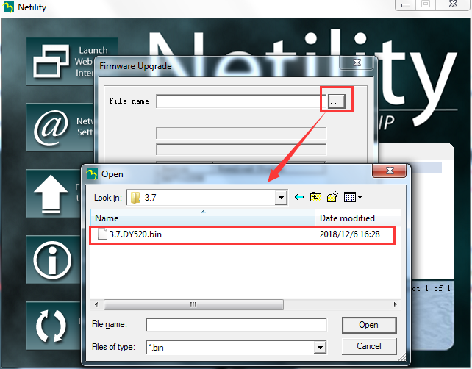

- After selecting the firmware file, click the “Download” button in the window to upgrade.
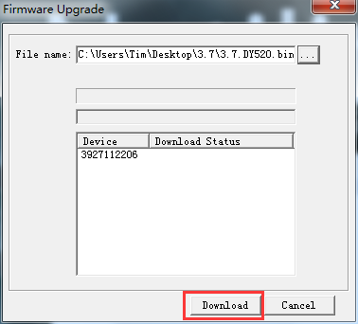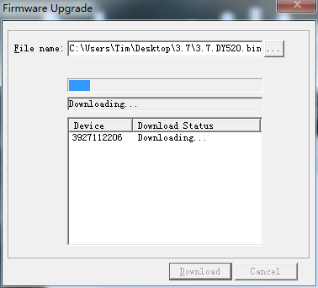

- When the window prompts “Download Successfully”, the upgrade is completed, click the “Cancel” button to close the current window.
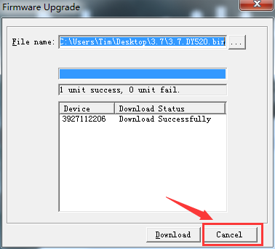
- After the upgrade is successful, it is recommended to perform the reset factory default setting again (pre-upgrade preparation step 3), then reset the device and use it normally.

Upgrade through a well-configured FTP server on the LAN
How to construct an FTP server under WINDOWS, you can find the method on your own or consult the network management.

- Upload the 3.7 firmware file to the root directory of the FTP.
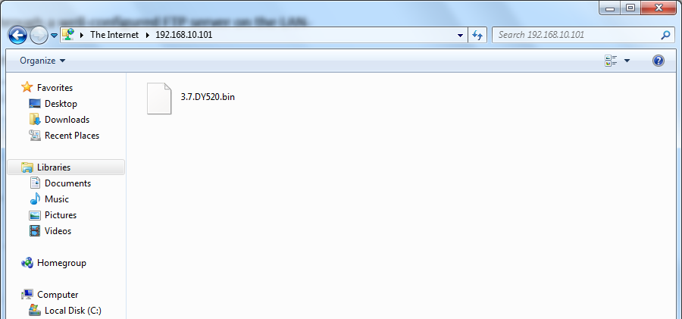

- Double-click the Netility list to open the SNMP card webpage management interface that has been restored to the factory default settings. Click the left menu “Help” “About” “Firmware Update Settings”, and set “FTP server” to the IP address of the FTP server that just uploaded the file, set “User” and “Password” to the FTP server login user name and password, and click the “Apply” button to take effect.
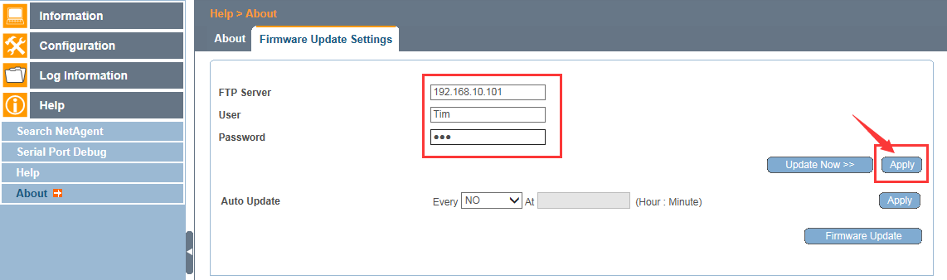

- After the page is refreshed, click the “Update Now >>” button; in the “This is not the latest version firmware” prompt box, click “Yes” to start the upgrade; after the upgrade is complete, click the “Exit” button to return to the SNMP card web page management interface.
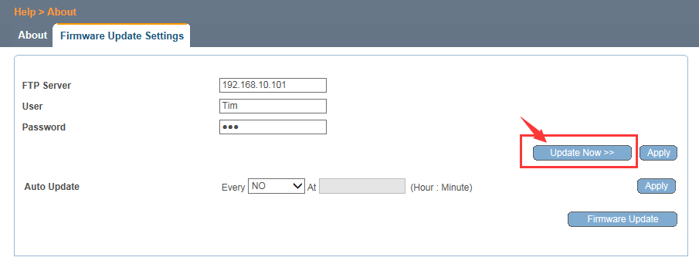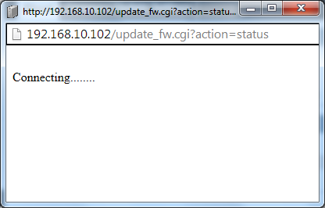
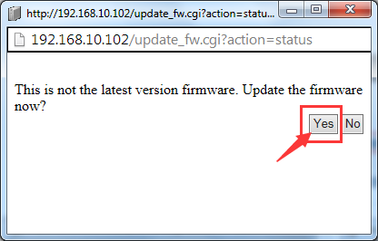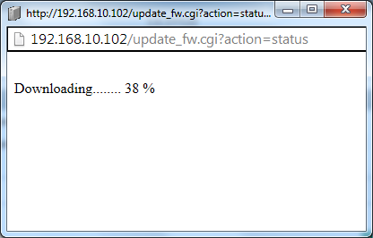
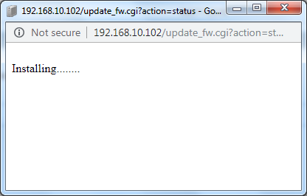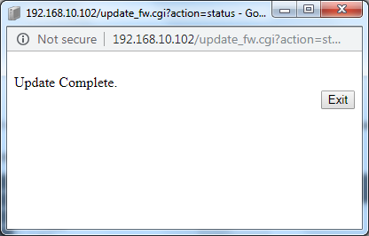

- After the upgrade is successful, it is recommended to perform the reset factory default setting again (pre-upgrade preparation step 3), then reset the device and use it normally.

Upgrade through the default FTP server icv99.com
In this method, the network of the equipment room needs to be able to connect to the World Wide Web and connect to our company icv99.com; before upgrading, you need to contact us to upload the 3.7 firmware file to the FTP server and allow users to access it.

- Use the PING command to confirm whether the network can connect to our company icv99.com.
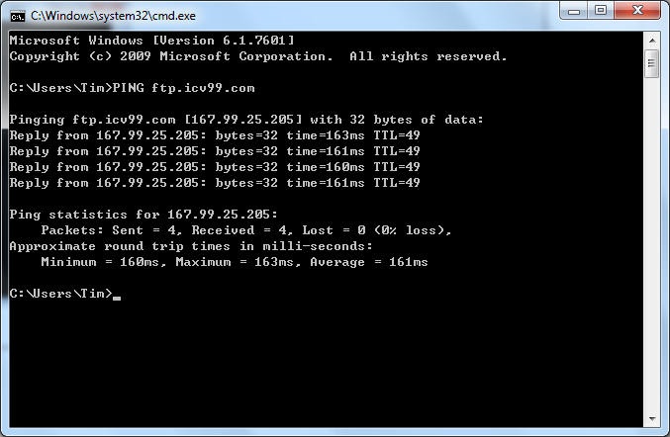

- In the SNMP card web page management interface, click “Help” “About” “Firmware Update Settings”, click the “Update Now >>” button to update the firmware.
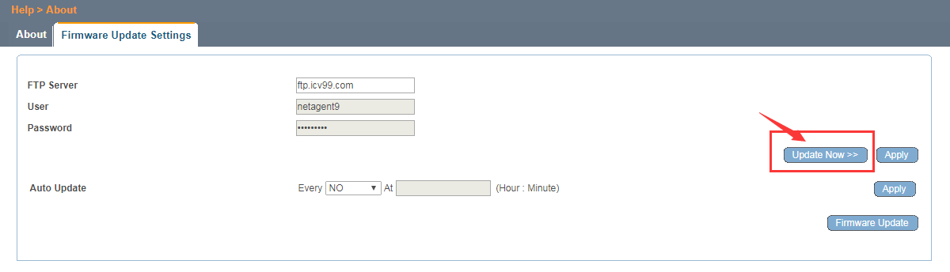
- The steps in the upgrade process are the same as those described above for using the LAN FTP server.
- After the upgrade is successful, it is recommended to perform the reset factory default setting again (pre-upgrade preparation step 3), then reset the device and use it normally.

Use the SNMP card's own FTP function to upgrade the firmware (Only for 3.6 ver. and above)
- Double-click the Netility list to open the SNMP card web page. Click on the left menu “Configuration” “Web/Telnet/FTP” “FTP Server” to confirm whether the SNMP card is enabled for the SNMP card.
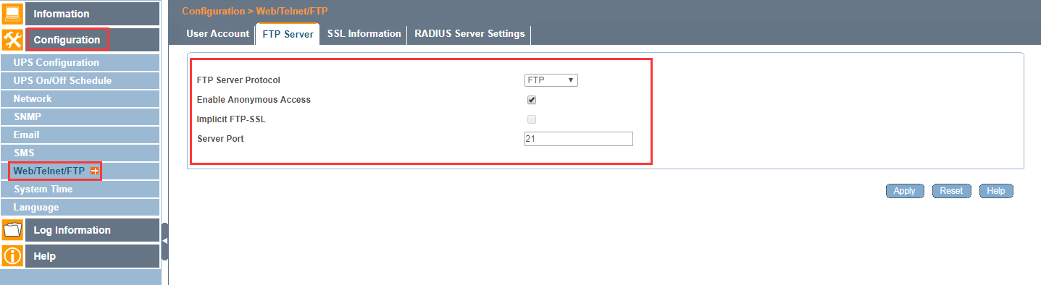

- Right click the WINDOWS start button in the lower left corner, click “Open Windows Explorer”, and enter ftp://IP (IP is the IP address of the SNMP card) in the resource manager.
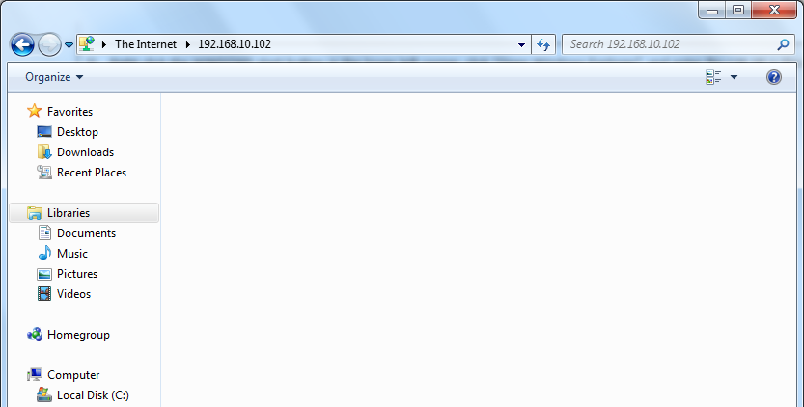

- In the login window that pops up (if there is no pop-up window, right click on the blank space and click "Login"), enter the username “admin” (case sensitive), and the password is "Password" (case sensitive) on the label behind the device.
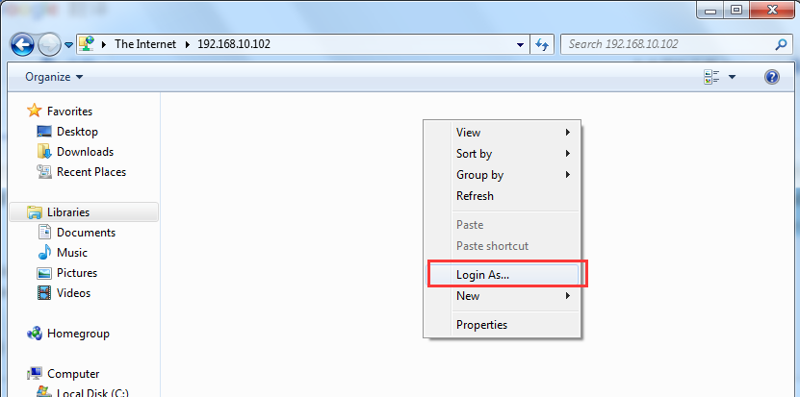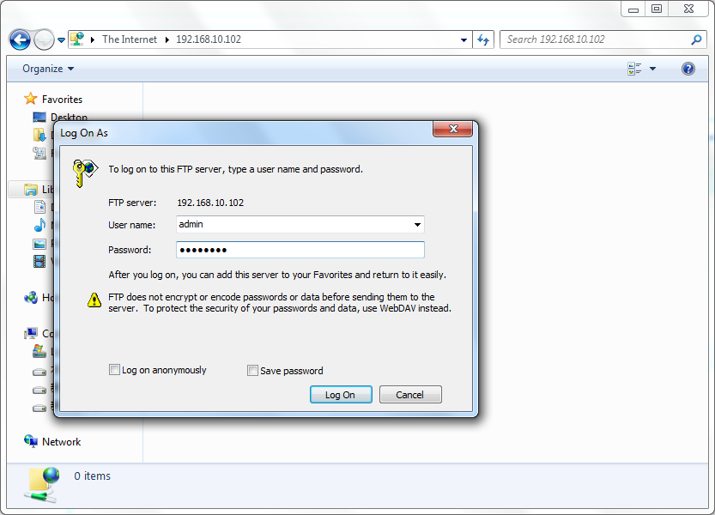

- After the login is successful, copy the 3.7 firmware file directly to the FTP root directory. After the copy is completed, SNMP card will be automatically upgraded and written. (Note: The SNMP card can also be accessed during the SNMP card writing process. At this time, do not perform any settings, etc.)
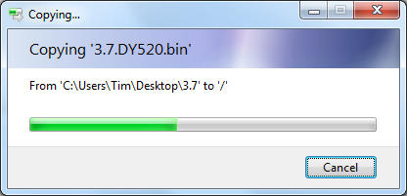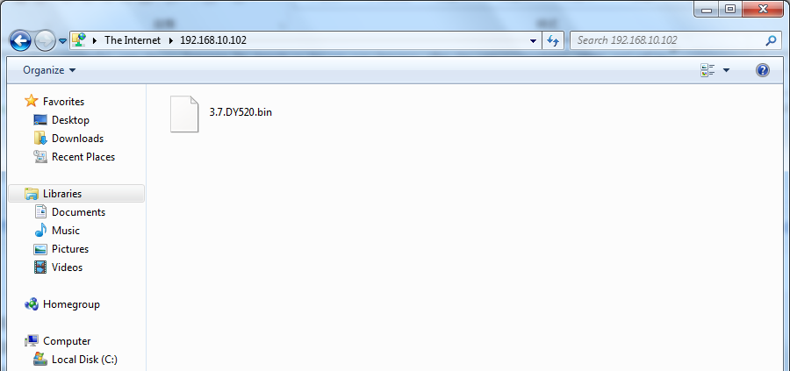
- After waiting for about 5 minutes, refresh the FTP interface to see if the firmware file you just uploaded has been deleted. If it has been deleted, the SNMP card upgrade is complete.
- After the upgrade is successful, it is recommended to perform the reset factory default setting again (pre-upgrade preparation step 3), then reset the device and use it normally.

Suitable for the World Wide Web upgrade method
Upgrade Notes: Remote users can upgrade SNMP cards in this way. During the upgrade process, the network and SNMP card power supply cannot be interrupted. Once it is interrupted, the upgrade will fail and the SNMP card needs to be returned to our company for repair.

Prepare for the upgrade
- The remote network administrator needs to transfer the SNMP card IP address through IP mapping or port forwarding (TCP/IP port 80), so that remote users can access the web management interface of the SNMP card.
- Optional: The remote network administrator needs to forward the FTP port 21 of the SNMP card. This is to prepare to upgrade the SNMP card using the FTP function.
- Optional: You need to contact us to upload the 3.7 firmware file to the FTP server of icv99.com. This is to prepare to upgrade the SNMP card using our icv99.com FTP server.
- Access the external network IP address of the SNMP card, open the web management interface, and perform the steps to set the factory defaults.

Upgrade through a well-configured FTP server on the remote network
The upgrade procedure for this method is the same as upgrading through a well-configured FTP server on the LAN.

Upgrade through the default FTP server icv99.com
The upgrade procedure for this method is the same as upgrading through the default FTP server icv99.com.

Use the SNMP card's own FTP function to upgrade the firmware (Only for 3.6 ver. and above)
The upgrade procedure for this method is the same as using the SNMP card’s own FTP function to upgrade the firmware.

