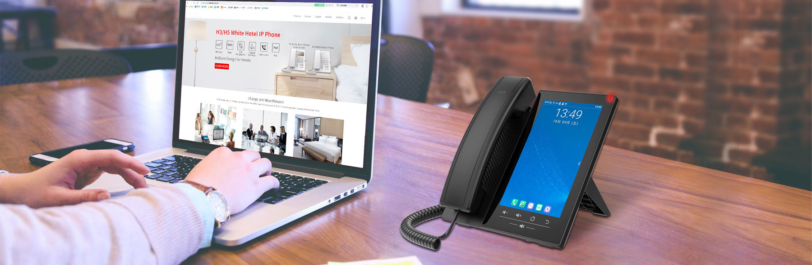



**H7 Android Touch Screen IP Phone**

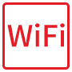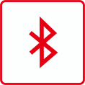

|  |  |
| --- | --- |
| As a high-end enterprise IP phone with Android 9.0 OS, J7A provides a more intelligent and smoother touch operation experience for the users. 120 DSS keys on the 7-inch color touch screen, supported 3rd party apps, built-in Wi-Fi and Bluetooth, allows daily communication smarter and simpler. Matching an adjustable USB camera, J7A can deliver a superb audio and video for the group conference.  **Highlights**  20 SIP lines, 3-way conference, hotspot  Support an external designated USB camera (optional)  120 one-touch DSS keys on 7” capacity color touch screen  HD audio on speaker and handset  Built-in Bluetooth 5.0 and 2.4G/5G Wi-Fi  Video Codec H.264 support for receiving video calls.  Dual Gigabit ports, integrated PoE  Stand with 2 adjustable angles of 40 and 50 degrees  Compatible with major platforms: Asterisk, Broadsoft, 3CX, Metaswitch, Elastix, Avaya etc.  **OEM Support**  Software Logo  Web Logo and Model  Packaging (Label and Gift box) | **J7A_03_20200508** |

**Generic**

* 20 SIP Lines
* HD Voice
* Support receiving video call­­­­­­­­
* PoE Enabled
* 7-inch (1024x600) color touch screen
* Handset / Hands-free / Headset mode
* Intelligent DSS Keys(Virtual buttons)
* Optional External Power Supply

**Operation System**

* Android 9.0 OS with higher security and better compatibility
* Built-in Applications:

Files, Calendar, Gallery, Browser, Email, Calculator, Notepad, Sound Recorder, Clock, Video, Music

* Support 3rd Party Applications
* [Secondary](javascript:;) [Development](javascript:;) of API

**Phone Features**

* Local Phonebook (2000 entries)
* Remote Phonebook (XML/LDAP, 2000 entries)
* Intelligent Search for Contacts and Call Log
* Call logs (In/out/missed, 1000 entries)
* Black/White List Call Filter
* Screen saver
* Voice Message Waiting Indication (VMWI)
* Programmable DSS/Soft keys
* Network Time Synchronization
* Built-in Bluetooth 5.0: Support Bluetooth headset/ Bluetooth of

Mobile Device

* Built-in Wi-Fi
* 2.4GHz, 802.11 b/g/n
* 5GHz, 802.11 a/n/ac
* Support Recording
* Action URL / Active URI
* UaCSTA
* Audio/Video Recording
* SIP Hotspot
* Group Broadcasting
* Action Plan
* Group listening

**Call Features**

* Call out / Answer / Reject
* Mute / Unmute (Microphone)
* Call Hold / Resume
* Call Waiting
* Intercom
* Caller ID Display
* Speed Dial
* Anonymous Call (Hide Caller ID)
* Call Forwarding (Always/Busy/No Answer)
* Call Transfer (Attended/Unattended)
* Call Parking/Pick-up (Depending on server)
* Redial
* Do-Not-Disturb
* Auto-Answering
* Voice Message (On server)
* 3-way Audio Conference
* Hot Line
* Hot desking
* BLF

**Video**

* Video decoding: H.264 /H.265(Optional)
* Video call resolution: CIF/VGA/4CIF/720P/1080P
* Image format: JPEG/PNG/BMP
* Video format: MP4
* Bandwidth selection: 64kbps~4Mbps
* Frame rate selection: 5~30fps
* Video from remote site can be displayed in full screen
* 3-way Video Call with External Camera
* Optional designated USB Camera
* 2 Mega Pixel
* Plug and Play
* Flexible Placement and Angle Adjustment
* Video Preview

**Audio**

* HD Voice Microphone/Speaker (Handset/Hands-free, 0 ~ 7KHz Frequency Response)
* HAC handset
* Wideband ADC/DAC 16KHz Sampling
* Narrowband Codec: G.711a/u, G.729AB, iLBC
* Wideband Codec: G.722, Opus
* Full-duplex Acoustic Echo Canceller (AEC)
* Noise Reduction (NR)
* Packet Loss Concealment (PLC)
* Dynamic Adaptive Jitter Buffer
* DTMF: In-band, Out-of-Band – DTMF-Relay(RFC2833) / SIP INFO

**Network**

* Physical: 10/100/1000 Mbps Ethernet, dual bridged port for PC bypass
* IP Mode:IPv4
* IP Configuration: Static / DHCP
* Network Access Control: 802.1x
* VPN: OpenVPN (Requires third-party app support)
* VLAN
* LLDP
* CDP
* QoS

**Protocols**

* SIP2.0 over UDP/TCP/TLS
* RTP/RTCP/SRTP
* STUN
* DHCP
* CDP
* LLDP
* PPPoE
* 802.1x
* OpenVPN (Requires third-party app support)
* SNTP
* FTP/TFTP
* HTTP/HTTPS
* TR-069

**Deployment & Management**

* Auto-Provisioning via FTP/TFTP/HTTP/HTTPS/DHCP OPT66/SIP PNP/TR-069
* Web Management Portal
* Supports the third party communication APP
* Supports Web, Telnet
* Supports encrypted configuration files download with AES
* Supports Web upgrade
* Supports factory reset data

**Physical Specifications**

* Color: Black
* LCD x1: 7- inch (1024x600) color touch screen
* Touch keys x5: Volume -/Volume +/Home/Return/Hands-free
* HD Handset (RJ9) x1
* Standard RJ9 Handset Wire x1
* 1.5M CAT5 Ethernet Cable x1
* Back Rack x1
* RJ9 Port x2: Handset x1, Headset x1
* RJ45 Port x2: Network x1, PC x1 (Bridged to Network)
* USB2.0 Port x1: Standard A, Connect with Flash Driver
* Safety keyhole x1
* Power: 5V/2A or PoE
* Power Consumption (PoE): 2.39W ~ 8.77W
* Power Consumption (Adapter): 1.64W ~ 6.9W
* Working Temperature: 0~45℃
* Working Humidity: 10~95%
* Installation:
* Desktop stand
* Wall-mounted (need an additional wall hanging parts)
* Device Dimensions
* Desktop stand (angles 1: 40 degree): 181 x 175.75 x 184.4 mm
* Desktop stand (angles 2: 50 degree): 181 x 175.85 x 185.1 mm
* Wall-mounted: 181 x 115.43 x 208.75 mm
* Gift Box Dimensions: 283 x 210 x 82mm
* Outer CTN Dimensions: 440 x 435 x 304 mm (10 PCS)

The above specifications may be updated in the future without prior notice. All hardware/software/physical features should be based on the final shipped products.

**Compatibility List:**

****