Date: 2015-10-25
TYPE TEST
Test Report
HT33100X

SN: HT33100X-TYPE TEST

Test Conclusion: | PASS FAIL

Tester : | Qinhaiyan
Approver: | Jason Liu

BASIC INFORMATION
EUT Description
Equipment Under Test (EUT)……….……….. | HT33100X
Model number………………………………………. | 2013-202
EUT Specification…………………………… | Input: 220/230/240Vac, Output: 220/230/240Vac
Quantity of Tested Samples…………………. | 1
Serial No.…………………………………... | 006
EUT Configuration:…………………………. | Hardware version: |  | A.01~A.01
 | Software version: | A.01~A.03
Manufacture………………………………... | INVT Power System(Shenzhen) CO., LTD.
Client::
Applicant……………………………………. | Huang Zhengzhong
Applied department/Company:………………. | UPS R&D department
Regulations:
Test Type……………………………………… | TYPE TEST
Test Regulation……………………………….. | IEC 62040-3;(2011)
Test Engineer…………………………………. | qinhaiyan  Email: qinhaiyan@invt.com.cn
Date of Test…………………………………….. | 2015-10-20 to 2015-10-21
Test Site:……………………………………… | 5# Building, Gaofa Industrial Park, Longjing, Nanshan District, Shenzhen, China, 518055

Test items
No. | Test description | Subclause | PASS/FAIL
Basics
1 | Cable and interconnection check | 6.2.2.2
2 | Control device(s) | 6.2.2.3.a
3 | Protective device(s) | 6.2.2.3.b
4 | Auxiliary device(s) | 6.2.2.3.c
5 | Supervisory, monitoring, signalling device(s) | 6.2.2.3.d
6 | Auto transfer to stored energy mode and back to normal | 6.2.2.3.e
7 | Auto transfer to bypass / isolation mode and back to normal | 6.2.2.3.f
8 | Manual transfer to bypass/isolation mode and back to normal | 6.2.2.3.g
9 | No load | 6.2.2.4
10 | Full load | 6.2.2.5
11 | Frequency slew-rate | 6.2.2.6
12 | AC input failure | 6.2.2.7
13 | AC input return | 6.2.2.8
14 | Parallel redundant UPS fault | 6.4.2.12
15 | Transfer test to bypass | 6.2.2.9
Input supply compatibility
16 | Steady-state input voltage tolerance | 6.4.1.1
17 | Input frequency tolerance | 6.4.1.2
18 | Input inrush current | 6.4.1.3
19 | Harmonic distortion of input current | 6.4.1.4
20 | Power factor | 6.4.1.5
21 | Efficiency | 6.4.1.6
22 | Stand-by generator compatibility | 6.4.1.9
Output – Linear load
23 | Normal mode – No load | 6.4.2.1
24 | Normal mode – Full load | 6.4.2.2
25 | Stored energy mode – No load | 6.4.2.3
26 | Stored energy mode – Full load | 6.4.2.4
27 | 3-phase voltage unbalance | 6.4.2.5
28 | DC voltage component | 6.4.2.6
29 | Current division across paralleled UPS | 6.4.2.7
30 | Output overvoltage test | 6.4.2.8
31 | Periodic output voltage variation test (modulation) | 6.4.2.9
32 | Overload – Normal mode | 6.4.2.10.1
33 | Overload – Stored energy mode | 6.4.2.10.2
34 | Fault clearing capability – Normal mode | 6.4.2.10.3
35 | Fault clearing capability – Stored energy mode | 6.4.2.10.4
36 | Dynamic performance – Normal to stored energy mode | 6.4.2.11.1
37 | Dynamic performance – Stored energy to normal mode | 6.4.2.11.2
38 | Dynamic performance – Normal to bypass mode - overload | 6.4.2.11.3
39 | Dynamic performance – Step load – Normal mode | 6.4.2.11.4
40 | Dynamic performance – Step load – Stored energy mode | 6.4.2.11.5
Output – Non-linear load
41 | Normal mode – Full load | 6.4.3.1
42 | Stored energy mode – Full load | 6.4.3.2
43 | Dynamic performance – Normal to stored energy mode | 6.4.3.3.1
44 | Dynamic performance – Stored energy to normal mode | 6.4.3.3.2
45 | Dynamic performance – Step load – Normal mode | 6.4.3.3.3
46 | Dynamic performance – Step load – Stored energy mode | 6.4.3.3.4
Stored and restored energy times
47 | Stored energy time | 6.4.4.1
48 | Restored energy time | 6.4.4.2
49 | Battery ripple current | 6.4.4.3
50 | Restart test | 6.4.4.4
Environmental
51 | Repetitive shock during transportation | 6.5.2.1
52 | Free-fall during transportation | 6.5.2.2
53 | Storage in dry heat, damp heat and cold environments | 6.5.3
54 | Operation in dry heat, damp heat and cold environments | 6.5.4
55 | Acoustic noise | 6.5.5
Others
56 | Safety X Refer | IEC 62040-1
57 | Electromagnetic compatibility X Refer | IEC 62040-2

Basic check (1~15)

Basic-1~5
Basic-1~5 back to list
 | NO | Test items | Description/ Demand | PASS/FAIL
 | 1 | Cable and interconnection check | 6.2.2.2-The UPS shall be inspected in accordance with the manufacturer’s installation and wiring diagrams to determine that:  – all a.c. and d.c. supply terminals are connected to the a.c. input supply, to the stored energy source (as applicable) and to the load;  – any communication circuit is connected as required.  Further, all temporary test connections introduced or removed during any insulation and dielectric tests shall be confirmed as having been restored to their normal condition. | PASS
6.2.2.3-The light load test is a functional test carried out to verify that the UPS is correctly connected and that all functions operate properly. The load applied is limited, for practical and cost reasons, to a percentage of the rated value, for example 10 %. Correct operation of the following shall be verified:
(Compliance is verified by observation that the devices and functions intended to control,
protect, supervise, measure and signal UPS activities perform as expected and that the load
voltage remains within specified values during the manual and automatic transfers.)
 | 2 | Control device(s) | 6.2.2.3.a-all control switches and other means to activate UPS operation | PASS
 | 3 | Protective device(s) | 6.2.2.3.b-protective devices (refer to 7.5.3 of IEC 60146-1-1); | PASS
 | 4 | Auxiliary device(s) | 6.2.2.3.c-auxiliary devices, such as contactors, fans, outlets, annunciators and communication devices; | PASS
 | 5 | Supervisory, monitoring, signalling device(s) | 6.2.2.3.d-supervisory, monitoring and remote signalling devices (if any); | PASS

Basic 6
Basic 6 Auto transfer to stored energy mode and back to normal back to list
6.2.2.3.e-auto transfer to stored energy mode and back to normal mode by failing and subsequently restoring the a.c. input voltage;
NOTE 1 This test may be performed in conjunction with a.c. fail/return tests of 6.2.2.7 and 6.2.2.8.
10%load
Transfer to stored energy mode—G2 mode |  | Transfer back to normal—G2 mode
450.png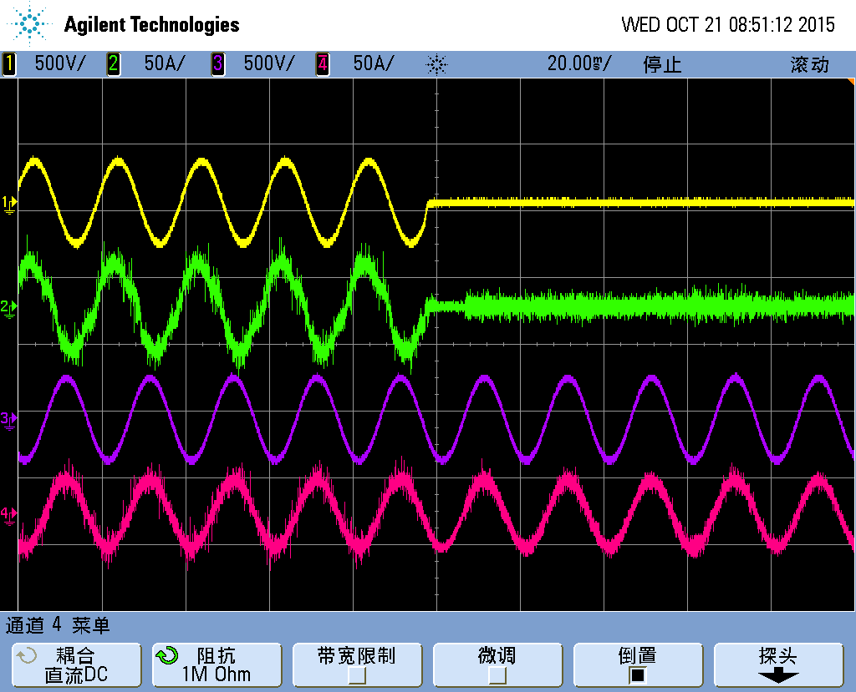 |  | 451.png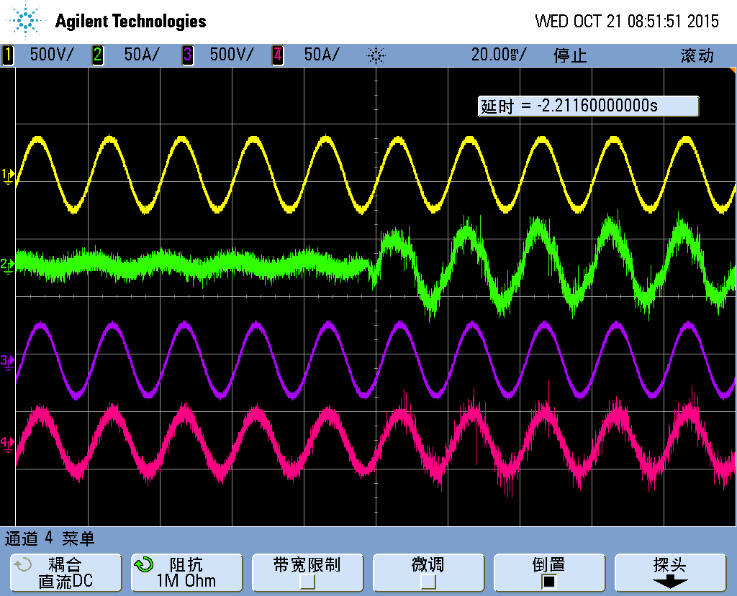
CH1 | Va-input | CH1 | Va-input
CH2 | Ia-input | CH2 | Ia-input
CH3 | Va-output | CH3 | Va-output
CH4 | Ia-output | CH4 | Ia-output
Conclusion: PASS

PS: Stand-by generator compatibility
Transfer to stored energy mode—G2 mode |  | Transfer back to normal—G2 mode
CH1 | Va-input | CH1 | Va-input
CH2 | Ia-input | CH2 | Ia-input
CH3 | Va-output | CH3 | Va-output
CH4 | Ia-output | CH4 | Ia-output
Conclusion: N/A

Basic 7
Basic 7 Auto transfer to bypass / isolation mode and back to normal back to list
6.2.2.3.f-auto transfer to bypass or isolation of the inverter from a common a.c. output bus (as applicable) and back to normal mode by failing and subsequently restoring the inverter a.c. output voltage;
NOTE 2 This test may be performed in conjunction with parallel/bypass tests of 6.2.2.9 and 6.4.2.12.
Light load~ 10% load
Transfer to bypass-inverter shut down |  | Transfer back to normal-inverter restart
453.png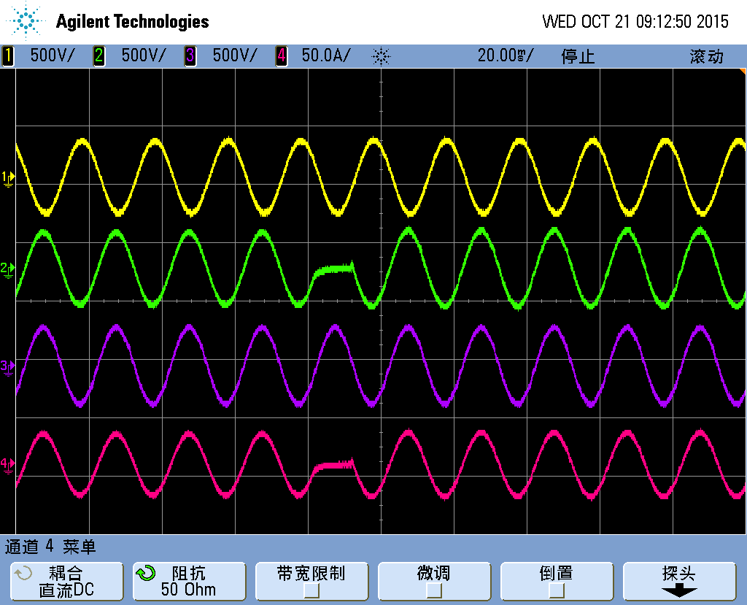 |  | 452.png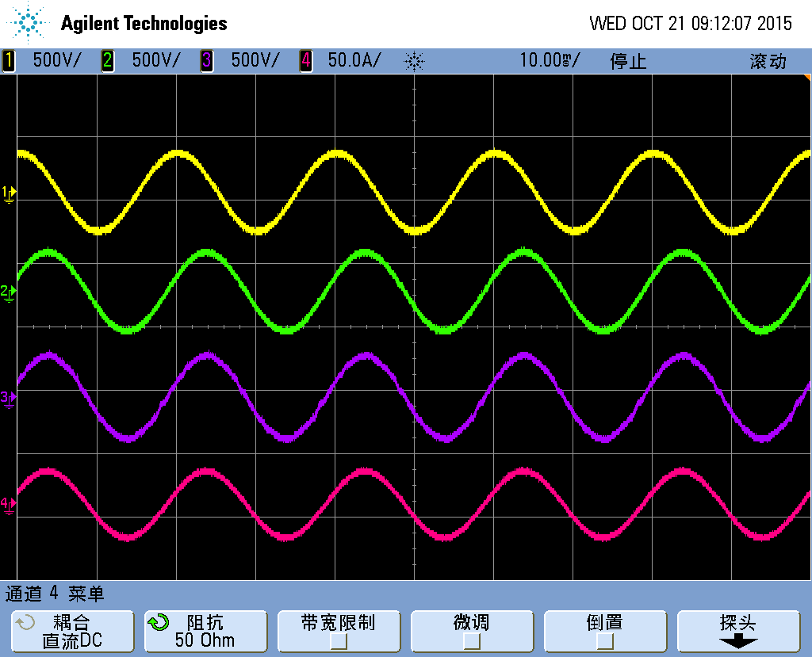
CH1 | V-invB | CH1 | V-invB
CH2 | V-outB | CH2 | V-outB
CH3 | V-bypinB | CH3 | V-bypinB
CH4 | I-outB | CH4 | I-outB
Conclusion: PASS

PS: Stand-by generator compatibility
Transfer to bypass-inverter shut down |  | Transfer back to normal-inverter restart
CH1 | V-invB | CH1 | V-invB
CH2 | V-outB | CH2 | V-outB
CH3 | V-bypinB | CH3 | V-bypinB
CH4 | I-outB | CH4 | I-outB
Conclusion: N/A

Basic 8
Basic 8 Manual transfer to bypass/isolation mode and back to normal back to list
6.2.2.3.g-manual transfer to bypass or isolation of the inverter from a common a.c. output bus and back to normal mode (as applicable) by operating appropriate switches and/or controls.
Light load~ 10% load
Transfer to bypass-manual |  | Transfer back to normal-manual
454.png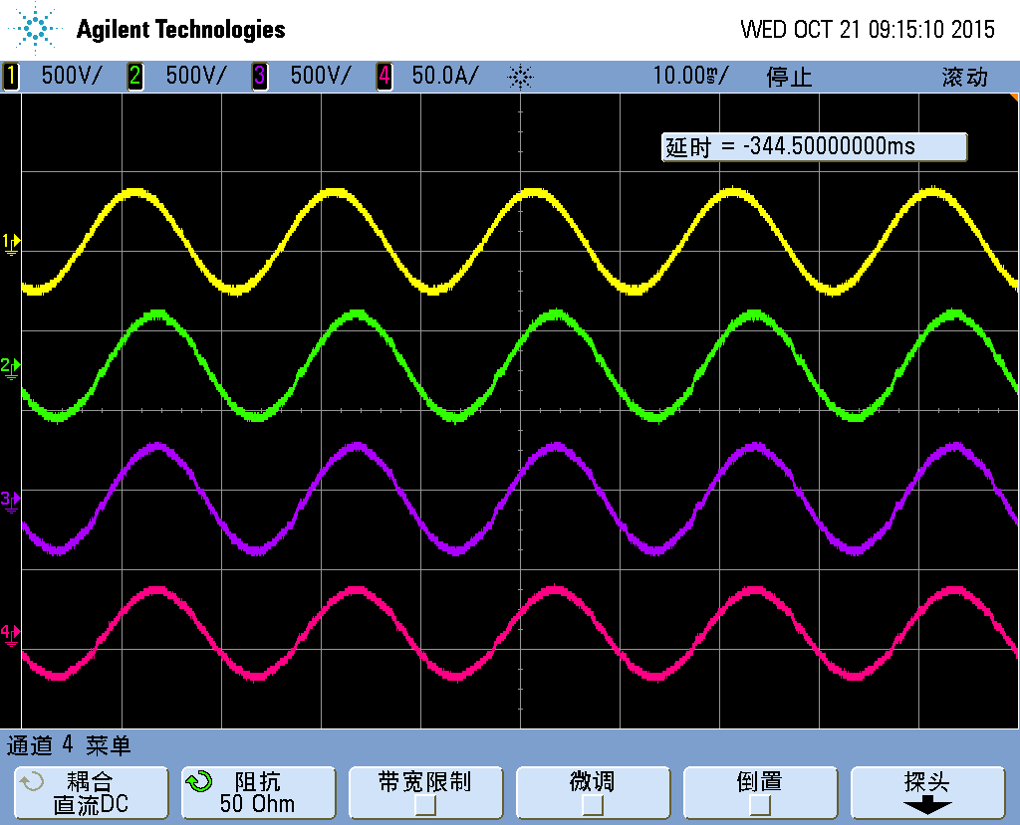 |  | 455.png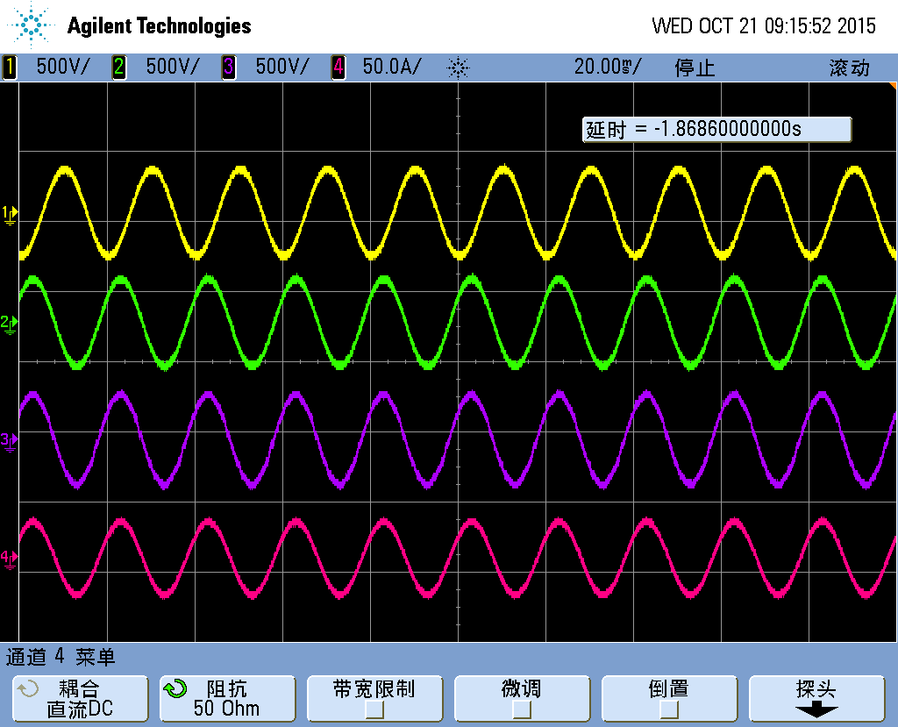
CH1 | V-invB | CH1 | V-invB
CH2 | V-outB | CH2 | V-outB
CH3 | V-bypinB | CH3 | V-bypinB
CH4 | I-outB | CH4 | I-outB
Conclusion: PASS

PS: Stand-by generator compatibility
Transfer to bypass-manual |  | Transfer back to normal-manual
CH1 | V-invB | CH1 | V-invB
CH2 | V-outB | CH2 | V-outB
CH3 | V-bypinB | CH3 | V-bypinB
CH4 | I-outB | CH4 | I-outB
Conclusion: N/A

Basic 9
Basic 9 No load back to list
6.2.2.4-The UPS output voltage shall remain within the specified values when the UPS operates at nominal input voltage and frequency and with no load connected at the output.
No load. Normal mode.
Output | Settings | measured value in | measured value out | Precision | Conclusion: PASS
U-A | 220V | 220.5 | 220.6 | 0.3%
U-B | 220V | 220.6 | 220.7 | 0.3%
U-C | 220V | 220.6 | 220.5 | 0.3%
f | 50Hz | 50.01 | 49.99 | 0.02%

PS: Stand-by generator compatibility
Output | Settings | measured value | measured value out | Precision | Conclusion: N/A
U-A | 220V
U-B | 220V
U-C | 220V
f | 50Hz

Basic 10
Basic 10 Full load back to list
6.2.2.5-The UPS shall remain in normal mode of operation and its output voltage within the specified values when operating at nominal input voltage and frequency while supplying a reference test load.
Large UPS in parallel connection may be load tested by testing the individual UPS units separately or as a whole.
Full load. Rated load or linear load.
Output | Settings | measured value in | measured value out | Precision | Conclusion: PASS
U-A | 220V | 220.5 | 219.5 | 0.2%
U-B | 220V | 220.6 | 219.6 | 0.2%
U-C | 220V | 220.6 | 219.7 | 0.2%
f | 50Hz | 50.01 | 49.99 | 0.02%

PS: Stand-by generator compatibility
Output | Settings | measured value in | measured value out | measured value in | Conclusion: N/A
U-A | 220V | / | / | /
U-B | 220V | / | / | /
U-C | 220V | / | / | /
f | 50Hz | / | / | /

Basic 11
Basic 11 Frequency slew-rate back to list
6.2.2.6- This test shall be performed when synchronization to an external source is required.
Frequency variation limits shall be tested by use of a variable frequency generator or by simulation of circuit conditions. While synchronized, the phase angle between the external source and the UPS inverter shall be measured and checked against the manufacturer's acceptable limits.
Where applicable, the frequency slew-rate shall be determined i.e. the output frequency rate of change during synchronization to an external source.
This test may be performed in conjunction with another test if it is more convenient
10% load.
Setting:0.5Hz/s  External source: 0.5Hz/s |  | Setting:1.5Hz/s  External source: 1.5Hz/s
456.png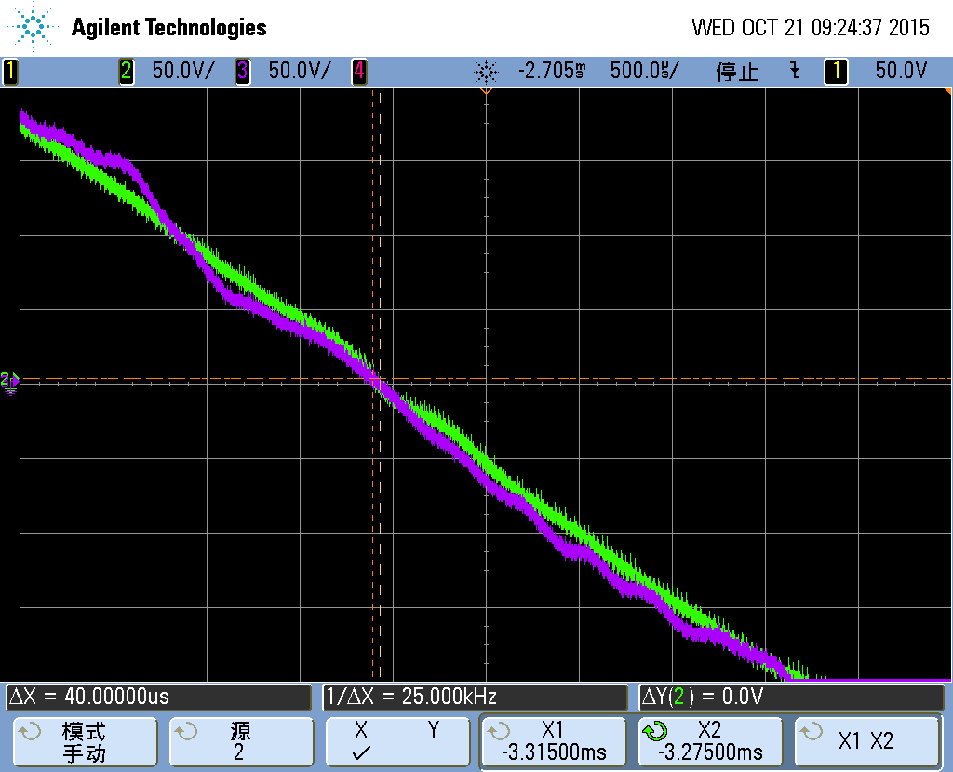 |  | 458.png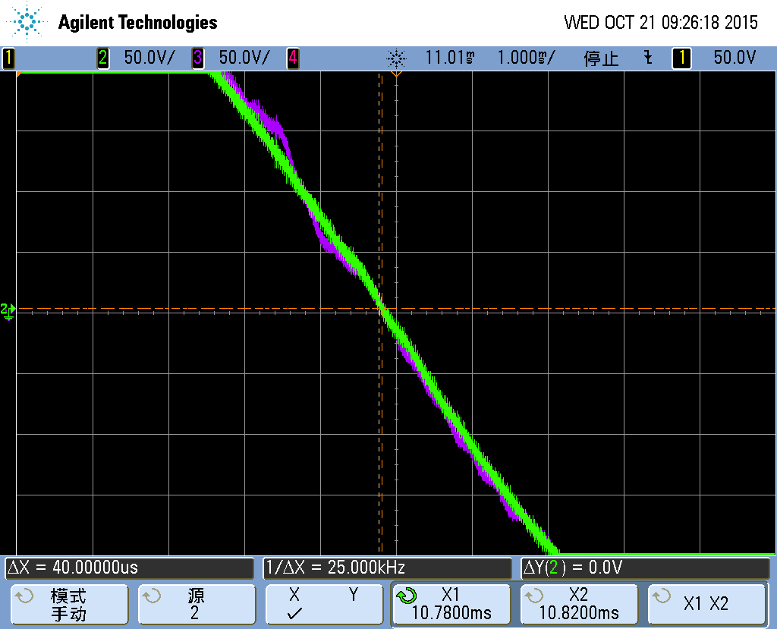
CH2 | V-inB of bypass | CH2 | V-inB of bypass
CH3 | V-outB of invter | CH3 | V-outB of inverter
phase angle | 40us(0.72°) | phase angle | 40us(0.72°)
Conclusion: PASS

Basic 12
Basic 12 AC input failure back to list
6.2.2.7- The test shall be performed with a battery or other appropriate d.c. source. The input failure should be conducted by interrupting the a.c. input as far upstream as practical and carried out in accordance with Annex G, Clause G.2 (and Clause G.3 for type test only).
Compliance is verified when, following the input a.c. failure, the UPS operates in stored energy mode within steady state output voltage and frequency limits specified in 5.3.4.
The UPS shall not be damaged during operation with the loss of one phase (type test only).
NOTE This test may be performed in conjunction with the light load test of 6.2.2.3.e.
10% load
AC input failure—G3 mode |  | AC input failure—loss of one phase
459.png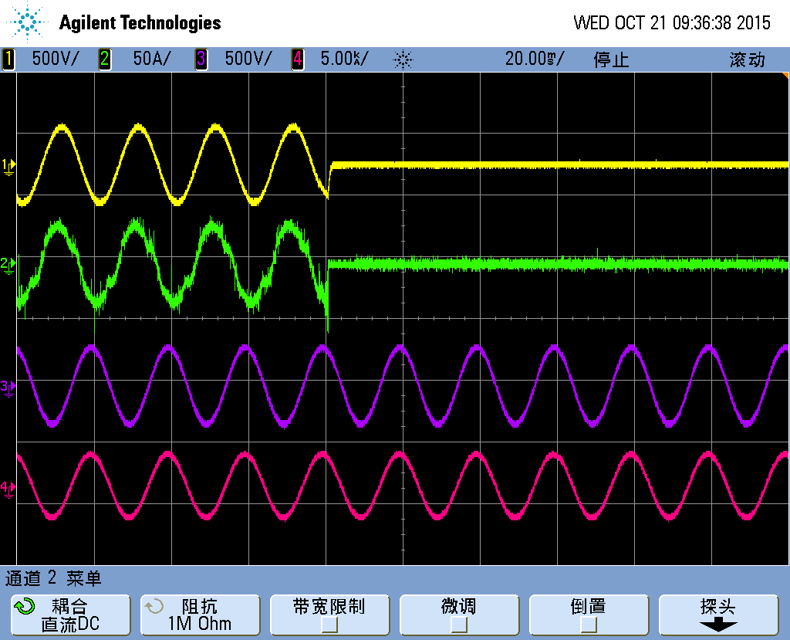 |  | 460.png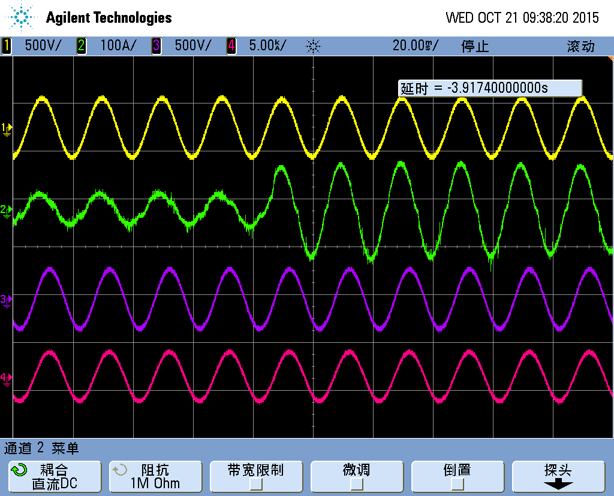
CH1 | Va-input | CH1 | Va-input
CH2 | Ia-input | CH2 | Ia-input
CH3 | Va-output | CH3 | Va-output
CH4 | Ia-output | CH4 | Ia-output
interruption | 0 | interruption | 0
Dynamic output performance See “Ouput-L 36 Dynamic performance”
PS: Stand-by generator compatibility
AC input failure—G3 mode |  | AC input failure—loss of one phase
CH1 | Va-input | CH1 | Va-input
CH2 | Ia-input | CH2 | Ia-input
CH3 | Va-output | CH3 | Va-output
CH4 | Ia-output | CH4 | Ia-output
interruption | N/A | interruption | N/A

Waveform characteristic---
Phase A:
Normal mode:M1, Stored energy mode:M2 |  |  |  |  |  |  |  |  | THDu of M1 |  |  |  | 0.91% |  |  |  | THDu of M2 |  |  |  | 0.86%
N | % | M1 | M2 | N | % | M1 | M2 | N |  | % | M1 | M2 |  | N | % | M1 |  | M2 | N | % |  | M1 | M2
0 | / |  |  | 10 | 0.50 | 0.01 | 0.01 | 20 |  | 0.38 | 0 | 0 |  | 30 | 0.33 | 0.01 |  | 0.01 | 40 | 0.31 |  | 0 | 0.02
1 | / | 100 | 100 | 11 | 3.50 | 0.21 | 0.21 | 21 |  | 0.20 | 0.12 | 0.14 |  | 31 | 0.97 | 0.08 |  | 0.06 | 41 | 0.67 |  | 0.02 | 0.02
2 | 2.00 | 0.08 | 0.09 | 12 | 0.46 | 0.01 | 0.01 | 22 |  | 0.36 | 0.01 | 0.01 |  | 32 | 0.33 | 0 |  | 0 | 42 | 0.31 |  | 0 | 0.02
3 | 5.00 | 0.55 | 0.46 | 13 | 3.00 | 0.19 | 0.18 | 23 |  | 1.41 | 0.12 | 0.12 |  | 33 | 0.20 | 0.06 |  | 0.05 | 43 | 0.63 |  | 0.01 | 0.01
4 | 1.00 | 0.01 | 0.01 | 14 | 0.43 | 0.01 | 0.01 | 24 |  | 0.35 | 0.01 | 0.01 |  | 34 | 0.32 | 0 |  | 0.01 | 44 | 0.31 |  | 0.01 | 0.01
5 | 6.00 | 0.38 | 0.4 | 15 | 0.30 | 0.18 | 0.17 | 25 |  | 1.27 | 0.1 | 0.12 |  | 35 | 0.83 | 0.03 |  | 0.04 | 45 | 0.20 |  | 0.02 | 0.01
6 | 0.50 | 0 | 0 | 16 | 0.41 | 0.01 | 0.02 | 26 |  | 0.35 | 0.01 | 0.01 |  | 36 | 0.32 | 0.01 |  | 0.01 | 46 | 0.30 |  | 0.01 | 0
7 | 5.00 | 0.29 | 0.3 | 17 | 2.00 | 0.16 | 0.15 | 27 |  | 0.20 | 0.09 | 0.09 |  | 37 | 0.77 | 0.03 |  | 0.02 | 47 | 0.55 |  | 0.01 | 0.01
8 | 0.50 | 0 | 0.01 | 18 | 0.39 | 0.01 | 0.02 | 28 |  | 0.34 | 0.01 | 0.01 |  | 38 | 0.32 | 0.01 |  | 0.01 | 48 | 0.30 |  | 0 | 0.01
9 | 1.50 | 0.23 | 0.24 | 19 | 1.76 | 0.15 | 0.14 | 29 |  | 1.06 | 0.08 | 0.08 |  | 39 | 0.20 | 0.03 |  | 0.01 | 49 | 0.52 |  | 0.01 | 0.01
Output frequency: 49.98Hz

Phase B:
Normal mode:M1, Stored energy mode:M2 |  |  |  | THDu of M1 |  |  |  | 0.94% |  |  |  | THDu of M2 |  |  |  | 0.86%
N | % | M1 | M2 | N | % | M1 | M2 | N | % | M1 | M2 | N | % | M1 | M2 | N | % | M1 | M2
0 | / | / | / | 10 | 0.50 | 0 | 0.01 | 20 | 0.38 | 0 | 0.01 | 30 | 0.33 | 0 | 0.01 | 40 | 0.31 | 0.01 | 0.01
1 | / | 100 | 100 | 11 | 3.50 | 0.22 | 0.21 | 21 | 0.20 | 0.14 | 0.12 | 31 | 0.97 | 0.08 | 0.06 | 41 | 0.67 | 0.01 | 0.02
2 | 2.00 | 0.06 | 0.06 | 12 | 0.46 | 0.01 | 0.02 | 22 | 0.36 | 0.01 | 0 | 32 | 0.33 | 0 | 0 | 42 | 0.31 | 0 | 0.01
3 | 5.00 | 0.56 | 0.47 | 13 | 3.00 | 0.2 | 0.19 | 23 | 1.41 | 0.14 | 0.12 | 33 | 0.20 | 0.07 | 0.04 | 43 | 0.63 | 0.01 | 0.01
4 | 1.00 | 0.01 | 0.02 | 14 | 0.43 | 0.01 | 0.01 | 24 | 0.35 | 0 | 0.01 | 34 | 0.32 | 0.01 | 0.01 | 44 | 0.31 | 0.01 | 0.01
5 | 6.00 | 0.39 | 0.41 | 15 | 0.30 | 0.18 | 0.16 | 25 | 1.27 | 0.13 | 0.1 | 35 | 0.83 | 0.05 | 0.03 | 45 | 0.20 | 0.01 | 0
6 | 0.50 | 0 | 0.01 | 16 | 0.41 | 0.01 | 0.01 | 26 | 0.35 | 0.01 | 0.01 | 36 | 0.32 | 0.01 | 0.02 | 46 | 0.30 | 0.01 | 0.01
7 | 5.00 | 0.29 | 0.29 | 17 | 2.00 | 0.17 | 0.16 | 27 | 0.20 | 0.11 | 0.08 | 37 | 0.77 | 0.03 | 0.02 | 47 | 0.55 | 0 | 0.01
8 | 0.50 | 0 | 0.01 | 18 | 0.39 | 0.01 | 0.01 | 28 | 0.34 | 0.01 | 0.02 | 38 | 0.32 | 0.01 | 0.01 | 48 | 0.30 | 0 | 0
9 | 1.50 | 0.25 | 0.24 | 19 | 1.76 | 0.16 | 0.16 | 29 | 1.06 | 0.1 | 0.07 | 39 | 0.20 | 0.01 | 0.01 | 49 | 0.52 | 0.01 | 0.01
Output frequency: 49.97Hz

Phase C:
Normal mode:M1, Stored energy mode:M2 |  |  |  |  |  |  |  |  | THDu of M1 |  |  |  | 0.93% |  |  |  | THDu of M2 |  |  |  | 0.89%
N | % | M1 | M2 | N | % | M1 | M2 | N |  | % | M1 | M2 |  | N | % | M1 |  | M2 | N | % |  | M1 | M2
0 | / | / | / | 10 | 0.50 | 0 | 0 | 20 |  | 0.38 | 0.01 | 0.01 |  | 30 | 0.33 | 0.01 |  | 0.01 | 40 | 0.31 |  | 0 | 0.01
1 | / | 100 | 100 | 11 | 3.50 | 0.2 | 0.21 | 21 |  | 0.20 | 0.11 | 0.12 |  | 31 | 0.97 | 0.03 |  | 0.07 | 41 | 0.67 |  | 0.01 | 0.02
2 | 2.00 | 0.08 | 0.12 | 12 | 0.46 | 0.01 | 0.01 | 22 |  | 0.36 | 0.01 | 0.01 |  | 32 | 0.33 | 0 |  | 0 | 42 | 0.31 |  | 0.01 | 0.01
3 | 5.00 | 0.61 | 0.51 | 13 | 3.00 | 0.18 | 0.2 | 23 |  | 1.41 | 0.11 | 0.12 |  | 33 | 0.20 | 0.04 |  | 0.05 | 43 | 0.63 |  | 0.01 | 0
4 | 1.00 | 0.01 | 0.01 | 14 | 0.43 | 0.01 | 0.01 | 24 |  | 0.35 | 0 | 0 |  | 34 | 0.32 | 0 |  | 0.01 | 44 | 0.31 |  | 0.01 | 0.01
5 | 6.00 | 0.38 | 0.39 | 15 | 0.30 | 0.17 | 0.18 | 25 |  | 1.27 | 0.1 | 0.12 |  | 35 | 0.83 | 0.02 |  | 0.03 | 45 | 0.20 |  | 0 | 0.01
6 | 0.50 | 0.01 | 0.01 | 16 | 0.41 | 0.01 | 0 | 26 |  | 0.35 | 0.01 | 0.01 |  | 36 | 0.32 | 0.01 |  | 0 | 46 | 0.30 |  | 0 | 0
7 | 5.00 | 0.3 | 0.29 | 17 | 2.00 | 0.14 | 0.15 | 27 |  | 0.20 | 0.08 | 0.1 |  | 37 | 0.77 | 0.02 |  | 0.02 | 47 | 0.55 |  | 0.01 | 0.01
8 | 0.50 | 0 | 0 | 18 | 0.39 | 0 | 0.01 | 28 |  | 0.34 | 0.01 | 0 |  | 38 | 0.32 | 0 |  | 0.01 | 48 | 0.30 |  | 0 | 0
9 | 1.50 | 0.23 | 0.24 | 19 | 1.76 | 0.13 | 0.14 | 29 |  | 1.06 | 0.06 | 0.08 |  | 39 | 0.20 | 0.01 |  | 0.03 | 49 | 0.52 |  | 0.01 | 0
Output frequency: 49.98Hz

Basic 13
Basic 13 AC input return back to list
6.2.2.8- This test shall be performed either by restoring the a.c. input power, or simulated by energizing all UPS input feeders at the same time. This test shall normally be performed with a battery or appropriate d.c. source.
Proper operation of all UPS rectifiers, including walk-in, if applicable, shall be observed. AC output voltage and frequency variations shall also be measured.
Compliance is verified when, following the input a.c. return, the UPS operates in normal mode within steady state output voltage and frequency limits specified in 5.3.4.
The UPS shall not be damaged upon a.c. return with improper phase rotation (type test only).
NOTE 1 Walk-in is a function that controls the input a.c. current so that it increases gradually within a specified time when the UPS starts or restarts. Walk-in is also called soft-start.
NOTE 2 This test may be performed in conjunction with the light load test of 6.2.2.3.e.
10% load
AC input return—G2 mode |  | AC input return—improper phase rotation
156.png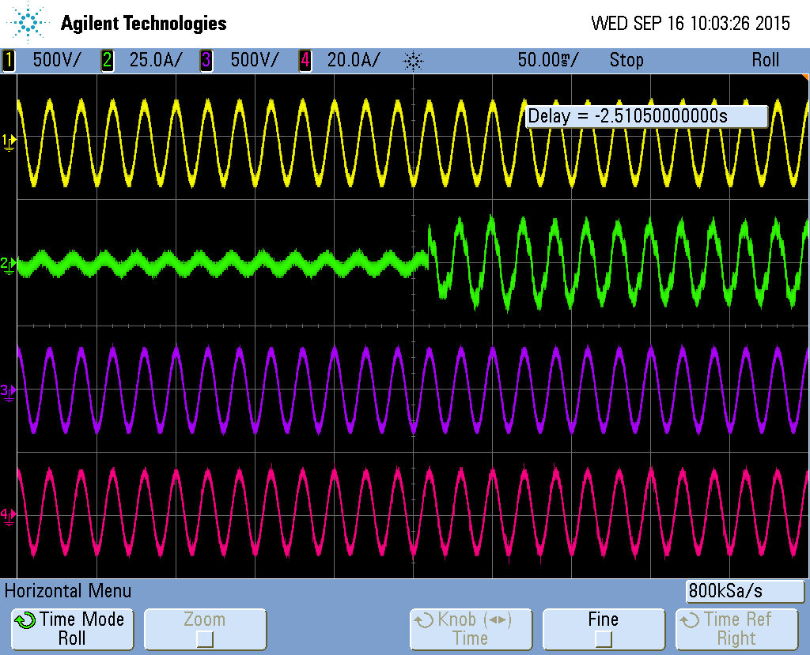 |  | 158.png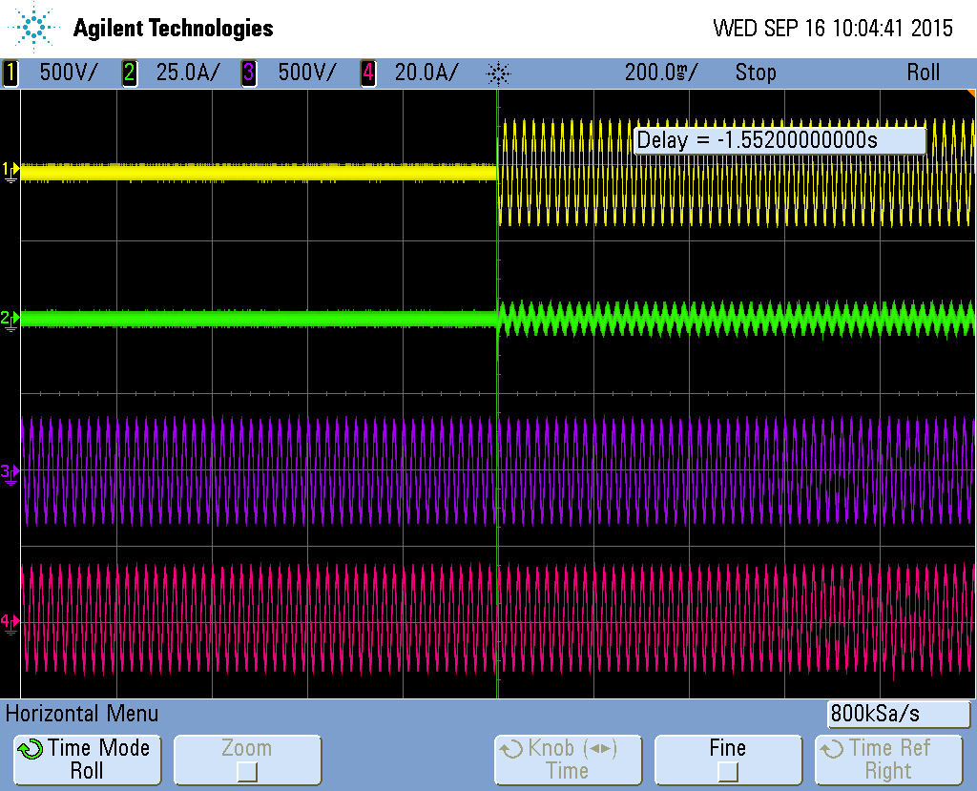  Not start
CH1 | Va-input | CH1 | Va-input
CH2 | Ia-input | CH2 | Ia-input
CH3 | Va-output | CH3 | Va-output
CH4 | Ia-output | CH4 | Ia-output
interruption | 0 | interruption | Not start
Dynamic output performance See “Ouput-L 37 Dynamic performance”
PS: Stand-by generator compatibility
AC input failure—G3 mode |  | AC input failure—loss of one phase
CH1 | Va-input | CH1 | Va-input
CH2 | Ia-input | CH2 | Ia-input
CH3 | Va-output | CH3 | Va-output
CH4 | Ia-output | CH4 | Ia-output
interruption |  | interruption

Basic 14 -
Basic 14 Parallel redundant UPS fault back to list
6.4.2.12- This test is required for UPS incorporating parallel redundancy. The test shall be conducted with rated load applied to the UPS. By failure simulation, the redundant functional units or UPS units shall be made to fail (e.g. inverter semiconductor failure). The output voltage transients and frequency shall be measured and shall comply with the manufacturer's declared limits. Both high and low impedance failures in redundant UPS shall be considered.
Rated load(consider it is a redundancy system)
Low impedance-IGBT shorted |  | High impedance-IGBT open
CH1 | Va-input | CH1 | Va-input
CH2 | Ia-input | CH2 | Ia-input
CH3 | Va-output | CH3 | Va-output
CH4 | Ia-output | CH4 | Ia-output
interruption |  | interruption
Conclusion: N/A

Basic 15
Basic 15 Transfer test to bypass back to list
6.2.2.9- This test shall be performed for UPS with bypass capability, particularly in the case of an electronic bypass switch.
The test shall be conducted with rated load applied to the output of the UPS. By failure simulation or output overload, the load shall be transferred to the bypass automatically and then back to the UPS either automatically or operator controlled when failure simulation or output overload is removed.
The output voltage transient shall be measured and comply with the manufacturer's declared limits. The phase angle between the bypass and the UPS inverter shall also be observed during this operation.
NOTE This test may be performed in conjunction with the full load test of 6.2.2.5.
Rated load-> over load time out
Overload timeout-transfer to bypass |  | Remove load-transfer back to inverter
462.png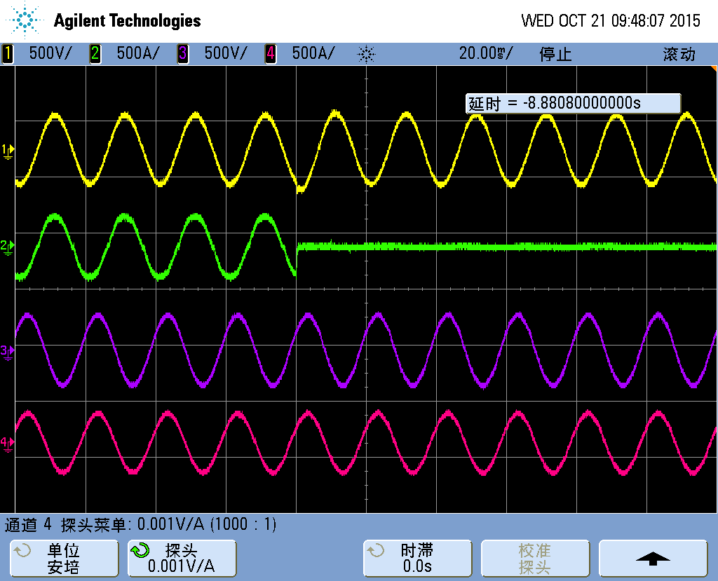 |  | 461.png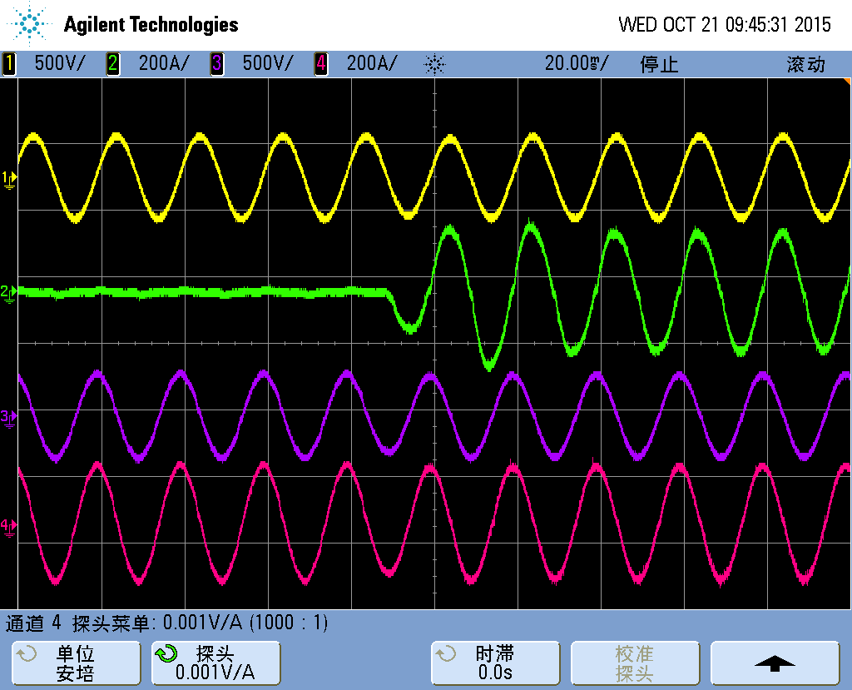
CH1 | Va-input | CH1 | Va-input
CH2 | Ia-input | CH2 | Ia-input
CH3 | Va-output | CH3 | Va-output
CH4 | Ia-output | CH4 | Ia-output
interruption | 0 | interruption | 0

PS: Stand-by generator compatibility
Overload timeout-transfer to bypass |  | Remove load-transfer back to inverter
CH1 | Va-input | CH1 | Va-input
CH2 | Ia-input | CH2 | Ia-input
CH3 | Va-output | CH3 | Va-output
CH4 | Ia-output | CH4 | Ia-output
interruption |  | interruption

Input supply compatibility (16~22)

Input 16
Input 16 Steady-state input voltage tolerance back to list
6.4.1.1- With the UPS in normal mode of operation and input frequency set at nominal frequency, the input voltage shall be adjusted to the minimum and maximum values of the tolerance range specified by the manufacturer. The UPS shall remain in normal mode of operation over the specified tolerance range with the ability to recharge the battery.
The UPS output voltage shall be measured and its tolerance recorded at nominal, minimum and maximum input voltage.
Where the design of the UPS prevents normal mode of operation above 10 % of nominal supply voltage by a change of mode to stored energy mode, the value recorded shall be the voltage prior to change of mode. The input voltage shall be the maximum rated input voltage to ensure operation without circuit damage.
Rated input setting: 220V

Full load & battery charging:
Adjust voltage | Input voltage |  |  |  | Output voltage |  |  |  | Percentage
 | V-A | V-B | V-C | f(Hz) | V-A | V-B | V-C | f(Hz) | A | B | C | f(Hz)
MAX | 271.5 | 272.9 | 271.4 | 49.97 | 219.8 | 219.9 | 219.8 | 49.98 | 0.1% | 0.1% | 0.1% | 0.04%
MIN | 176.2 | 176.3 | 176 | 49.98 | 219.8 | 219.9 | 219.6 | 49.98 | 0.6% | 0.6% | 0.5% | 0.04%

Full load & battery not charging:
Adjust voltage | Input voltage |  |  |  | Output voltage |  |  |  | Percentage
 | V-A | V-B | V-C | f(Hz) | V-A | V-B | V-C | f(Hz) | A | B | C | f(Hz)
MAX | 272 | 272.6 | 271.9 | 49.98 | 219.8 | 220 | 219.9 | 49.98 | 0.09% | 0.05% | 0.05% | 0.04%
MIN | 176.2 | 176.3 | 176 | 49.97 | 219.8 | 219.9 | 219.6 | 49.98 | 0.09% | 0.05% | 0.02% | 0.04%

No load & battery charging:
Adjust voltage | Input voltage |  |  |  | Output voltage |  |  |  | Percentage
 | V-A | V-B | V-C | f(Hz) | V-A | V-B | V-C | f(Hz) | A | B | C | f(Hz)
MAX | 272.5 | 272.5 | 272.4 | 49.98 | 220.8 | 220.0 | 221 | 49.97 | 0.36% | 0% | 0.45% | 0.06%
MIN | 176.2 | 176.3 | 176 | 49.98 | 219.8 | 219.9 | 219.6 | 49.97 | 0.09% | 0.05% | 0.18% | 0.06%

No load & battery not charging:
Adjust voltage | Input voltage |  |  |  | Output voltage |  |  |  | Percentage
 | V-A | V-B | V-C | f(Hz) | V-A | V-B | V-C | f(Hz) | A | B | C | f(Hz)
MAX | 272.5 | 272.5 | 272.4 | 49.97 | 220.8 | 220.0 | 220.9 | 49.97 | 0.36% | 0% | 0.45% | 0.06%
MIN | 132.3 | 132.5 | 132.2 | 49.99 | 220.7 | 220.9 | 220.8 | 49.97 | 0.31% | 0.41% | 0.36% | 0.06%

Input 17
Input 17 Input frequency tolerance back to list
6.4.1.2- The steady-state input voltage tolerance test (see 6.4.1.1) shall be repeated with the input frequency adjusted to the limits specified by the manufacturer in conjunction with the input voltage variations (see Note).
Where the UPS output frequency is synchronized with the input frequency, the range of synchronization shall be checked.
Where the total input frequency range exceeds the stated range of synchronization, the UPS output normally reverts to free running operation. The free running frequency shall be recorded for non-synchronous conditions.
NOTE A decrease in frequency is assumed not to coincide with an increase in line voltage, and vice versa.

Main input
Adjust frequency | Input voltage |  |  |  | Output voltage |  |  |  | Percentage
 | V-A | V-B | V-C | f(Hz) | V-A | V-B | V-C | f(Hz) | A | B | C | f(Hz)
MAX | 222.7 | 222.3 | 221.2 | 69.87 | 222.0 | 222.0 | 221.9 | 50.00 | / | / | / | 0%
MIN | 222.2 | 221.9 | 220.8 | 40.08 | 222.0 | 222.0 | 221.9 | 49.99 | / | / | / | 0.02%

Bypass-min setting
Adjust frequency | Input voltage |  |  |  | Output voltage |  |  |  | Percentage
 | V-A | V-B | V-C | f(Hz) | V-A | V-B | V-C | f(Hz) | A | B | C | f(Hz)
MIN | 220.7 | 220.6 | 220.6 | 45.28 | 222.0 | 222.0 | 222.0 | 55.06 | / | / | / | 0.02%

Bypass-max setting
Adjust frequency | Input voltage |  |  |  | Output voltage |  |  |  | Percentage
 | V-A | V-B | V-C | f(Hz) | V-A | V-B | V-C | f(Hz) | A | B | C | f(Hz)
MAX | 220.7 | 220.7 | 220.7 | 55.06 | 222.0 | 222.1 | 222.0 | 49.99 | / | / | / | 0.02%

Bypass-default setting
Adjust frequency | Input voltage |  |  |  | Output voltage |  |  |  | Percentage
 | V-A | V-B | V-C | f(Hz) | V-A | V-B | V-C | f(Hz) | A | B | C | f(Hz)
50 | 220.7 | 220.7 | 220.6 | 49.97 | 222.1 | 222.1 | 222.0 | 49.98 | / | / | / | 0.04%

Input 18
Input 18 Input inrush current back to list
6.4.1.3- Two inrush current tests shall be performed sequentially. The first test shall be performed after an absence of input voltage for more than 5 min.
The subsequent test shall be performed after an absence of input voltage for 1 s. If the UPS topology requires a time delay greater than 1 s, the test shall be performed with the manufacturer specified delay, which shall be stated in the installation instructions.
For the purpose of this test, initial current surges attributable to energization of RFI capacitors in input filters with a time duration of less than 1 ms shall be disregarded.
The a.c. input power supply shall be capable of providing a prospective short-circuit current so that the short-circuit ratio Rsce is at least 33. Testing at an Rsce lower than 33 is permitted when the test result is corrected by an appropriate calculation.
The mains input supply shall be switched on to the UPS input coincident with various angular points on the input voltage waveform in order to determine the worst-case inrush current condition.
NOTE The test should be repeated sufficiently to obtain worst-case peak current which will normally be found for transformer coupled units, when switched at the zero voltage point and for direct rectifier/capacitor loads at or near the peak of the input supply voltage waveform.

Rated load
Input inrush current-first time |  | Input inrush current- after an absence of input voltage for 1 s
33.png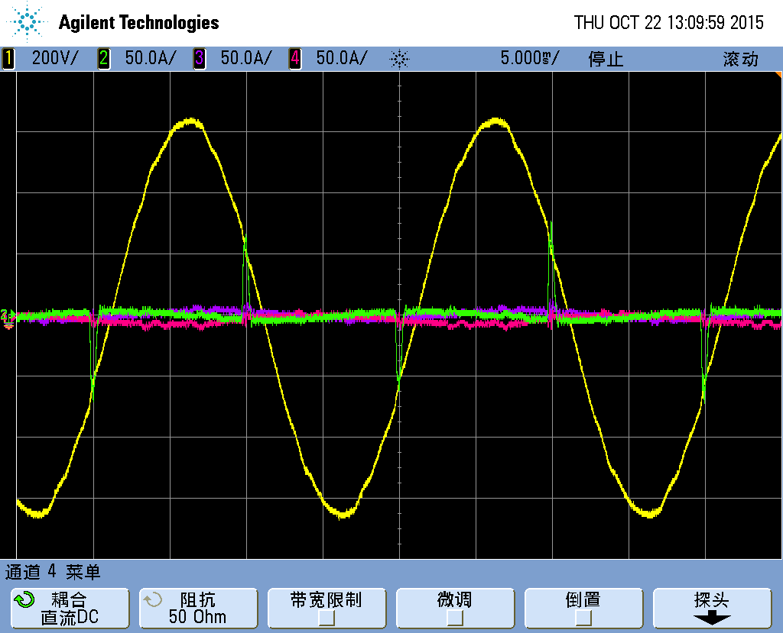 |  | 32.png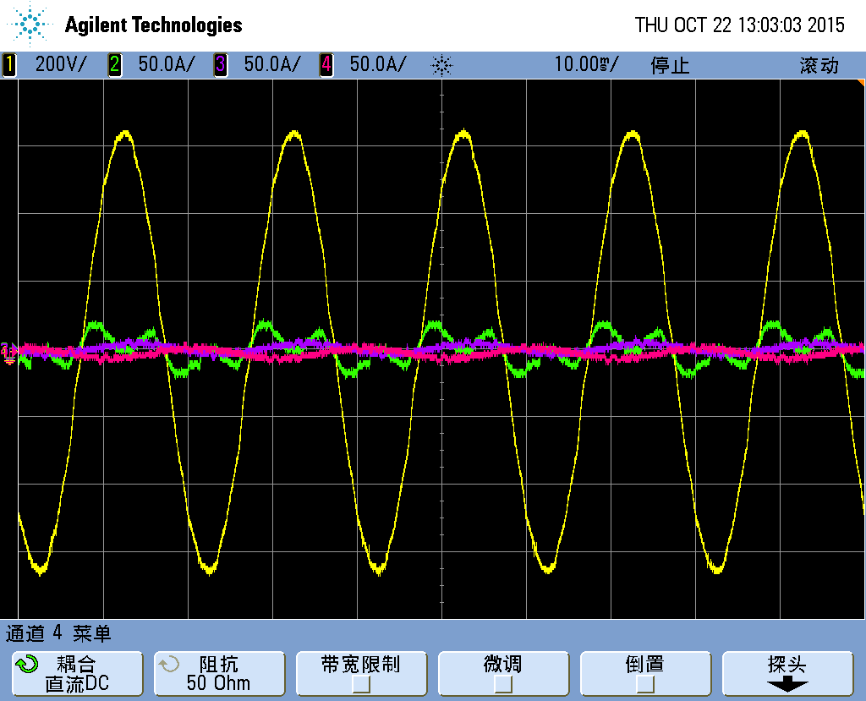
CH1 | Va-input | CH1 | Va-input
CH2 | Ia-input | CH2 | Ia-input
CH3 | Ib-input | CH3 | Ib-input
CH4 | Ic-input | CH4 | Ic-input
inrush | <100% | inrush | <100%

Input 19
Input 19 Harmonic distortion of input current back to list
6.4.1.4- The harmonic distortion of the input current is tested at reference test load.
Compliance is verified when the total harmonic distortion figures of the UPS input current are within the limits declared by the manufacturer.
NOTE 1 The limits declared by the manufacturer should at least comply with those prescribed by IEC 61000-3-2 (UPS≤16 A), IEC 61000-3-12 (16 A < UPS≤75 A), or IEC/TS 61000-3-4 (UPS > 75 A) taking into consideration the minimum short-circuit power capacity of the a.c. input supply as declared by the manufacturer.
NOTE 2 Where the reference test load is implemented by means of returning the output power to the UPS input, the harmonic distortion of the input current of concern is that actually drawn by the UPS input (as opposed to that drawn from the a.c. input source).

UPS=16 A < UPS≤75 A
 |  |  | A |  |  | B |  |  | C |  |  |  |  |  | A |  |  | B |  |  | C
THDU-in |  |  | 0.75 |  |  | 0.68 |  |  | 0.73 |  |  | THDI-in |  |  | 3.27 |  |  | 3.91 |  |  | 3.77
N | S | A |  | B | C | N | S | A |  | B | C | N | S | A |  | B | C | N | S | A |  | B | C
1 |  | 100 |  | 100 | 100 | 11 |  | 0.81 |  | 0.97 | 0.89 | 21 |  | 0.67 |  | 0.62 | 0.52 | 31 |  | 0.11 |  | 0.21 | 0.22
2 |  | 0.05 |  | 0.53 | 0.19 | 12 |  | 0.04 |  | 0.14 | 0.07 | 22 |  | 0.04 |  | 0.01 | 0.03 | 32 |  | 0.01 |  | 0.02 | 0.01
3 |  | 2.13 |  | 2.53 | 2.49 | 13 |  | 0.49 |  | 0.84 | 0.75 | 23 |  | 0.22 |  | 0.37 | 0.29 | 33 |  | 0.08 |  | 0.1 | 0.09
4 |  | 0.1 |  | 0.07 | 0.06 | 14 |  | 0.07 |  | 0.05 | 0.03 | 24 |  | 0.09 |  | 0.04 | 0.06 | 34 |  | 0.02 |  | 0.01 | 0
5 |  | 1.06 |  | 1.38 | 1.45 | 15 |  | 0.91 |  | 0.96 | 0.87 | 25 |  | 0.37 |  | 0.3 | 0.4 | 35 |  | 0.06 |  | 0.09 | 0.09
6 |  | 0.07 |  | 0.06 | 0.01 | 16 |  | 0.05 |  | 0.19 | 0.11 | 26 |  | 0.02 |  | 0.04 | 0.03 | 36 |  | 0.01 |  | 0.01 | 0
7 |  | 1.13 |  | 1.09 | 1.06 | 17 |  | 0.58 |  | 0.79 | 0.6 | 27 |  | 0.25 |  | 0.27 | 0.19 | 37 |  | 0.06 |  | 0.1 | 0.07
8 |  | 0.11 |  | 0.09 | 0.08 | 18 |  | 0.07 |  | 0.05 | 0.09 | 28 |  | 0.04 |  | 0.01 | 0.03 | 38 |  | 0 |  | 0.01 | 0.01
9 |  | 0.66 |  | 1.02 | 1.05 | 19 |  | 0.66 |  | 0.67 | 0.72 | 29 |  | 0.08 |  | 0.15 | 0.14 | 39 |  | 0.04 |  | 0.04 | 0.09
10 |  | 0.1 |  | 0.01 | 0.04 | 20 |  | 0.06 |  | 0.06 | 0.05 | 30 |  | 0.06 |  | 0.06 | 0.02 | 40 |  | 0.02 |  | 0.02 | 0.02
Conclusion: PASS

Input 20
Input 20 Power factor back to list
6.4.1.5- The input power factor is tested at reference test load in normal mode of operation and at rated a.c. input supply conditions.
Compliance is verified when the input power factor of the UPS input current is equal or greater that that declared by the manufacturer
NOTE Where the reference test load is implemented by means of returning the output power to the UPS input, the input power factor of concern is that referred to the current actually drawn by the UPS input (as opposed to that drawn from the a.c. input source).
Input voltage & frequency = rated
Reference linear load—full load & MAX charge |  |  |  | Reference nonlinear load—full load & MAX charge
Phase | V-input | I-input | PF | Phase | V-input | I-input | PF
A | 219.1 | 139.6 | 0.999 | A | 219.3 | 102.1 | 0.998
B | 220.8 | 138.8 | 0.998 | B | 221.1 | 101.5 | 0.997
C | 218.9 | 138.6 | 0.999 | C | 219.2 | 100.9 | 0.997
Reference linear load—75% load & full charge |  |  |  | Reference nonlinear load—75% load & full charge
Phase | V-input | I-input | PF | Phase | V-input | I-input | PF
A | 219.3 | 105.5 | 0.998 | A | 219.5 | 80.5 | 0.997
B | 221 | 105 | 0.997 | B | 221.1 | 79.4 | 0.995
C | 219.3 | 104.8 | 0.998 | C | 219.5 | 79.4 | 0.996
Reference linear load—50% load & full charge |  |  |  | Reference nonlinear load—50% load & full charge
Phase | V-input | I-input | PF | Phase | V-input | I-input | PF
A | 219.6 | 73.3 | 0.996 | A | 219.8 | 52.0 | 0.991
B | 221.2 | 72.8 | 0.994 | B | 221.4 | 520.4 | 0.989
C | 219.6 | 72.6 | 0.995 | C | 219.8 | 49.58 | 0.990
Reference linear load—25% load & full charge |  |  |  | Reference nonlinear load—25% load & full charge
Phase | V-input | I-input | PF | Phase | V-input | I-input | PF
A | 219.9 | 39.1 | 0.986 | A | 220.1 | 24.26 | 0.974
B | 221.7 | 39.1 | 0.984 | B | 221.5 | 23.30 | 0.974
C | 219.9 | 38.6 | 0.987 | C | 220.0 | 22.86 | 0.977
Conclusion: PASS

Input 21
Input 21 Efficiency back to list
6.4.1.6- The UPS efficiency shall be measured at 25 %, 50 %, 75 % and 100 % reference test load as prescribed in Annex J.
Compliance is verified when the computed efficiency values are equal to or greater than those declared by the manufacturer.
NOTE Refer to Annex I for applicable minimum efficiency values to be considered.
100% linear load |  |  |  |  |  |  |  |  |  | 100% nonlinear load
PH | Vi | Ii | PFi | Pi | Vo | Io | PFo | Po | Es | PH | Vi | Ii | PFi | Pi | Vo | Io | PFo | Po | Es
A | 219.2 | 137.8 | 0.999 | 90.39k | 219.5 | 129.7 | 1 | 85.6k | 94.71 | A | 219.3 | 102.1 | 0.998 | 70.5k | 219.8 | 140.8 | 0.703 | 65.57k | 92.94
B | 220.9 | 137.0 | 0.998 |  | 219.8 | 129.1 | 1 |  |  | B | 221.1 | 101.5 | 0.997 |  | 219.8 | 140.9 | 0.707
C | 219.1 | 137 | 0.999 |  | 219.5 | 131.1 | 1 |  |  | C | 219.2 | 100.9 | 0.997 |  | 219.7 | 140.1 | 0.707
75% linear load |  |  |  |  |  |  |  |  |  | 75% nonlinear load
PH | Vi | Ii | PFi | Pi | Vo | Io | PFo | Po | Ef | PH | Vi | Ii | PFi | Pi | Vo | Io | PFo | Po | Es
A | 219.4 | 103.6 | 0.999 | 67.9 | 220 | 98.2 | 1 | 64.6 | 95.12 | A | 219.5 | 80.5 | 0.997 | 52.44k | 220 | 108.8 | 0.676 | 48..82k | 93.09
B | 221.1 | 103.1 | 0.997 |  | 220 | 99.1 | 1 |  |  | B | 221.1 | 79.4 | 0.995 |  | 220.2 | 108.6 | 0.682
C | 219.3 | 102.7 | 0.997 |  | 220.2 | 96.13 | 1 |  |  | C | 219.5 | 79.4 | 0.996 |  | 219.9 | 108.8 | 0.682
50% linear load |  |  |  |  |  |  |  |  |  | 50% nonlinear load
PH | Vi | Ii | PFi | Pi | Vo | Io | PFo | Po | Es | PH | Vi | Ii | PFi | Pi | Vo | Io | PFo | Po | Es
A | 219.7 | 71.4 | 0.996 | 46.68k | 220.2 | 67.9 | 1 | 44.5k | 95.4 | A | 219.8 | 52.0 | 0.991 | 33.12k | 220.3 | 70.8 | 0.654 | 30.69k | 92.66
B | 221.2 | 71 | 0.994 |  | 220.4 | 66.1 | 1 |  |  | B | 221.4 | 520.4 | 0.989 |  | 220.4 | 70.9 | 0.653
C | 219.6 | 70.7 | 0.995 |  | 220.1 | 68.3 | 1 |  |  | C | 219.8 | 49.58 | 0.990 |  | 220.3 | 71.2 | 0.655
25% linear load |  |  |  |  |  |  |  |  |  | 25% nonlinear load
PH | Vi | Ii | PFi | Pi | Vo | Io | PFo | Po | Es | PH | Vi | Ii | PFi | Pi | Vo | Io | PFo | Po | Es
A | 220 | 37.8 | 0.985 | 24.39k | 220.4 | 36.2 | 1 | 23.1k | 94.83 | A | 220.1 | 24.26 | 0.974 | 15.14k | 220.5 | 34.9 | 0.579 | 73.48 | 89.02
B | 221.4 | 37.4 | 0.984 |  | 220.6 | 31.8 | 1 |  |  | B | 221.5 | 23.30 | 0.974 |  | 220.1 | 35.4 | 0.581
C | 219.9 | 37.2 | 0.985 |  | 220.4 | 36.9 | 1 |  |  | C | 220.0 | 22.86 | 0.977 |  | 220.6 | 34.8 | 0.58
100% linear load—change channel of instrument |  |  |  |  |  |  |  |  |  | 100% nonlinear load- change channel of instrument
PH | Vi | Ii | PFi | Pi | Vo | Io | PFo | Po | Es | PH | Vi | Ii | PFi | Pi | Vo | Io | PFo | Po | Es
A |  |  |  |  |  |  |  |  |  | A
B |  |  |  |  |  |  |  |  |  | B
C |  |  |  |  |  |  |  |  |  | C
50% linear load- change channel of instrument |  |  |  |  |  |  |  |  |  | 50% nonlinear load- change channel of instrument
PH | Vi | Ii | PFi | Pi | Vo | Io | PFo | Po | Es | PH | Vi | Ii | PFi | Pi | Vo | Io | PFo | Po | Es
A |  |  |  |  |  |  |  |  |  | A
B |  |  |  |  |  |  |  |  |  | B
C |  |  |  |  |  |  |  |  |  | C
Conclusion: PASS

Input 22
Input 22 Stand-by generator compatibility back to list
6.4.1.9- The applicable routine tests listed in Table 3 shall be repeated using the output of a stand-by generator as the source of input supply. The characteristics of the stand-by generator shall be specified by the manufacturer.
NOTE 1 This test may be performed in conjunction with the input voltage and frequency tolerance tests (see 6.4.1.1 and 6.4.1.2)
NOTE 2 Subject to an agreement between the manufacturer/supplier and the purchaser, this test may be performed on site.
NOTE 3 IEC 60034-22 may be consulted regarding characteristics for internal combustion engine driven generating sets.

See ” basic check 1~15”

Ouput-Linear load (23~40)

Ouput-L 23
Ouput-L 23 Normal mode – No load back to list
6.4.2.1- With the UPS operating in normal mode of operation at no load and nominal input voltage and frequency, measure the r.m.s. output voltage and its fundamental and harmonic components.
Vout |  | A |  | B |  | C |  | THDu |  | A |  | B |  | C |  | f | A | B | C
 |  | 220.9 |  | 221.5 |  | 221.1 |  |  |  | 0.73 |  | 0.71 |  | 0.72 |  |  |  | 49.97
N | S | A | B | C | N | S | A | B | C | N | S | A | B | C | N | S | A | B | C
1 |  | 100 | 100 | 100 | 11 | 3.50 | 0.06 | 0.07 | 0.07 | 21 | 0.20 | 0.12 | 0.1 | 0 | 31 | 0.97 | 0.08 | 0.06 | 0
2 | 2.00 | 0.07 | 0.08 | 0.08 | 12 | 0.46 | 0.01 | 0 | 0.01 | 22 | 0.36 | 0.01 | 0 | 0.09 | 32 | 0.33 | 0 | 0 | 0.04
3 | 5.00 | 0.42 | 0.4 | 0.43 | 13 | 3.00 | 0.08 | 0.1 | 0.11 | 23 | 1.41 | 0.11 | 0.13 | 0.01 | 33 | 0.20 | 0.04 | 0.03 | 0
4 | 1.00 | 0.01 | 0.01 | 0.01 | 14 | 0.43 | 0 | 0.01 | 0 | 24 | 0.35 | 0.01 | 0 | 0.1 | 34 | 0.32 | 0.01 | 0 | 0.02
5 | 6.00 | 0.39 | 0.39 | 0.38 | 15 | 0.30 | 0.11 | 0.11 | 0.13 | 25 | 1.27 | 0.12 | 0.13 | 0 | 35 | 0.83 | 0.03 | 0.02 | 0.01
6 | 0.50 | 0 | 0.01 | 0 | 16 | 0.41 | 0 | 0.01 | 0.01 | 26 | 0.35 | 0.01 | 0.01 | 0.14 | 36 | 0.32 | 0.01 | 0 | 0.02
7 | 5.00 | 0.24 | 0.22 | 0.22 | 17 | 2.00 | 0.11 | 0.11 | 0.11 | 27 | 0.20 | 0.11 | 0.12 | 0.01 | 37 | 0.77 | 0.02 | 0.02 | 0.01
8 | 0.50 | 0 | 0.01 | 0.01 | 18 | 0.39 | 0.01 | 0 | 0 | 28 | 0.34 | 0.01 | 0.01 | 0.13 | 38 | 0.32 | 0 | 0 | 0.02
9 | 1.50 | 0.14 | 0.12 | 0.11 | 19 | 1.76 | 0.11 | 0.1 | 0.09 | 29 | 1.06 | 0.1 | 0.1 | 0 | 39 | 0.20 | 0.03 | 0.03 | 0
10 | 0.50 | 0.01 | 0 | 0.01 | 20 | 0.38 | 0.01 | 0.01 | 0.07 | 30 | 0.33 | 0 | 0 | 0.08 | 40 | 0.31 | 0 | 0 | 0.02
Conclusion: PASS

Ouput-L 24
Ouput-L 24 Normal mode – Full load back to list
6.4.2.2- Apply 100 % reference test load to the UPS output.
In steady-state conditions, measure the r.m.s. output voltage and its fundamental and harmonic components. Compute no-load to full-load output voltage regulation.
For UPS whose output in normal mode of operation is directly connected solely by a switching device to the input supply, the harmonic content test is unnecessary.
Vout |  | A |  | B |  | C |  | THDu |  | A |  | B |  | C |  | f | A | B | C
 |  | 219.8 |  | 219.8 |  | 219.7 |  |  |  | 0.91 |  | 0.94 |  | 0.94 |  |  |  | 49.98
N | S | A | B | C | N | S | A | B | C | N | S | A | B | C | N | S | A | B | C
1 |  | 100 | 100 | 100 | 11 | 3.50 | 0.21 | 0.22 | 0.21 | 21 | 0.20 | 0.14 | 0.13 | 0.15 | 31 | 0.97 | 0.06 | 0.08 | 0.08
2 | 2.00 | 0.07 | 0.06 | 0.09 | 12 | 0.46 | 0 | 0.01 | 0 | 22 | 0.36 | 0.02 | 0.01 | 0.02 | 32 | 0.33 | 0.01 | 0.01 | 0.01
3 | 5.00 | 0.55 | 0.57 | 0.56 | 13 | 3.00 | 0.19 | 0.2 | 0.19 | 23 | 1.41 | 0.13 | 0.13 | 0.13 | 33 | 0.20 | 0.05 | 0.06 | 0.05
4 | 1.00 | 0.01 | 0.01 | 0.01 | 14 | 0.43 | 0 | 0 | 0.01 | 24 | 0.35 | 0.01 | 0.01 | 0.01 | 34 | 0.32 | 0 | 0 | 0
5 | 6.00 | 0.38 | 0.39 | 0.4 | 15 | 0.30 | 0.17 | 0.18 | 0.18 | 25 | 1.27 | 0.12 | 0.13 | 0.12 | 35 | 0.83 | 0.04 | 0.05 | 0.04
6 | 0.50 | 0.01 | 0.01 | 0.01 | 16 | 0.41 | 0.01 | 0.01 | 0.01 | 26 | 0.35 | 0 | 0.01 | 0.01 | 36 | 0.32 | 0.01 | 0.01 | 0.01
7 | 5.00 | 0.29 | 0.29 | 0.3 | 17 | 2.00 | 0.15 | 0.17 | 0.16 | 27 | 0.20 | 0.1 | 0.1 | 0.1 | 37 | 0.77 | 0.03 | 0.03 | 0.02
8 | 0.50 | 0 | 0 | 0.01 | 18 | 0.39 | 0.01 | 0.01 | 0 | 28 | 0.34 | 0.01 | 0 | 0.01 | 38 | 0.32 | 0.01 | 0.01 | 0.01
9 | 1.50 | 0.25 | 0.26 | 0.25 | 19 | 1.76 | 0.14 | 0.15 | 0.17 | 29 | 1.06 | 0.09 | 0.08 | 0.09 | 39 | 0.20 | 0.02 | 0.02 | 0.04
10 | 0.50 | 0.01 | 0.01 | 0.01 | 20 | 0.38 | 0.01 | 0.02 | 0.02 | 30 | 0.33 | 0.01 | 0.01 | 0.01 | 40 | 0.31 | 0.02 | 0.02 | 0.01
Conclusion: PASS

No-load to full-load output voltage regulation:
Vout-NO | A | B | C | Vout-FULL | A | B | C | RE
 | 220.9 | 221.5 | 221.1 |  | 219.8 | 219.8 | 219.7
Conclusion:

Ouput-L 25
Ouput-L 25 Stored energy mode – No load back to list
6.4.2.3- With the UPS operating in stored energy mode and the output at no-load, measure the output voltage, frequency and its fundamental and harmonic components.

Vout |  | A |  | B |  | C |  | THDu |  | A |  | B |  | C |  | f | A | B | C
 |  | 220.9 |  | 221 |  | 220.8 |  |  |  | 0.73 |  | 0.69 |  | 0.72 |  |  | 49.98 | 49.98
N | S | A | B | C | N | S | A | B | C | N | S | A | B | C | N | S | A | B | C
1 |  | 100 | 100 | 100 | 11 | 3.50 | 0.06 | 0.06 | 0.07 | 21 | 0.20 | 0.09 | 0.11 | 0.12 | 31 | 0.97 | 0.06 | 0.06 | 0.06
2 | 2.00 | 0.08 | 0.06 | 0.1 | 12 | 0.46 | 0.01 | 0 | 0.01 | 22 | 0.36 | 0.03 | 0 | 0.01 | 32 | 0.33 | 0.01 | 0.01 | 0
3 | 5.00 | 0.41 | 0.38 | 0.42 | 13 | 3.00 | 0.1 | 0.1 | 0.11 | 23 | 1.41 | 0.11 | 0.12 | 0.12 | 33 | 0.20 | 0.04 | 0.03 | 0.03
4 | 1.00 | 0.01 | 0.01 | 0 | 14 | 0.43 | 0.01 | 0 | 0.01 | 24 | 0.35 | 0.01 | 0.02 | 0 | 34 | 0.32 | 0.02 | 0.01 | 0.01
5 | 6.00 | 0.38 | 0.38 | 0.38 | 15 | 0.30 | 0.12 | 0.12 | 0.13 | 25 | 1.27 | 0.13 | 0.13 | 0.14 | 35 | 0.83 | 0.04 | 0.02 | 0.02
6 | 0.50 | 0.01 | 0.01 | 0.01 | 16 | 0.41 | 0.01 | 0.01 | 0.01 | 26 | 0.35 | 0.01 | 0.02 | 0.01 | 36 | 0.32 | 0.01 | 0.01 | 0
7 | 5.00 | 0.23 | 0.22 | 0.22 | 17 | 2.00 | 0.13 | 0.12 | 0.1 | 27 | 0.20 | 0.12 | 0.11 | 0.12 | 37 | 0.77 | 0.03 | 0.03 | 0.02
8 | 0.50 | 0.01 | 0.01 | 0.01 | 18 | 0.39 | 0.02 | 0.02 | 0.01 | 28 | 0.34 | 0.01 | 0.01 | 0.01 | 38 | 0.32 | 0 | 0.01 | 0.01
9 | 1.50 | 0.13 | 0.12 | 0.11 | 19 | 1.76 | 0.12 | 0.11 | 0.11 | 29 | 1.06 | 0.1 | 0.08 | 0.09 | 39 | 0.20 | 0.04 | 0.03 | 0.02
10 | 0.50 | 0.01 | 0.01 | 0 | 20 | 0.38 | 0.01 | 0.01 | 0.02 | 30 | 0.33 | 0.01 | 0.02 | 0.01 | 40 | 0.31 | 0 | 0.01 | 0.01
Conclusion: PASS

Ouput-L 26
Ouput-L 26 Stored energy mode – Full load back to list
6.4.2.4- Apply 100 % reference test load to the UPS output. In steady-state conditions at the beginning of battery discharge time, measure the output voltage, frequency and its
fundamental and harmonic components. Compute the no-load to full-load output voltage regulation.
NOTE This test requires instrumentation with scanning time sufficient to observe changes resulting from the storage device voltage fall with time. For UPS with a storage device rated for less than 10 min, it is permissible to connect an additional battery to enable testing and to stabilise measurements.
Vout  (V) |  | A |  | B |  | C |  | THDu  (%) |  | A |  | B |  | C |  | F  (Hz) | A | B | C
 |  | 219.9 |  | 219.9 |  | 219.7 |  |  |  | 0.91 |  | 0.9 |  | 0.93 |  |  | 49.99 | 50.00
N | S | A | B | C | N | S | A | B | C | N | S | A | B | C | N | S | A | B | C
1 |  | 100 | 100 | 100 | 11 | 3.50 | 0.22 | 0.21 | 0.22 | 21 | 0.20 | 0.14 | 0.12 | 0.13 | 31 | 0.97 | 0.07 | 0.08 | 0.09
2 | 2.00 | 0.1 | 0.06 | 0.1 | 12 | 0.46 | 0.01 | 0.01 | 0.01 | 22 | 0.36 | 0.01 | 0.01 | 0.01 | 32 | 0.33 | 0.01 | 0.01 | 0
3 | 5.00 | 0.49 | 0.49 | 0.53 | 13 | 3.00 | 0.19 | 0.21 | 0.2 | 23 | 1.41 | 0.13 | 0.13 | 0.13 | 33 | 0.20 | 0.06 | 0.06 | 0.06
4 | 1.00 | 0.01 | 0 | 0.02 | 14 | 0.43 | 0 | 0.01 | 0.01 | 24 | 0.35 | 0.01 | 0 | 0.01 | 34 | 0.32 | 0.01 | 0.01 | 0
5 | 6.00 | 0.42 | 0.41 | 0.41 | 15 | 0.30 | 0.18 | 0.17 | 0.17 | 25 | 1.27 | 0.12 | 0.12 | 0.13 | 35 | 0.83 | 0.05 | 0.04 | 0.04
6 | 0.50 | 0.01 | 0 | 0 | 16 | 0.41 | 0 | 0.01 | 0.01 | 26 | 0.35 | 0.01 | 0.01 | 0 | 36 | 0.32 | 0.01 | 0.01 | 0.01
7 | 5.00 | 0.3 | 0.29 | 0.31 | 17 | 2.00 | 0.17 | 0.17 | 0.16 | 27 | 0.20 | 0.1 | 0.11 | 0.11 | 37 | 0.77 | 0.03 | 0.03 | 0.03
8 | 0.50 | 0 | 0 | 0.01 | 18 | 0.39 | 0.01 | 0.02 | 0.02 | 28 | 0.34 | 0.01 | 0 | 0 | 38 | 0.32 | 0.02 | 0.02 | 0.02
9 | 1.50 | 0.24 | 0.24 | 0.25 | 19 | 1.76 | 0.16 | 0.14 | 0.16 | 29 | 1.06 | 0.09 | 0.09 | 0.1 | 39 | 0.20 | 0.02 | 0.04 | 0.02
10 | 0.50 | 0.01 | 0.01 | 0 | 20 | 0.38 | 0.02 | 0.01 | 0.01 | 30 | 0.33 | 0 | 0 | 0 | 40 | 0.31 | 0.01 | 0.02 | 0.02
Conclusion: PASS

Ouput-L 27
Ouput-L 27 3-phase voltage unbalance back to list
6.4.2.5- Output voltage unbalance on three-phase output UPS shall be checked under symmetrical load conditions and unbalanced load conditions. For the unbalanced load condition, two phases shall be loaded phase to phase or phase to neutral if a neutral exists at nominal rated current linear load, the other phase at no load unless otherwise specified by the manufacturer/supplier.

One phase 100% load:
Phase-load |  | Vout:L-N | Vout:L-L | Phase-load |  | Vout:L-N | Vout:L-L | Phase-load |  | Vout:L-N | Vout:L-L
A | 100% | 219.5 | 382.2 | A | 0% | 221.6 | 382.7 | A | 0% | 221.1 | 383.5
B | 0% | 221.2 | 382.6 | B | 100% | 219.8 | 382.2 | B | 0% | 222.2 | 382.7
C | 0% | 221 | 382.1 | C | 0% | 221.1 | 382.6 | C | 100% | 219.5 | 381.7
Unbalance: |  |  | 0.08% | Unbalance:% |  |  | 0.8% | Unbalance:% |  |  | 0.27%

One phase 0% load:
Phase-load |  | Vout:L-N | Vout:L-L | Phase-load |  | Vout:L-N | Vout:L-L | Phase-load |  | Vout:L-N | Vout:L-L
A | 100% | 219.4 | 380.9 | A | 0% | 221.9 | 382.1 | A | 100% | 219.8 | 383.4
B | 100% | 219.8 | 383.2 | B | 100% | 219.5 | 380.8 | B | 0% | 223.0 | 383.1
C | 0% | 222.6 | 382.1 | C | 100% | 219.7 | 381.7 | C | 100% | 219.5 | 380.6
Unbalance:% |  |  | 0.35% | Unbalance:% |  |  | 0.2% | Unbalance:% |  |  | 0.46%

Ouput-L 28
Ouput-L 28 DC voltage component back to list
6.4.2.6- The 10 s average d.c. output voltage shall be less than 0,1 % of r.m.s. value

Balance linear full load | Comp. | A | B | C | Unbalance linear full load | Comp. | A | B | C
 | rms | 219.8 | 219.8 | 219.8 |  | rms | 219.5 | 222.9 | 222.4
 | DC | 0.13 | 0．14 | 0.14 |  | DC | 0.15 | 0.13 | 0.12
Conclusion: PASS

Ouput-L 29
Ouput-L 29 Current division across paralleled UPS back to list
6.4.2.7- Load sharing shall be measured for reference, (at the output of two or more UPS units in parallel configuration) in accordance with the manufacturer’s specification or with any specific agreement between the manufacturer and purchaser.

0% load |  |  |  | 50% load |  |  |  | 100% load
NO. | Iout-A | Iout-B | Iout-C | NO. | Iout-A | Iout-B | Iout-C | NO. | Iout-A | Iout-B | Iout-C
1 | 0.413 | 0.506 | 0.342 | 1 | 33.7 | 33.26 | 30.51 | 1 | 68.35 | 68.24 | 68.46
2 | 0.606 | 0.777 | 0.589 | 2 | 33.57 | 33.19 | 30.71 | 2 | 68.46 | 68.26 | 68.73
3 | / | / | / | 3 | / | / | / | 3 | / | / | /
4 | / | / | / | 4 | / | / | / | 4 | / | / | /
5 | / | / | / | 5 | / | / | / | 5 | / | / | /
6 | / | / | / | 6 | / | / | / | 6 | / | / | /
7 | / | / | / | 7 | / | / | / | 7 | / | / | /
8 | / | / | / | 8 | / | / | / | 8 | / | / | /
9 | / | / | / | 9 | / | / | / | 9 | / | / | /
10 | / | / | / | 10 | / | / | / | 10 | / | / | /
Unit: A
AVG |  |  |  | AVG |  |  |  | AVG
MAX |  |  |  | MAX |  |  |  | MAX
MIN |  |  |  | MIN |  |  |  | MIN
%
Conclusion: N/A

Ouput-L 30
Ouput-L 30 Output overvoltage test back to list
6.4.2.8- Output overvoltage protection shall be checked.

Simulate an overvoltage on the detection circuit of inverter:
Alarm and history log | Action of UPS | How to recover?
Inverter protect | Transfer to bypass | When inverter voltage come back to normal, system retransfer to inverter automatically.
Conclusion: PASS

Ouput-L 31
Ouput-L 31 Periodic output voltage variation test (modulation) back to list
6.4.2.9- Only when, subject to a specific agreement between the purchaser and the manufacturer, this test is specified, it shall be checked by voltage recording at different loads and operating conditions.
Compliance is verified when, during the test, the UPS output voltage remains within the limits of curve 1, 2 or 3 of Figures 2, 3 and 4, as applicable.

See performance test forms: “^^^.xls”

Ouput-L 32
Ouput-L 32 Overload – Normal mode back to list
6.4.2.10.1- With the UPS operating under at light load in normal mode, apply a resistive load which shall result in the UPS output in excess of the manufacturer’s full load rating. Check that the UPS continues to operate within the manufacturer’s stated conditions for the time duration specified.
NOTE In some cases, the UPS will change mode of operation to bypass mode where so declared by the manufacturer.
The UPS shall not be damaged, or show signs of over-heating.
Linear load
Load percent | Overload time duration | Actions of UPS | How to recover? | Pass or not?
<105% | / | NO ACTION | / | PASS
105%~110% | 108%  61 min 11s | Transfer to bypass | Reduce load under 90%. | PASS
110%~125% | 124%  10 min 6s | Transfer to bypass | Reduce the load under 90% | PASS
125%~150% | 142%  1 min 04 s | Transfer to bypass | Reduce the load under 90% | PASS
>150% | 155%  231ms | Transfer to bypass | Reduce the load under 90% | PASS

Ouput-L 33
Ouput-L 33 Overload – Stored energy mode back to list
6.4.2.10.2- The test of 6.4.2.10.1 shall be repeated in stored energy mode, with the storage energy device fully charged. The UPS shall not be damaged and shall function correctly when restarted.
Linear load
Load percent | Overload time duration | Actions of UPS | How to recover? | Pass or not?
<105% | / | NO ACTION | / | PASS
105%~110% | 107%  61 min 24s | Transfer to bypass | Reduce load under 90%. | PASS
120%~125% | 124%  10 min 2s | Transfer to bypass | Reduce the load under 90% | PASS
145%~150% | 144%  1 min 03 s | Transfer to bypass | Reduce the load under 90% | PASS
>150% | 155%  234ms | Transfer to bypass | Reduce the load under 90% | PASS

Ouput-L 34
Ouput-L 34 Fault clearing capability – Normal mode back to list
6.4.2.10.3- With the UPS operating under normal mode test conditions of 6.4.2.1, a light load may be applied if desired (see 6.2.2.3). A short circuit shall then be applied through a suitable fuse or circuit breaker of a current rating in accordance with the manufacturer or supplier’s stated protective device clearance capability (see 5.3.2 n).
The manufacturer or supplier shall state whether a static bypass circuit takes part in the fault clearance.
Compliance is verified when the dynamic output performance remains within the limits of Figures 2, 3 or 4 during this event unless otherwise stated by the manufacturer or supplier.
If the UPS is rated for operation at multiple input and output voltages, the short circuit test shall be performed at the highest nominal rated input and output voltages.
The manufacturer may specify conditions for compliance, provided that such conditions represent realistic site conditions.
NOTE 1 A fault clearing capability test verifies the UPS output performance when applying a conditional short circuit.
The manufacturer may specify conditions for compliance, provided that such conditions represent realistic site conditions. Typical conditions may include a lower limit for the impedance of cables connecting the UPS output to the protective device and to the short-circuit.
NOTE 2 Safety requirements related to UPS short-circuit currents are specified in IEC 62040-1.

Ouput-L 35
Ouput-L 35 Fault clearing capability – Stored energy mode back to list
6.4.2.10.4- The test of 6.4.2.10.3 shall be repeated in stored energy mode unless the manufacturer or supplier states that the UPS cannot co-ordinate with external protective devices in this mode of operation.

Ouput-L 36
Ouput-L 36 Dynamic performance – Normal to stored energy mode back to list
6.4.2.11.1- With the UPS initially operating at full load in normal mode, the input supply shall be interrupted for a minimum of 1 s, starting at each of the following conditions independently:
a) where the input voltage waveform passes through zero;
b) at the peak of the input voltage waveform.
At each of these conditions, the tests shall be performed a minimum of three times to ascertain repeatability.
The UPS input and output waveforms shall be observed on suitable storage instrumentation to permit the calculation of any transient performance deviation of the output voltage waveform during the transition from normal to stored energy mode of operation.

a) where the input voltage waveform passes through zero;
Normal to stored energy mode (waveforms) |  | Normal to stored energy mode (data comparison)
17.png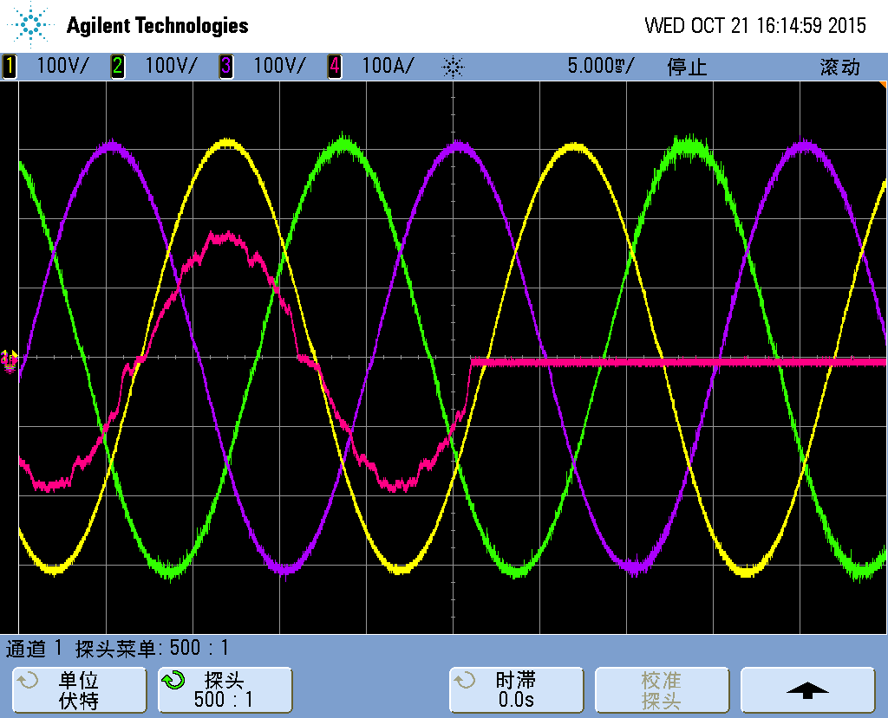 |  | 18.csv
CH1 | Va-output | 1 | Curve1 | 4 | Va-output
CH2 | Vb-output | 2 | Curve2 | 5 | Vb-output
CH3 | Vc-output | 3 | Curve3 | 6 | Vc-output
CH4 | Ia-input | Conclusion: PASS
b) at the peak of the input voltage waveform.
Normal to stored energy mode (waveforms) |  | Normal to stored energy mode (data comparison)
20.png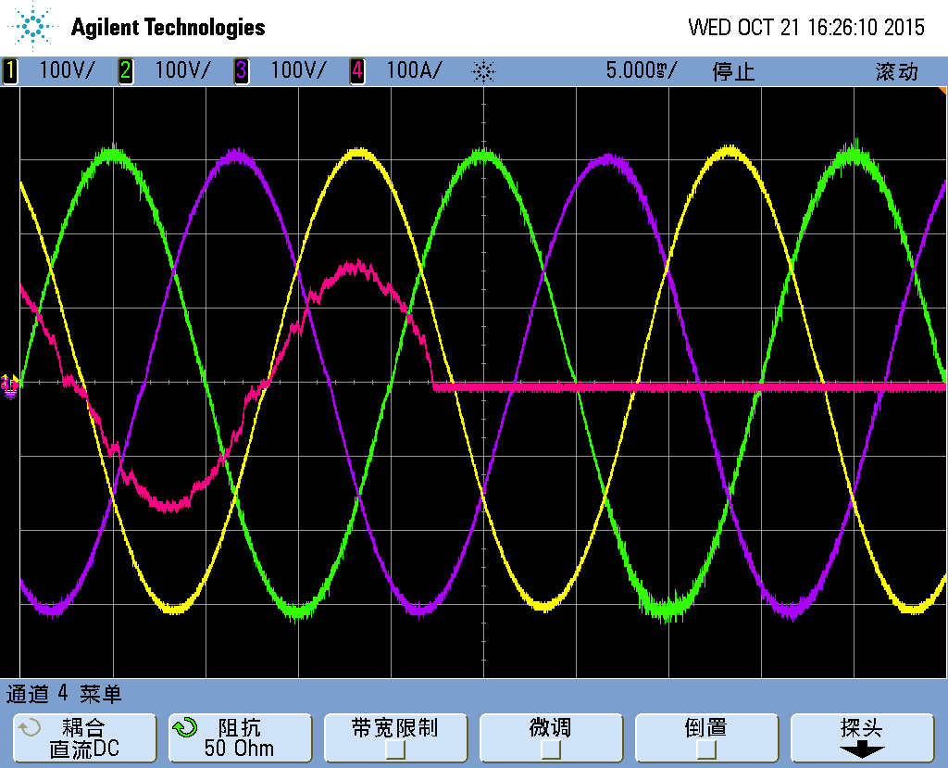 |  | 19.csv
CH1 | Va-output | 1 | Curve1 | 4 | Va-output
CH2 | Vb-output | 2 | Curve2 | 5 | Vb-output
CH3 | Vc-output | 3 | Curve3 | 6 | Vc-output
CH4 | Ia-input | Conclusion: PASS

Ouput-L 37
Ouput-L 37 Dynamic performance – Stored energy to normal mode back to list
6.4.2.11.2- With the UPS initially operating a full load in stored energy mode, the input supply shall be reconnected (at any angular position on the input supply waveform) and the output observed for any deviation during the transition from stored energy mode to normal mode of operation.
This test is generally performed in conjunction with the previous test (see 6.4.4.1).
Where synchronization is a feature of the UPS, during a time interval covering the transition back to normal mode, the input and output voltage waveforms shall be checked to ensure that, at the point of transition, the phase angle between the input supply voltage waveform and output voltage waveform does not exceed any limits stated.
NOTE This test requires instrumentation that can capture a delayed time event since the synchronization period prior to change of mode is a variable. In some cases, it may be possible to use communication signals from the UPS or trigger signals within the UPS to assist in this test. Where this is not possible, the test is done by comparison of both waveforms in time intervals.
Stored energy to normal (waveforms) |  | Stored energy to normal (data comparison)
21.png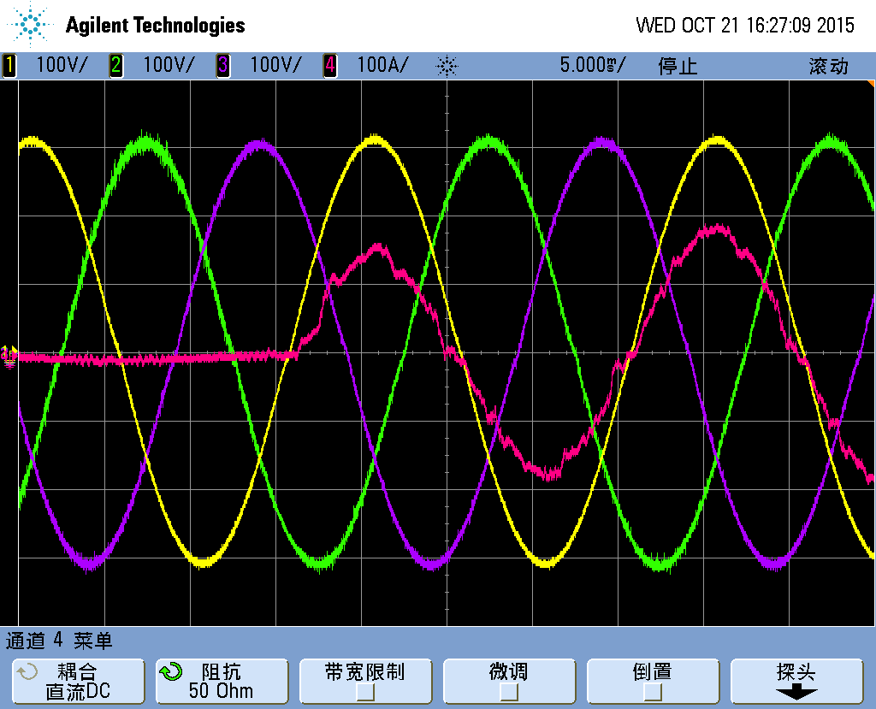 |  | 22.csv
CH1 | Va-output | 1 | Curve1 | 4 | Va-output
CH2 | Vb-output | 2 | Curve2 | 5 | Vb-output
CH3 | Vc-output | 3 | Curve3 | 6 | Vc-output
CH4 | Va-input | Conclusion: PASS

Additional waveforms:
Stored energy to normal (waveforms) | Stored energy to normal (waveforms)
/ | /

Ouput-L 38
Ouput-L 38 Dynamic performance – Normal to bypass mode - overload back to list
6.4.2.11.3- Where the UPS has a bypass mode of operation which is automatic in operation under conditions of output overload or UPS inverter fault, the overload test 6.4.3.1 shall be repeated to force bypass operation due to overload. The input and output voltage waveforms shall be observed during transitions normal to bypass mode, and vice versa, which shall remain within stated values.
Where in addition the manufacturer declares that automatic change to bypass mode is inhibited if the bypass voltage or frequency is out of tolerance (except under certain fault conditions), the input supply voltage and frequency shall be adjusted beyond the specified range to demonstrate compliance with the UPS specification beyond which the UPS operation in bypass mode is inhibited.
Normal to bypass mode (waveforms) |  | Normal to bypass mode (data comparison)
29.png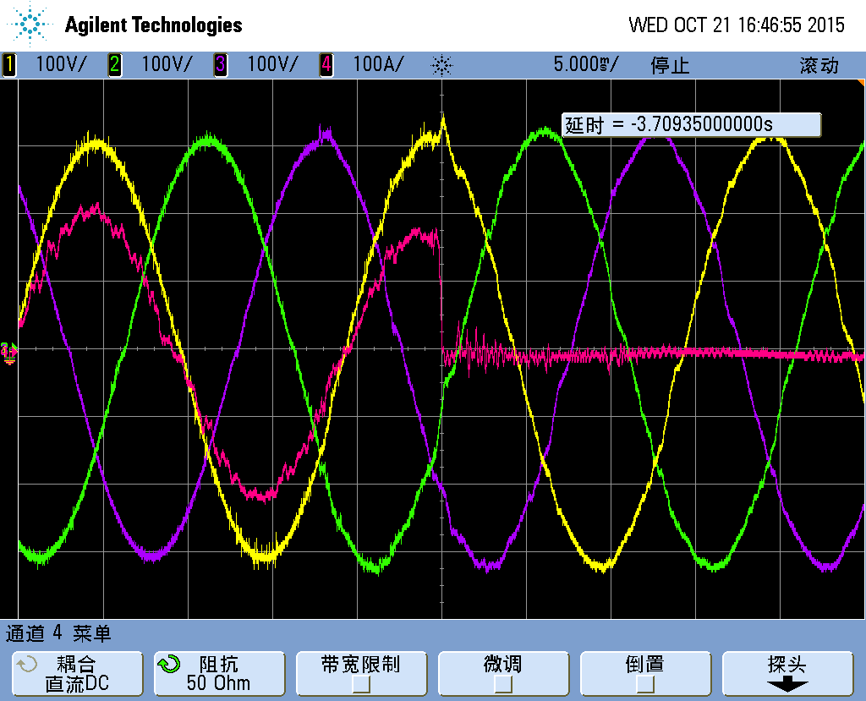 |  | 30.csv
CH1 | Va-output | 1 | Curve1 | 4 | Va-output
CH2 | Vb-output | 2 | Curve2 | 5 | Vb-output
CH3 | Vc-output | 3 | Curve3 | 6 | Vc-output
CH4 | Ia-input | Conclusion: PASS

Additional waveforms:
Normal to bypass mode (waveforms) | Normal to bypass mode (waveforms)
/ | /

Ouput-L 39
Ouput-L 39 Dynamic performance – Step load – Normal mode back to list
6.4.2.11.4- With the UPS operating in normal mode under no load, apply a resistive load equal to 100 % output active power, comprising two loads: one equal to 20 % and one equal to 80 %.
At the point of application of the load when the output waveform is at its peak value, observe the output waveform on suitable storage instrumentation to permit calculation of any dynamic performance deviation.
Reduce the load to 20 % of rated output active power by switching off the 80 % load. Repeat the previous measurements at the instant of disconnection and compute the value, which
shall remain within the stated limits.
Step load (waveforms) |  | Step load (data comparison)
25.png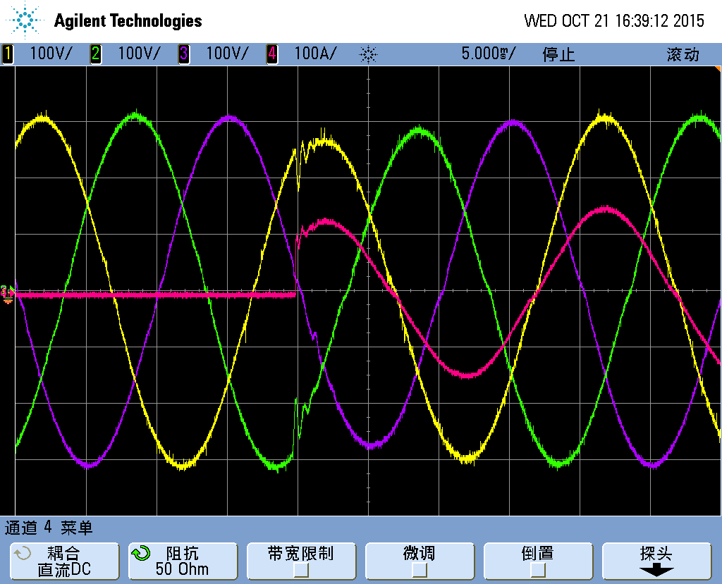 |  | 26.csv
CH1 | Va-output | 1 | Curve1 | 4 | Va-output
CH2 | Vb-output | 2 | Curve2 | 5 | Vb-output
CH3 | Vc-output | 3 | Curve3 | 6 | Vc-output
CH4 | Ia-output | Conclusion: PASS

Additional waveforms:
Step load (waveforms) | Step load (waveforms)
/ | /

Ouput-L 40
Ouput-L 40 Dynamic performance – Step load – Stored energy mode back to list
6.4.2.11.5- Repeat the previous test except that the UPS shall operate in stored energy mode
Step load (waveforms) |  | Step load (data comparison)
28.png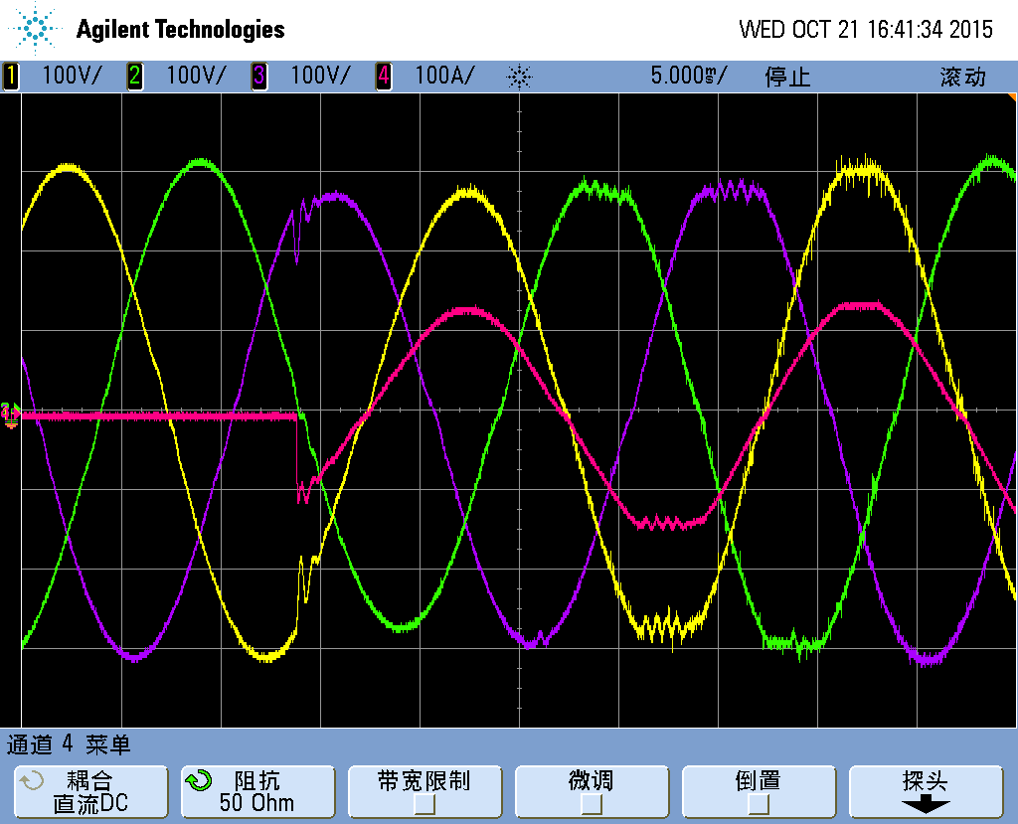 |  | 27.csv
CH1 | Va-output | 1 | Curve1 | 4 | Va-output
CH2 | Vb-output | 2 | Curve2 | 5 | Vb-output
CH3 | Vc-output | 3 | Curve3 | 6 | Vc-output
CH4 | Ia-output | Conclusion: PASS

Additional waveforms:
Step load (waveforms) | Step load (waveforms)
/ | /

Ouput-Non-linear load (41~46)

Ouput-N 41
Ouput-N 41 Normal mode – Full load back to list
6.4.3.1- With the UPS operating in normal mode of operation, apply a reference non-linear load (see Annex E) set to obtain rated output apparent power for the UPS under test.
In steady-state conditions, measure the output voltage waveform and its fundamental and harmonic content. The values shall not exceed the manufacturer's stated value.
Vout |  | A |  | B |  | C |  | THDu |  | A |  | B |  | C |  | f | A | B | C
 |  | 220 |  | 219.9 |  | 219.9 |  |  |  | 5.8 |  | 5.74 |  | 5.67 |  |  | 49.98 | 49.99
N | S | A | B | C | N | S | A | B | C | N | S | A | B | C | N | S | A | B | C
1 |  | 100 | 100 | 100 | 11 | 3.50 | 0.37 | 0.32 | 0.32 | 21 | 0.20 | 0.2 | 0.24 | 0.21 | 31 | 0.97 | 0.1 | 0.07 | 0.08
2 | 2.00 | 0.06 | 0.04 | 0.07 | 12 | 0.46 | 0.02 | 0.01 | 0 | 22 | 0.36 | 0.02 | 0.01 | 0.02 | 32 | 0.33 | 0.01 | 0 | 0.01
3 | 5.00 | 5.04 | 4.98 | 4.91 | 13 | 3.00 | 0.17 | 0.16 | 0.15 | 23 | 1.41 | 0.22 | 0.27 | 0.26 | 33 | 0.20 | 0.12 | 0.12 | 0.11
4 | 1.00 | 0.04 | 0.04 | 0.02 | 14 | 0.43 | 0.02 | 0 | 0.01 | 24 | 0.35 | 0.03 | 0.01 | 0.02 | 34 | 0.32 | 0.02 | 0.01 | 0
5 | 6.00 | 2.68 | 2.66 | 2.64 | 15 | 0.30 | 0.37 | 0.38 | 0.43 | 25 | 1.27 | 0.1 | 0.08 | 0.09 | 35 | 0.83 | 0.09 | 0.07 | 0.09
6 | 0.50 | 0.02 | 0 | 0 | 16 | 0.41 | 0 | 0.01 | 0.01 | 26 | 0.35 | 0.01 | 0.01 | 0.02 | 36 | 0.32 | 0.01 | 0.01 | 0.01
7 | 5.00 | 0.22 | 0.2 | 0.2 | 17 | 2.00 | 0.15 | 0.16 | 0.17 | 27 | 0.20 | 0.11 | 0.08 | 0.07 | 37 | 0.77 | 0.04 | 0.03 | 0.01
8 | 0.50 | 0.01 | 0.02 | 0.02 | 18 | 0.39 | 0.02 | 0.02 | 0.02 | 28 | 0.34 | 0.01 | 0 | 0.01 | 38 | 0.32 | 0.02 | 0 | 0
9 | 1.50 | 0.61 | 0.62 | 0.66 | 19 | 1.76 | 0.25 | 0.21 | 0.22 | 29 | 1.06 | 0.19 | 0.17 | 0.14 | 39 | 0.20 | 0.09 | 0.08 | 0.08
10 | 0.50 | 0.01 | 0.01 | 0.01 | 20 | 0.38 | 0.02 | 0.01 | 0.01 | 30 | 0.33 | 0 | 0.01 | 0.02 | 40 | 0.31 | 0.01 | 0.02 | 0.02
Conclusion: PASS
waveforms |  |  |  |  |  |  |  |  |  | /
/
CH1 |  | Va-output
CH2 |  | Vb-output
CH3 |  | Vc-output
CH4 |  | Ia-output

Ouput-N 42
Ouput-N 42 Stored energy mode – Full load back to list
6.4.3.2- Repeat the previous test (see 6.4.3.1) except that UPS shall operate in stored energy mode.
Vout |  | A |  | B |  | C |  | THDu |  | A |  | B |  | C |  | f | A | B | C
 |  | 220 |  | 220 |  | 220 |  |  |  | 5.84 |  | 5.75 |  | 5.69 |  |  | 49.98 | 50.00
N | S | A | B | C | N | S | A | B | C | N | S | A | B | C | N | S | A | B | C
1 |  | 100 | 100 | 100 | 11 | 3.50 | 0.37 | 0.33 | 0.33 | 21 | 0.20 | 0.2 | 0.25 | 0.19 | 31 | 0.97 | 0.1 | 0.08 | 0.06
2 | 2.00 | 0.05 | 0.04 | 0.06 | 12 | 0.46 | 0 | 0.01 | 0.01 | 22 | 0.36 | 0.01 | 0.03 | 0.01 | 32 | 0.33 | 0.01 | 0.01 | 0.01
3 | 5.00 | 5.08 | 4.98 | 4.92 | 13 | 3.00 | 0.17 | 0.16 | 0.16 | 23 | 1.41 | 0.23 | 0.26 | 0.25 | 33 | 0.20 | 0.12 | 0.12 | 0.1
4 | 1.00 | 0.04 | 0.04 | 0.06 | 14 | 0.43 | 0.02 | 0.02 | 0.01 | 24 | 0.35 | 0.02 | 0.01 | 0 | 34 | 0.32 | 0.01 | 0 | 0.01
5 | 6.00 | 2.7 | 2.69 | 2.67 | 15 | 0.30 | 0.37 | 0.38 | 0.41 | 25 | 1.27 | 0.09 | 0.08 | 0.06 | 35 | 0.83 | 0.09 | 0.09 | 0.07
6 | 0.50 | 0.02 | 0.02 | 0.02 | 16 | 0.41 | 0.01 | 0.01 | 0.02 | 26 | 0.35 | 0.02 | 0.02 | 0 | 36 | 0.32 | 0.01 | 0.01 | 0.01
7 | 5.00 | 0.2 | 0.18 | 0.18 | 17 | 2.00 | 0.16 | 0.16 | 0.15 | 27 | 0.20 | 0.12 | 0.1 | 0.08 | 37 | 0.77 | 0.02 | 0.02 | 0.02
8 | 0.50 | 0.01 | 0 | 0.01 | 18 | 0.39 | 0.01 | 0.02 | 0.01 | 28 | 0.34 | 0.01 | 0 | 0.01 | 38 | 0.32 | 0.01 | 0.01 | 0.01
9 | 1.50 | 0.6 | 0.6 | 0.64 | 19 | 1.76 | 0.23 | 0.21 | 0.24 | 29 | 1.06 | 0.19 | 0.18 | 0.16 | 39 | 0.20 | 0.09 | 0.07 | 0.07
10 | 0.50 | 0.01 | 0.01 | 0 | 20 | 0.38 | 0.02 | 0.03 | 0 | 30 | 0.33 | 0.01 | 0.02 | 0.02 | 40 | 0.31 | 0.02 | 0.01 | 0.01
Conclusion: PASS
waveforms |  |  |  |  |  |  |  |  |  | /
/
CH1 |  | Va-output
CH2 |  | Vb-output
CH3 |  | Vc-output
CH4 |  | Ia-output

Ouput-N 43
Ouput-N 43 Dynamic performance – Normal to stored energy mode back to list
6.4.3.3.1- Repeat the change of mode test of 6.4.2.11.1 except that 100 % reference non-linear load shall be used instead of a linear load. Refer to Annex E for guidance about reference nonlinear load.
a) where the input voltage waveform passes through zero;
Normal to stored energy mode (waveforms) |  | Normal to stored energy mode (data comparison)
16.png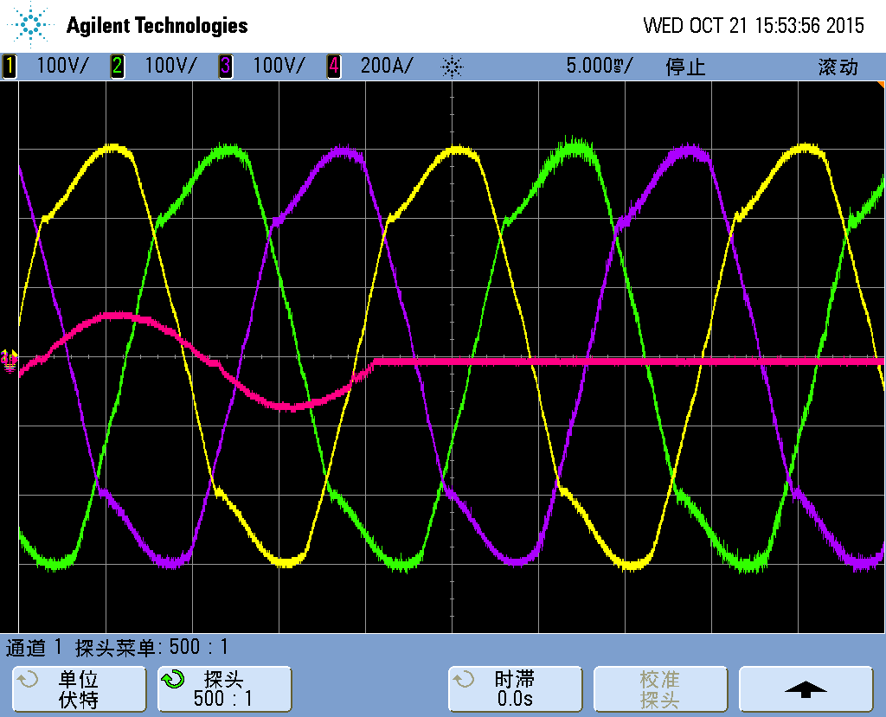 |  | 15.csv
CH1 | Va-output | 1 | Curve1 | 4 | Va-output
CH2 | Vb-output | 2 | Curve2 | 5 | Vb-output
CH3 | Vc-output | 3 | Curve3 | 6 | Vc-output
CH4 | Ia-input | Conclusion: PASS
b) at the peak of the input voltage waveform.
Normal to stored energy mode (waveforms) |  | Normal to stored energy mode (data comparison)
13.png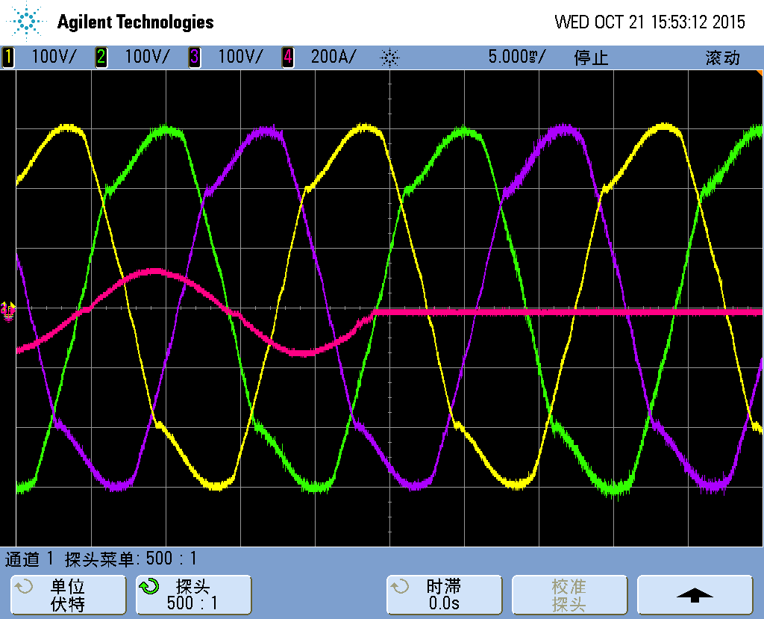 |  | 14.csv
CH1 | Va-output | 1 | Curve1 | 4 | Va-output
CH2 | Vb-output | 2 | Curve2 | 5 | Vb-output
CH3 | Vc-output | 3 | Curve3 | 6 | Vc-output
CH4 | Ia-output | Conclusion: PASS

Ouput-N 44
Ouput-N 44 Dynamic performance – Stored energy to normal mode back to list
6.4.3.3.2- Repeat the change of mode test of 6.4.2.11.2 except that 100 % reference non-linear load shall be used instead of a linear load. Refer to Annex E for guidance about reference nonlinear load.
Stored energy to normal (waveforms) |  | Stored energy to normal (data comparison)
176.png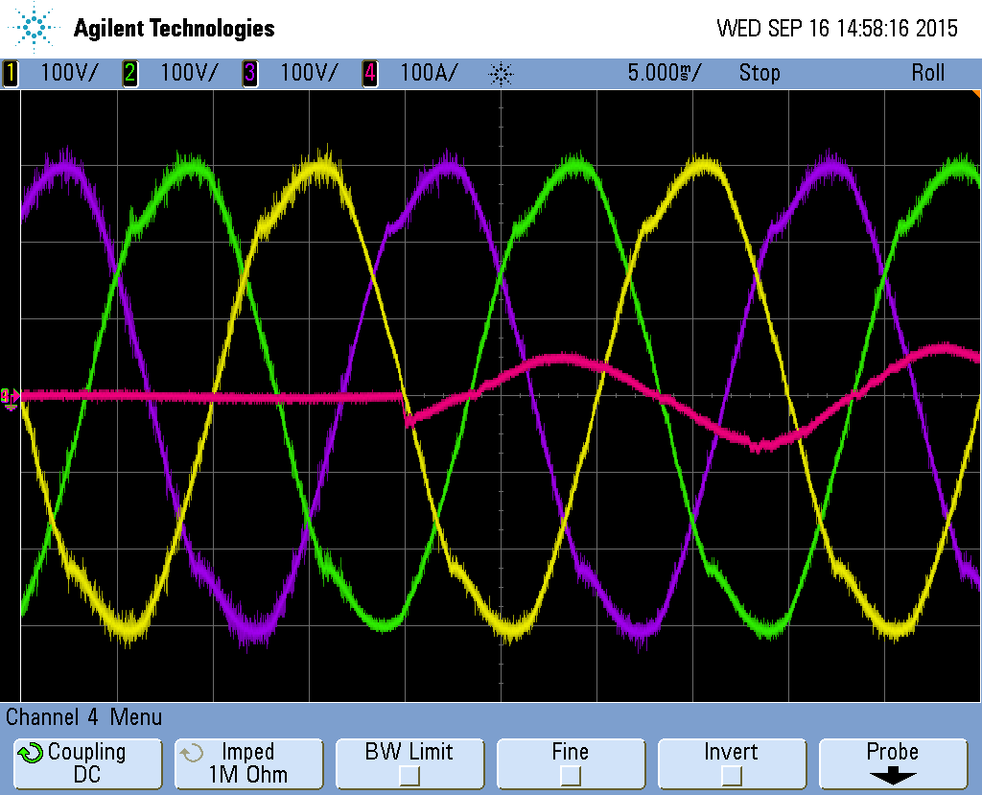 |  | 174.csv
CH1 | Va-output | 1 | Curve1 | 4 | Va-output
CH2 | Vb-output | 2 | Curve2 | 5 | Vb-output
CH3 | Vc-output | 3 | Curve3 | 6 | Vc-output
CH4 | Ia-input | Conclusion: PASS

Additional waveforms:
Stored energy to normal (waveforms) | Stored energy to normal (waveforms)
/ | /

Ouput-N 45
Ouput-N 45 Dynamic performance – Step load – Normal mode back to list
6.4.3.3.3- Apply load steps in accordance with the UPS rating as follows:
a) UPS < 4,0 kVA rating
With the UPS operating at no load in normal mode, apply, as a base load, a reference non-linear load set to obtain 25 % of rated output apparent power (see Annex E).
In steady-state conditions, apply at the peak value of the output voltage waveform an additional reference non-linear load set to 75 % of rated output apparent power. At the instant of application of the additional load, measure the output voltage waveform transient deviation.
In steady-state conditions, switch off the reference non-linear load set to 75 % rated output apparent power at the peak value of the output voltage waveform. At the time of disconnection, repeat the measurements of output voltage waveform transient deviation.
b) UPS > 4,0 kVA rating
With the UPS operating at no load in normal mode, apply, as a base load, a reference non-linear load set to obtain 33 % of rated output apparent power (see Annex E).
In steady-state conditions, apply at the peak value of the output voltage waveform an additional reference non-linear load set to 33 % of rated output apparent power. At the instant of application of the additional load, measure the output voltage waveform transient deviation.
With 66 % base load, apply at the peak of the output voltage waveform a further 33 % reference non-linear step load and repeat measurement of transient voltage deviations.
In steady-state conditions, switch off 33 % of the step reference non-linear load at the peak of the output voltage waveform. At the time of disconnection, repeat measurements of the output voltage waveform.
Repeat, switching off the next 33 % step reference non-linear load to return to the original 33 % base load and recording the transient deviation of the output waveform.
Compliance is verified in accordance with 6.4.3.3.5.
Step load (waveforms) |  | Step load (data comparison)
4.png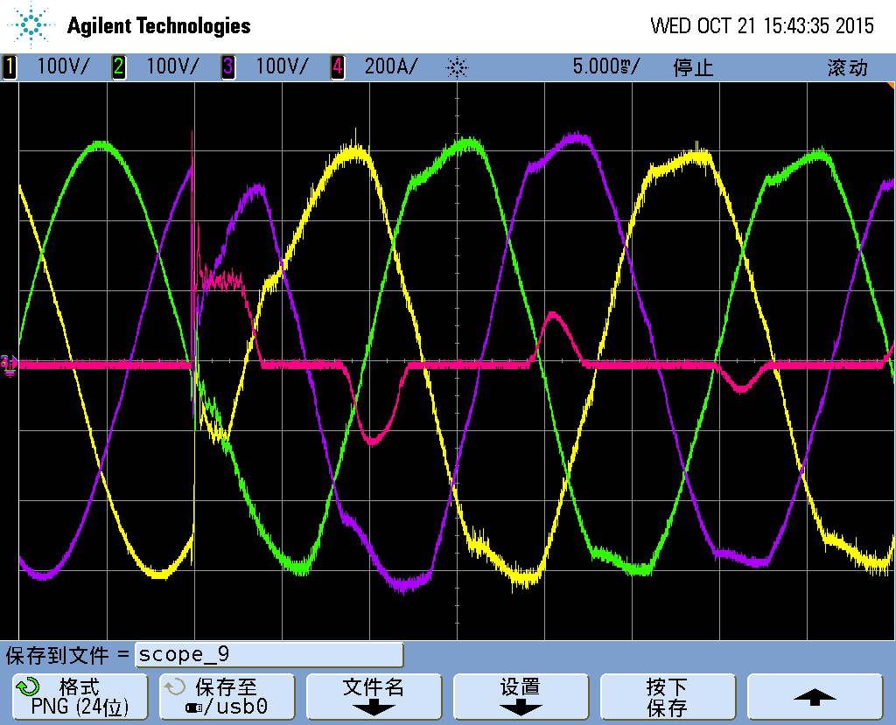  9.png |  | 3.csv  10.csv
CH1 | Va-output | 1 | Curve1 | 4 | Va-output
CH2 | Vb-output | 2 | Curve2 | 5 | Vb-output
CH3 | Vc-output | 3 | Curve3 | 6 | Vc-output
CH4 | Ia-output | Conclusion: PASS

Ouput-N 46
Ouput-N 46 Dynamic performance – Step load – Stored energy mode back to list
6.4.3.3.4- The previous test (see 6.4.3.3.3) shall be repeated in the stored energy mode.
Compliance is verified in accordance with 6.4.3.3.5.
Step load (waveforms) |  | Step load (data comparison)
5.png  8.png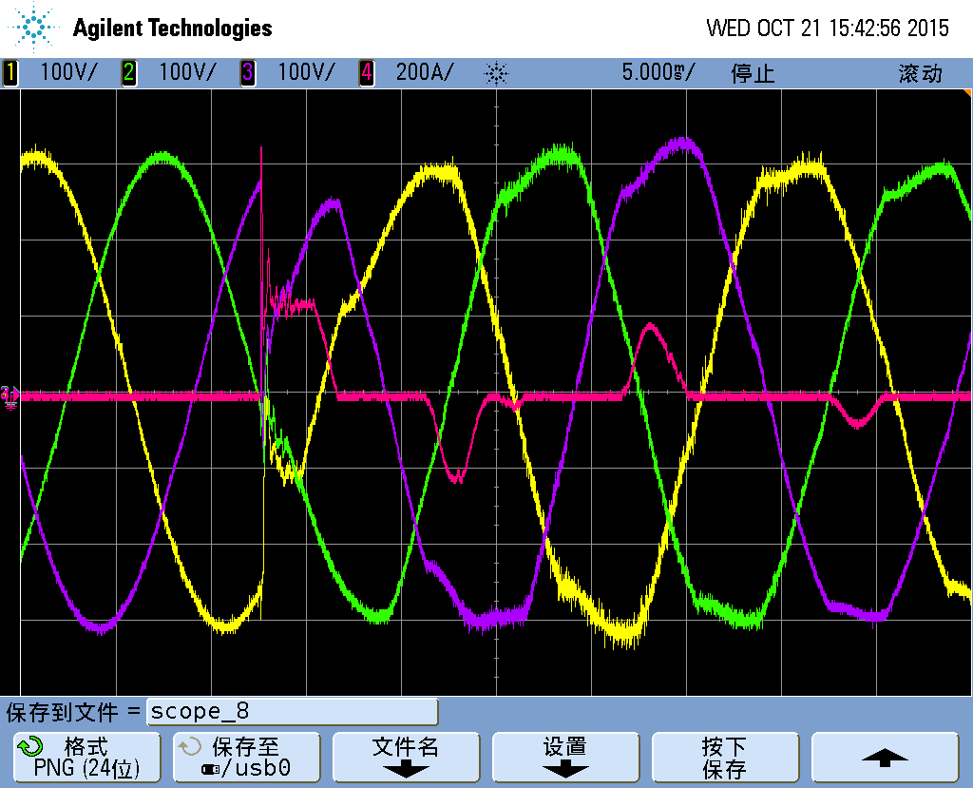 |  | 6.csv  7.csv
CH1 | Va-output | 1 | Curve1 | 4 | Va-output
CH2 | Vb-output | 2 | Curve2 | 5 | Vb-output
CH3 | Vc-output | 3 | Curve3 | 6 | Vc-output
CH4 | Ia-output | Conclusion: PASS

Stored an restored energy times (47~50)

BATT 47
BATT 47 Stored energy time back to list
6.4.4.1- The stored energy time shall be determined by switching off the a.c. input to the UPS operating at rated output active power and measuring the duration that the specified output power is maintained.
Assuming that the energy storage system is a battery, subject to any particular agreement between the purchaser and the UPS manufacturer, the reference temperature of the battery
shall be 25 °C. The temperature of the battery bank shall be measured immediately prior to the test for the purpose of calculation of any adjustment to the expected stored energy time.
NOTE 1 Similar consideration may apply for other stored energy technologies.
The battery cut-off voltage shall not fall below the specified value before this time has elapsed.
Before carrying out this test, operate the UPS in normal mode of operation with nominal input supply and no output load applied for a period in excess of the manufacturers stated restored energy time.
Apply a linear load equal to the rated output active power and interrupt the input supply to force stored energy mode of operation.
Measure the output voltage at the beginning and end of stored energy operation. Measure the time of operation in stored energy mode until the UPS shuts down on battery end-of discharge.
Evaluate the total output voltage regulation and worst-case fundamental and harmonic levels which shall not exceed the manufacturer’s declared values.
NOTE 2 Since new batteries often do not provide full capacity during a start-up period, the discharge test should be repeated after a reasonable restored energy time, if the time achieved initially is less than specified limit. A number of charge/discharge cycles may be necessary before full battery capacity is achieved.
Battery information: 100 Ah, 40 cells.
100% linear balance load | V-BATT |  | I-BATT |  | Vout |  |  | Other information
 | BATT+ | BATT- | BATT+ | BATT- | A | B | C | Time | Temp.
Before discharge(battery fully charged) | 276.1 | 276.3 | 0.4 | 0.3 | 221.3 | 222.0 | 221.9 | 8:30 AM | 26℃
Discharge begin | 252.4 | 252.1 | 75.2 | 75.8 | 221.5 | 220.1 | 221.9 | 8:32 AM | 26℃
Low battery alarm | 220.5 | 220.3 | 82.1 | 82.4 | 220.5 | 219.9 | 221.5 | 9:37 AM | 26℃
EOD- | 210.1 | 210.2 | 88.3 | 87.9 | 220.1 | 219.8 | 220.8 | 9:41 AM | 26℃
Conclusion: PASS

BATT 48
BATT 48 Restored energy time back to list
6.4.4.2- At the cessation of stored energy test of 6.4.4.1, reapply the input supply to the UPS and operate in normal mode of operation, at nominal input supply voltage and rated output active and apparent power. Measure maximum UPS input current at the start of restored energy time.
After the manufacturer's stated restored energy time has elapsed, the test of 6.4.4.1 shall then be repeated. Verify that the new value of stored energy time is not less than 90 % of the time previously measured.
NOTE 1 Worst-case consideration should apply where the charging capacity, in normal mode of operation, is affected by the amount of load applied to the UPS output.
NOTE 2 Stored energy and restored energy times are influenced by ambient temperature and the values stated by the manufacturer for restored energy time is the time to restore 90 % of rated capacity unless otherwise stated.

Battery information: XXX Ah, XXX cells. Brand of battery and etc.

Condition | V-BATT |  | I-BATT |  | Temp | Time
 | BATT+ | BATT- | BATT+ | BATT-
EOD+ | 210.2 | 210.3 | / | / |  | 8：35 AM
Charge start | 227.8 | 226.4 | 10.2A | 10.4A | 26℃ | 8:41 AM
90% restored | 276.2 | 276.5 | 0.2A | 0.3A | 26℃ | 18:17 PM
Conclusion: PASS

BATT 49
BATT 49 Battery ripple current back to list
6.4.4.3- The a.c. component (r.m.s. value) of the battery current shall be measured when a limit for battery ripple current is specified. The UPS shall operate in normal mode and the battery shall be fully charged. Worst-case ripple current shall be reported if this measurement is affected by the loading of the UPS. Balanced and unbalanced load conditions shall be considered.
Compliance is verified when the ripple current measured is equal or lower than that specified by the battery manufacturer.

Battery is fully charged:
0% load |  | I ripple  (A) | Full balance R load |  | I ripple  (A) | Full balance RCD load |  | I ripple  (A) | One phase full R load |  | I ripple  (A)
AC rms | BATT+ | 280.0mA | AC rms | BATT+ | 330.6mA | AC rms | BATT+ | 687.1mA | AC rms | BATT+ | 483.0mA
 | BATT- | 417.1mA |  | BATT- | 439.7mA |  | BATT- | 760.3mA |  | BATT- | 614.7mA
Two phase full R load |  | I ripple  (A) | One phase full RCD load |  | I ripple  (A) | Two phase full RCD load |  | I ripple  (A) | Conclusion: PASS
AC rms | BATT+ | 635.1mA | AC rms | BATT+ | 467.2mA | AC rms | BATT+ | 633.3mA
 | BATT- | 714.6mA |  | BATT- | 556.6mA |  | BATT- | 719.5mA

BATT 50
BATT 50 Restart test back to list
6.4.4.4- Automatic or other restart means shall be tested after a complete shutdown of the UPS
Settings | Actions of UPS | PASS or NOT
Total restart | Total restart to inverter | PASS
Restart to bypass | Restart to bypass only | PASS
No output | No output | PASS

Environmental (51~55)

Environmental 51
Environmental 51 Repetitive shock during transportation back to list
6.5.2.1- This shall be carried out on units with mass less than 50 kg complete, but excluding the shipping container. Perform shock tests in accordance with the following.
a) Initial measurements: perform the electrical routine tests described in 6.2.2 on the UPS and then pack it into its shipping state for transportation.
b) Mode of operation: The UPS is non-operational and packed in its normal shipping state for transportation.
c) Test: The packaged specimen shall be subjected, in all three planes, to two 15 g half-sine shock pulses of 11 ms nominal duration. The method of test shall be as in IEC 60068-2-27. Measurements during testing: No measurements are taken during the test.
d) Final requirements: After the tests, the UPS shall be unpacked and checked for signs of physical damage or distortion to component parts and shall continue to function according to this standard.
e) Final measurements: perform light load and functional test routine test (see 6.2.2.3).
NOTE Final measurements and requirements can be combined with those of the free fall test (see 6.5.2.2) .

See test report: “^^^.docx”

Environmental 52
Environmental 52 Free-fall during transportation back to list
6.5.2.2- Perform free fall tests in accordance with the following.
a) Initial measurements: perform the electrical routine tests described in 6.2.2 on the UPS.
b) Mode of operation: The UPS is non-operational during the test and packed in its normal shipping state for transportation.
c) Test: The specimen shall be allowed to fall freely from a point of suspension into a solid surface. The surface of the package which is caused to touch the solid surface through the fall is the surface on which the package normally rests. The method of test shall be as in IEC 60068-2-31. The following are the minimum requirements:
1) the test shall be carried out twice;
2) the test shall be made with the specimen in its integral transport case or shipping state for transportation;
3) the height of fall shall be according to Table 1;
4) the height of fall shall be measured from the part of the specimen nearest to the test surface.
Table 1 – Free fall testing
Mass of unpacked specimen kg Height of fall mm
M≤10 250
10 < M≤50 100
50 < M ≤ 100 50
100 < M 25
d) Measurements during testing: No measurement is taken during the test.
e) Final requirements: After the test, the UPS shall be unpacked and inspected for physical damage to component parts, and the UPS shall continue to perform in accordance with the initial characteristics and meet the constructional safety requirements.
f) Final measurements: perform light load and functional test routine test (see 6.2.2.3).

See test report: “^^^.docx”

Environmental 53
Environmental 53 Storage in dry heat, damp heat and cold environments back to list
6.5.3- Perform storage tests in accordance with the following
a) Initial measurements: Perform the electrical routine tests described in 6.2.2 on the UPS.
Before carrying out these tests, any internal battery shall have been charged for the period defined in the manufacturer's instructions and be in a state of full charge.
b) Mode of operation: The UPS is not operational, but packed in its normal shipping state for transportation and storage with controls set in shipping state.
c) Tests:
1) Dry heat as per the normal environmental conditions: +55 °C ± 2 °C for a duration of 16 h using the test method Bb of IEC 60068-2-2.
2) Damp heat as per the normal environmental conditions: +40 °C ± 2 °C at a humidity of 90 % to 95 % for a duration of 96 h using IEC 60068-2-78.
3) Cold as per the normal environmental conditions: –25 °C ± 3 °C for a duration of 16 h where practicable using test method Ab of IEC 60068-2-1.
4) Damp heat repeated.
d) Measurements during test: No measurement is taken during the tests.
e) Final requirements: After the tests, the UPS shall be unpacked and inspected for signs of damage to components or corrosion of metallic parts. The UPS shall continue to perform in accordance with the initial characteristics and meet the constructional safety requirements.
f) Final measurements: Allow unit to return to normal ambient temperature and pressure.
After tests, the UPS shall perform in accordance with the light load and functional test routine test (see 6.2.2.3).

See test report: “^^^.docx”

Environmental 54
Environmental 54 Operation in dry heat, damp heat and cold environments back to list
6.5.4- Perform operation tests in accordance with the following.
a) Initial measurements: Perform the electrical routine tests described in 6.2.2 on the UPS.
b) Mode of operation: The UPS works in normal mode of operation at rated input voltage and rated output apparent power.
c) Test: Tests shall be done in the following sequence:
1) Dry heat as per the normal environmental conditions or as per the manufacturer's stated maximum value for a duration of 16 h using test method Bd of IEC 60068-2-2.
2) Damp heat as per the normal environmental conditions: +30 °C ± 2 °C at a humidity of 82 % to 88 % for a duration of 96 h using IEC 60068-2-78.
3) Cold as per the normal environmental conditions or as per the manufacturer's stated minimum temperature for a duration of 2 h using test method Ad of IEC 60068-2-1.
4) Damp heat repeated.
Exceptionally, where the UPS incorporates energy storage system (s) in the form of batteries, the test temperature shall be at +5 °C minimum and +35 °C maximum.
d) Measurements during testing: Measurements are taken during the tests in order to check that the UPS continues to function according to this standard in normal, stored energy and bypass modes of operation as applicable.
e) Final measurements: Same as initial measurements.
f) Final requirements: After the tests, the UPS shall work in accordance with the light load and functional test routine test (see 6.2.2.3) and meet applicable constructional safety requirements.

See test report: “^^^.docx”

Environmental 55
Environmental 55 Acoustic noise back to list
6.5.5- The manufacturer shall state in the technical documentation the acoustic noise level that shall be measured in accordance with the method of measurement specified in ISO 7779 and governed by the normal positioning expected in use (for example, table-top, wall-mounted or free-standing).
Values shall be measured when the UPS operates at rated steady-state linear load under the following conditions:
– normal mode of UPS operation, at normal input voltage;
– stored energy mode of UPS operation.
The acoustic noise level shall be referred to the 1 m distance and stated in dBA (dB referenced to acoustic weighing scale A obtained from a sound level meter complying with IEC 61672-1).
The acoustic noise from audible alarms shall not be included in the values stated.
The acoustic noise from fans required to operate under any rated condition shall be included in the values stated.
Compliance is verified when the values measured are within the values declared by the UPS manufacturer.
Condition | Input |  |  |  | Output |  |  |  | ?dBA
Normal mode | Phase | voltage | current | PF | Phase | voltage | current | PF
 | A |  |  |  | A
 | B |  |  |  | B
 | C |  |  |  | C
Stored energy mode | Phase | voltage | current | PF | Phase | voltage | current | PF | ?dBA
 | A |  |  |  | A
 | B |  |  |  | B
 | C |  |  |  | C
Conclusion: N/A

Others 56&57
Others 56 Safety X Refer back to list
See test report: “^^^.docx”

Others 57 Electromagnetic compatibility X Refer back to list
See test report: “^^^.docx”

